Lesson 22
Objective: Count up to 5 objects and match the numerals.

Suggested Lesson Structure
 Fluency Practice (6 minutes)
 Application Problem (3 minutes)
 Concept Development (13 minutes)
 Student Debrief (3 minutes)
Total Time (25 minutes)
Fluency Practice (6 minutes)
- Counting the Math Way on the Piano PK.CC.3a (3 minutes)
- Hop-Hop PK.CC.2 (3 minutes)
Counting the Math Way on the Piano (3 minutes)
Materials: (T) Stickers (for students who still need them) (S) Piano mat (Lesson 17 Template)
Note: In counting the Math Way on the piano, students see the number of fingers increase as they count from 1 to 5, moving from left pinky to thumb without interruption. This provides a foundation for understanding the number path and number line, in which numbers also increase from left to right. Internalization of the number line develops multiple areas of number sense and facilitates future work in operations. Other methods of finger counting should not be discouraged outside of this activity. Students now have a special Math Way to add to their repertoire.
After a brief review, practice counting as described in Part 1 of the Concept Development of Lesson 17.
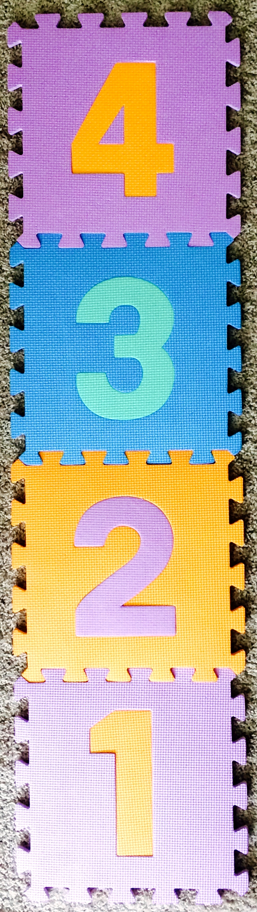
Hop-Hop (3 minutes)
Materials: (T) Hopscotch mat to 4, bean bag
Note: This fluency activity is intended to maintain students’ ability to count and match quantities with numerals to 4. Using the numbered hopscotch mat allows students to see numbers along a trajectory.
Conduct as in Lesson 17, but now use a hopscotch mat to generate numbers. Have one student toss the bean bag onto the mat. Everyone says the number and then hops that number of times.
Application Problem (3 minutes)
Materials: (T) 1 flower, 2 bees, 3 bluebirds (Lesson 12 Template 1), 4 kittens (Lesson 21 Template 1), 5 ducks (Template 1) or real objects
Gather children in a circle. Give an object or picture to each child, but do not group them by type. Say the following rhyme:
One little flower, 2 little bees,
3 little bluebirds in a tree.
Nice warm sun shines down on me.
I can count! 1, 2, 3!

4 little kittens come out to play,
On this warm and sunny day.
Five little ducks take a dive.
Count them: 1, 2, 3, 4, 5!

Ask questions such as, “How many ducks are there?” “How many kittens?” Discuss ways to make counting the animals easier (grouping, lining up by type) and try student ideas.
Note: The Application Problem reviews counting up to 5 in preparation for matching numerals to quantities in Concept Development. It also asks students to apply their knowledge to make counting easier and more efficient.
Concept Development (13 minutes)
Part 1: Concept Introduction
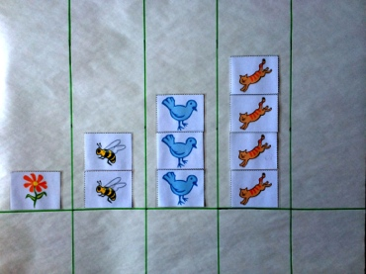
Materials: (T) Large white board with magnetic numerals 1–5; 1 flower, 2 bees, 3 bluebirds (Lesson 12 Template 1); 4 kittens (Lesson 21 Template 1), large numerals 2–5; sets of 5 magnetized objects (e.g., 5 ducks from Template 1) (S) 5-group strip with 1, 2, 3, 4, or 5 dots (Template 2)
Note: For Step 4, if using a magnetic white board, place a strip of white paper on the 5 column for the creation of a vertical 5-group using a dot painter or sponge.
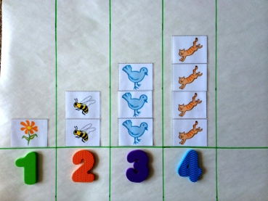
- Display white board without numerals, and reference the rhyme from the Application Problem. Distribute one magnetic numeral (1, 2, 3, or 4) to four students and ask them to affix it under the matching number of objects (e.g., 4 kittens). Ask, “Which group has 4 objects?” Invite remaining students to give a thumbs up if they agree.
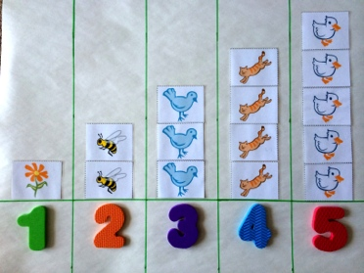
- Add one more vertical column to the white board so that there are five columns. Place 5 ducks in the fifth column. Ask students, “How many ducks are there?” Lead them to count and respond, “There are five ducks.”
- Place the numeral 5 below the ducks. Tell students, “This is the number 5.” Students repeat the statement.
- Remove each picture and make a dot in its place. Build to a vertical 5-group. Say, “Watch how I can make a group of 5!”
- Tell students, “Let’s play Find the Matching Number!” This time, display a large number 1, 2, 3, 4, or 5 in five areas of the classroom. Pass out 5-group strips, one to each student, printed with 1, 2, 3, 4, or 5 dots. Tell students to move to the number that matches the number of dots on their strip. Ask them, “What number matches the number of dots on your strip?”

NOTES ON
MULTIPLE MEANS
OF REPRESENTATION:
Circulate while students are playing Find the Matching Number. Guide students to ask their classmates, “How many?” and to answer using statements that include the unit (dots). This provides an opportunity for students to practice using math words and for the teacher to check for comprehension.
- Guide students to respond, “The number ___ matches.” Once all students are standing by a number, have them check to see if a friend in their area has the same number of dots, and that they match the numeral.
- Guide all the students at number 1 to stomp once, all the students at number 2 to stomp twice, and so on. Repeat with a different dot strip.
Part 2: Practice
Materials: (S) Per pair: baggie with numeral cards 1–5 (Lesson 21 Template 2, cut apart); baggie containing 5-group strips 1–5 (Template 2);
1. Pair students and send them to tables, saying, “Let’s play a game! One of you will be the teacher and one of you will be the student.”
2. Say, “Teachers, pick a dot strip and ask your student what number matches.”
3. Say, “Students, find the number that matches and hand it to the teacher.”
4. Students switch roles, repeating Steps 2 and 3.
MP.5
5. Circulate among groups and help students correctly match dots to numerals. Show students how to use the dots on the back of the numeral cards to check their work (e.g., “Look! The back of the number 4 has 1, 2, 3, 4 dots. This dot strip also has 4 dots. They match!”)

Student Debrief (3 minutes)
Lesson Objective: Count up to 5 objects and match the numerals.
The Student Debrief is intended to invite reflection and active processing of the total lesson experience. It is also an opportunity for informal assessment. Consider taking anecdotal notes or using a simple checklist to note each child’s progress towards meeting the lesson objective.
As students complete the Practice portion of the Concept Development, listen for misconceptions or misunderstandings that can be addressed in the Debrief. You may choose to use any combination of the questions below to help students express ideas, make connections, and explore new concepts.

CENTER CONNECTION:
Invite children to bring their numeral cards to the art center. After children draw a tree (provide a tree template to those who need it), invite them to squish up small tissue paper squares and glue them to the tree as fruit (provide tissue paper in sets of 5 or fewer). They can count the pieces of fruit and match the corresponding numeral card. Remind them to use the dots on the back to check their work.

- What important number did we learn about today? How did we show 5? Where else do we see 5 things?
- (Hold up the dot card or 5-group strip that shows 5. Display numerals on carpet.) Which number matches these dots?
- (Write the numeral 5 on the board or hold up a foam numeral 5.) Show me this number on your fingers. (Call a student forward to trace it with his finger. Have the other students trace in the air with the student.) What does the number 5 look like to you?

5 ducks
5-group strips

