Topic F
Matching 1 Numeral with up to 5 Objects
PK.CC.2, PK.CC.3ab, PK.CC.4
Focus Standard: | PK.CC.2 | Represent a number of objects with a written numeral 0–5 (with 0 representing a count of no objects).
 | PK.CC.3 | Understand the relationship between numbers and quantities to 10; connect counting to cardinality.  - When counting objects, say the number names in the standard order, pairing each object with one and only one number name and each number name with one and only one object.  - Understand that the last number name said tells the number of objects counted. The number of objects is the same regardless of their arrangement of the order in which they were counted.
 | PK.CC.4 | Count to answer "how many?" questions about as many as 10 things arranged in a line, a rectangular array, or a circle, or as many as 5 things in a scattered configuration; given a number from 1–10, count out that many objects.
Instructional Days: | 7
Coherence -Links to: | GK–M1 | Numbers to 10
 | GK–M5 | Numbers 10─20 and Counting to 100
In Topic D, children worked within 3, matching a group to the numeral that tells how many. Now, In Topic F, they extend this skill to groups of 4 and 5 (PK.CC.2, PK.CC.3ab).
In Lessons 21 and 22, children count groups of 4 and 5 and match them to the numeral that tells how many. They use objects and pictures to practice this skill.
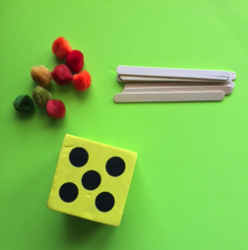
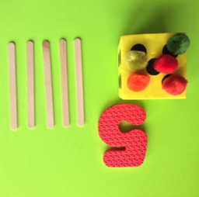
Lessons 23 and 24 follow the pattern developed in Topic D for creating a group. In Lesson 23, children roll a die (with dot configurations of 1, 2, 3, 4, and 5), count to tell how many dots, and find the matching numeral (PK.CC.2). Then, they create two different groups to match the number of dots shown: one using puffballs, and one using sticks. Lesson 24 asks students to create a group after seeing a numeral or hearing a number. As in Topic D, students use cards with numerals on one side and dots on the other to support those children who still need to use matching in order to create a group.
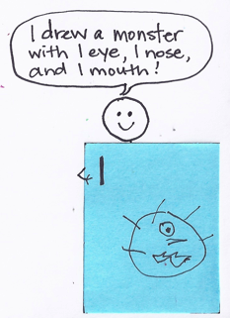
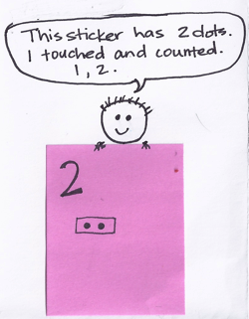
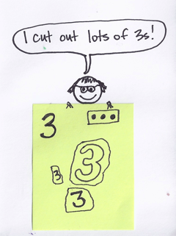
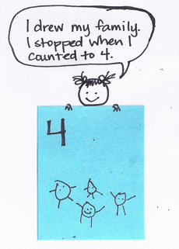
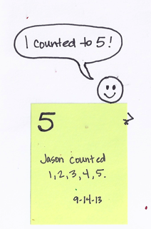
In Lessons 25 and 26, children create number books to demonstrate their understanding of numbers 1–5. The lessons are structured so that children make choices about how to represent the numbers using objects, pictures, and numerals (respectively: concrete, pictorial, and abstract). Differentiated opportunities (as pictured below) are provided for every child to represent numbers 1–5.
In Lesson 27, students synthesize their understanding of the quantities 1–5 by playing a bingo game. When children are shown a numeral card, they put a chip on the matching number of objects arranged in different formations on bingo boards. Likewise, when they are shown a dot card, children place their chip on the matching numeral.
In Topic F Fluency Practice, students maintain their skill of counting and matching quantities with numerals to 5 in the context of pretend play (e.g., Counting Ice Cubes activity), games, and movement. Students continue to practice counting the Math Way on the piano, now with matching numerals for each finger, so that they can begin to internalize the number line. This counting sequence anticipates the work with 1 more in Topic G.
A Teaching Sequence Towards Mastery of Matching 1 Numeral with up to 5 Objects
Objective 1: Count up to 4 objects and match the numerals.
(Lesson 21)
Objective 2: Count up to 5 objects and match the numerals.
(Lesson 22)
Objective 3: Make a group of up to 5 objects and match the numeral (concrete to abstract).
(Lesson 23)
Objective 4: Look at a numeral and count out a group of objects to match (abstract to concrete).
(Lesson 24)
Objective 5: Represent numbers 1─5 using objects, pictures, and numerals.
(Lessons 25─26)
Objective 6: Play a game involving numbers to 5.
(Lesson 27)

