Lesson 20
Objective: Arrange and count 5 objects in a circular configuration.

Suggested Lesson Structure
 Fluency Practice (6 minutes)
 Application Problem (2 minutes)
 Concept Development (14 minutes)
 Student Debrief (3 minutes)
Total Time (25 minutes)
Fluency Practice (6 minutes)
- Counting Ice Cubes to 3 PK.CC.3 (3 minutes)
- Baggie Buddies PK.CC.2 (3 minutes)

NOTES ON
SUPPORTING
BACKGROUND KNOWLEDGE:
Students may not be familiar with the carnival and carousel context in the Concept Development. Use photographs or video to provide this background knowledge in advance of the lesson.

Counting Ice Cubes to 3 (3 minutes)
Materials: (S) 3 linking cubes, small paper or plastic cup
Note: In this activity, students practice counting out a group of objects and answering how many questions to 3.
Conduct the activity as before in Lesson 14, with students filling cups to match the ice cube order.
Baggie Buddies (3 minutes)
Materials: (T) 3 objects (natural objects such as leaves, sticks, and rocks are particularly engaging to students) (S) Baggie filled with numeral cards 1, 2, and 3 (Lesson 12 Template 2)
Note: This fluency activity maintains students’ ability to match quantities with numerals to 3.
Hold up 1–3 objects and have students show the matching numeral. See Lesson 14 for full a description.

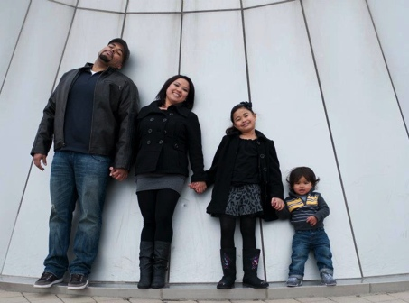
Application Problem (2 minutes)
Materials: (T) Family picture (Template 1) inside a plastic sheet protector
Show the family photo and have students count the number of people in the family. Ask students for ideas about how they can make the family into two groups (adults and children, girls and boys, wearing a hat and not wearing a hat). Circle the groups based on student suggestions. “How many girls are there?” “How many boys are there?”
Reverse the process to show composition. “When we put the family members back together in one group, how many are there?”
Note: This activity reviews embedded numbers by helping students see that a group can be broken into two parts. This early work with decomposition and composition hints at the part–part–whole relationship fundamental to addition and subtraction concepts.
Concept Development (14 minutes)
Part 1: Concept Introduction
Materials: (T) Party hat, small paper plate, 5 teddy bear counters, sticker or paper clip (to mark the start of the count), crayon, table image (Template 2)
- Call 5 students forward and arrange them in a line. Tap each one on the shoulder as you count chorally, “1, 2, 3, 4, 5.”
- Tell students that these friends are at a birthday party, and they would like to play Duck-Duck-Goose. “I’ll be the counter.” Instruct them to hold hands to form a circle, and then, sit down.
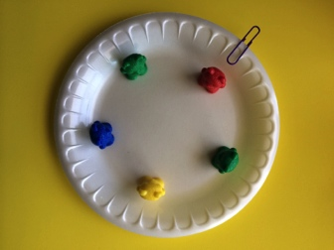
- Describe what you are doing using self-talk: “I want to know how many friends are playing, so I am going to tap (on the shoulder) and count each one.” Count beyond 5, continuing around the circle, even as students say to stop counting.
- Count again, this time asking students to tell you when to stop. Then, say, “Hmm… I need to remember where I started. How can I remember?” Affirm student suggestions: “Yes, I need something to mark the start!”
- Repeat the count, this time placing a party hat on the first friend’s head to mark the start of the count.
- Arrange 5 teddy bear counters around a paper plate. Tell students that these bear friends are on a merry-go-round. Count past 5 again, and ask students, “How can I remember where I started?” “Mark the start!” Repeat the count, using a paper clip to mark the start of the count.
- Repeat with a picture of 5 plates on a circular table. Say, “Jordan helped his parents set the table. How many plates are on the table?” Call a student forward to touch and count each plate on the table. Show him how to make a dot on the first plate with a crayon to mark the start of the count.
Part 2: Practice
Materials: (T) Small paper plate from Part 1 (S) Small paper plate; baggie with 5 linking cubes, a sticker, and crayon; Problem Set
- Give each student a paper plate and baggie and send them to tables to line up their cubes and quietly count them with a partner.

NOTES ON
MULTIPLE MEANS
OF ACTION AND EXPRESSION:
Provide a variety of ways for students to mark the start of the count. For example, students who are having difficulty could use a sticker to mark the first cube. Other students will not need a marker because they can visualize where to start and end the count.

- Hold up the paper plate. Say, “Some friends (cubes) are riding on the carousel at the carnival.” Instruct students to put the friends in a circle around the plate and count them.
MP.5
- Allow children time to discover that they need to mark the starting point (sticker provided in each baggy). Encourage children to start their count with a different bear each time.
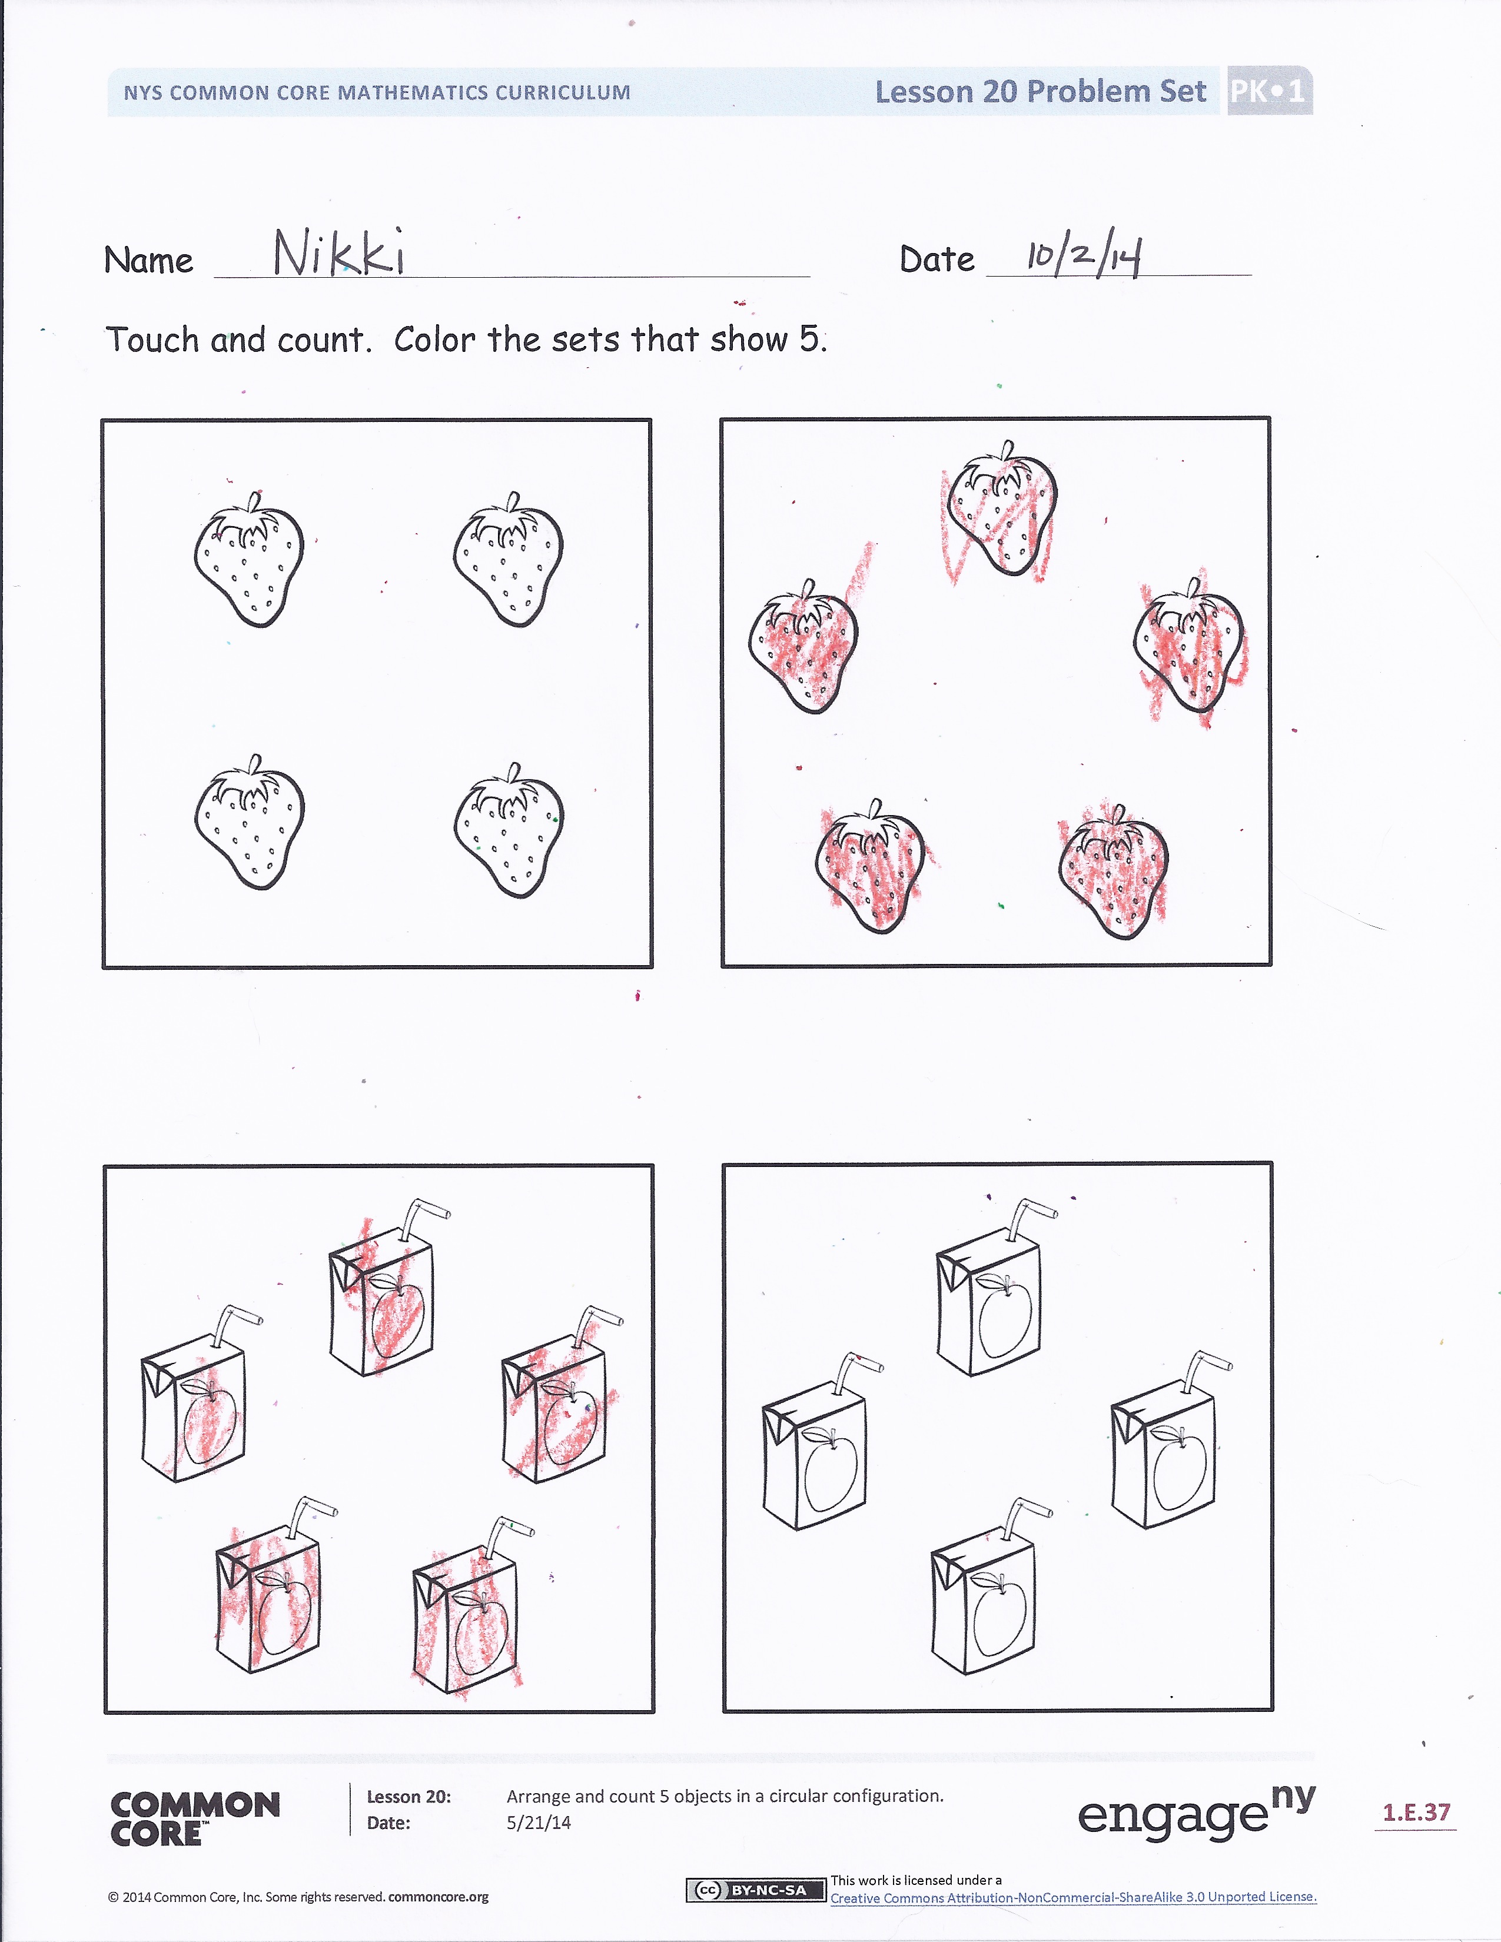
- As students practice counting with a partner, circulate and describe what they are doing using parallel talk: “Serena is marking the first cube with a paper clip, so she knows where to stop counting,” or “Asher is touching and counting around the circle, and he knows exactly where to start and stop.”
- Tell students to take a crayon from their baggies. Distribute the Problem Set, and instruct students to touch and count each object in the circle. Show them how to make a dot on the first object with their crayon to mark where their count starts.
Student Debrief (3 minutes)
Lesson Objective: Arrange and count 5 objects in a circular configuration.
The Student Debrief is intended to invite reflection and active processing of the total lesson experience. It is also an opportunity for informal assessment. Consider taking anecdotal notes or using a simple checklist to note each child’s progress towards meeting the lesson objective.

As students complete the Practice portion of the Concept Development, listen for misconceptions or misunderstandings that can be addressed in the Debrief. You may choose to use any combination of the questions below to help students express ideas, make connections, and use new vocabulary (mark).

CENTER CONNECTION:
Look for opportunities to count objects in a circle during centers activities. If students are sitting in a circle at a table, ask them to count how many students in chairs are at the table. Assist them in marking the starting point of their count if needed.

- How did you know which strawberry you counted first? What did you do to mark the first strawberry you counted?
- Show your partner which group of juice boxes you colored. Did you color the same ones?
- Is it easier to count things in a line or in a circle? Why?

Name Date
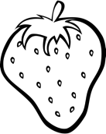
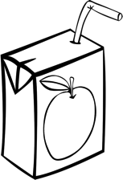
Touch and count. Color the sets that show 5.

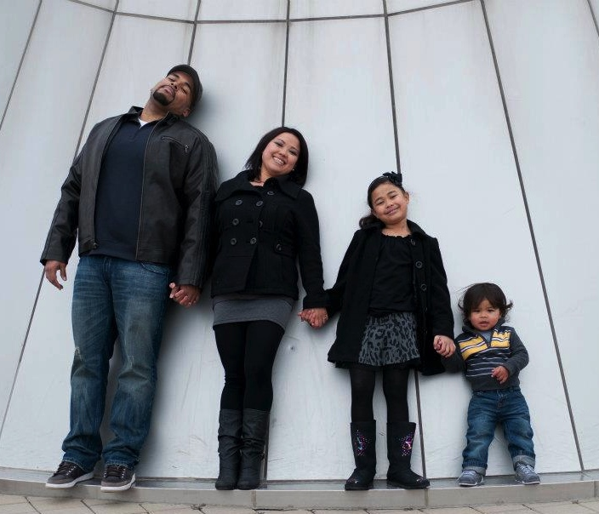

family picture
table image (5 plates)

