Lesson 19
Objective: Find embedded numbers within 4 and 5 objects.

Suggested Lesson Structure
 Fluency Practice (4 minutes)
 Application Problem (3 minutes)
 Concept Development (15 minutes)
 Student Debrief (3 minutes)
Total Time (25 minutes)
Fluency Practice (4 minutes)
- Peek-a-Boo Counting PK.CC.3b (3 minutes)
- Number Cha-Cha to 5 PK.CC.1 (1 minute)

Peek-a-Boo Counting (3 minutes)
Materials: (T) 5 large objects (e.g., 5 beach balls), 2 manila file folders with ends stapled together to form a screen
Note: This variation subtly guides students to recognize numbers 1, 2, 3, and 4 embedded in the group of 5, preparing students to work with embedded numbers.
Conduct the activity as described in Lesson 10, but now leave a substantial gap between objects (see example below) to show 5 as 4 and 1, 3 and 2, and 2 and 2 and 1 (as well as the inverse combinations).

Number Cha-Cha to 5 (1 minute)
See Lesson 15 for full description. 1 (hand out), 2 (other hand out), 3, 4, 5 (step in place, rhythmically).
Note: In addition to developing fluidity in the counting sequence, a movement-based fluency placed before a less active component improves students’ engagement and ability to attend to instruction.
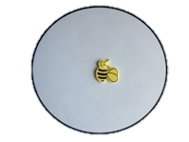
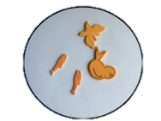
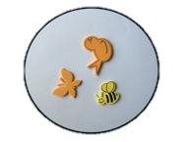
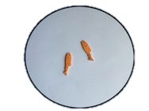
Application Problem (3 minutes)
Materials: (T) 2 sorting mats (Lesson 5 Template, set of objects that can be sorted in more than one way (e.g., orange alligator, orange bird, yellow fish, yellow bee, yellow butterfly)
Show the children the set and ask for ideas about how to sort. Use a suggestion to have children sort in one way, for instance by color. Count the number of animals in each group. Then, ask students to sort in a different way (use suggestions if available), for instance, animals that fly and animals that swim. Count the number of animals in each group. Encourage students to point out differences between the first and second sort.
Note: Sorting into groups in more than one way anticipates the work with embedded numbers in the Concept Development and supports seeing multiple perspectives and flexible thinking.
Concept Development (15 minutes)
Part 1: Concept Introduction
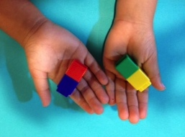
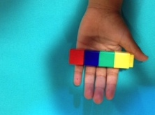
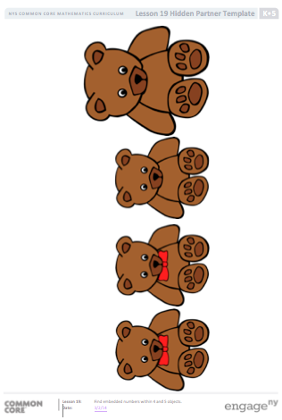
Materials: (T) 4 different colored linking cubes, partners of 4 picture (Template 1) inside a plastic sheet protector, dry erase marker (S) 4 different colored linking cubes
- While building a tower of 4 cubes, tell a story about Charlie building a tower and his baby sister breaking it. Break the tower and show one small tower in each hand.
- Ask, “How many small towers does Charlie have now?” Guide students to say, “Charlie has 2 small towers inside his big tower.”
- Guide students to see that when the 2 small towers are put back together, you get back to the original tower. “The 2 small towers make the big tower.”
- Have students each build a tower of 4 cubes and repeat the activity. Encourage them to keep one small tower in each hand to reinforce the idea that there are two parts. “Do you have 4 in your right hand? Do you have 4 in your left hand? Put the towers back together. Do you have 4 now?”
- Show the partners of 4 picture. Guide students to use the sentence stem, “I have a group of… (bears).”
- Use self-talk to explain your thinking, “How could I make these bears into two groups? Hmm… some of the bears have bowties. I could make one group of bears with bowties (circle) and one group of bears with no bowties (circle).”
- Invite students to think of other ways to make the bears into two groups. If they don’t respond, circle a group of small bears and a group of big bears. Guide them to say, “I found small bears and big bears inside this group.” Ask them, “When I put the groups back together, do I have 4 bears again?”
Part 2: Practice
Materials: (S) 5 linking cubes, crayon; per pair: baggie with partners of 4–5 cards (Template 2, cut out)
Before sending children to prepared tables, give each student 5 linking cubes so she can practice making and breaking towers of 5.
- Have students each build a tower of 5 cubes and break it in two. Encourage students to count and see how many cubes are in each of their small towers before putting them back together to have 5 again.
- Pair students to work at tables. For each picture, encourage them to use the sentence stems, “I have a group of…,” and “I found ____ and ____ inside this group.”
- Once children understand that there are two smaller groups inside the larger group, you might encourage them to count the number of objects in each group. (“I found 3 sitting cats and 2 walking cats inside 5.”)
Note: This lesson is intended to expose students to the concept of embedded numbers, but students are not expected to master this skill in Module 1. The objective is foundational to the work in later modules where students will be composing and decomposing numbers.
Student Debrief (3 minutes)

CENTER CONNECTION:
Point out sets of objects that show embedded numbers (partners) at centers. For example, as children play with 5 vehicles, notice aloud that there are 5 vehicles. Ask, “How many are cars? How many are trucks?”

Lesson Objective: Find embedded numbers within 4 and 5 objects.
The Student Debrief is intended to invite reflection and active processing of the total lesson experience. It is also an opportunity for informal assessment. Consider taking anecdotal notes or using a simple checklist to note each child’s progress towards meeting the lesson objective.
As students complete the Practice portion of the Concept Development, listen for misconceptions or misunderstandings that can be addressed in the Debrief. You may choose to use any combination of the questions below to help students express ideas, make connections, and use new vocabulary (partners).
- (Show the fish picture from the partners of 4–5 cards.) What two groups do you see inside this group of fish? Does anyone see something different? We call these partners.
- Show me 5 fingers. Wiggle 3 fingers. (Repeat with different numbers of fingers. Let children use their fingers in any way they wish.)
- (Build a tower of 5.) What happens if I break this tower? What if I put it back together?

partners of 4 picture
partners of 4–5 cards

