Lesson 18

Objective: Arrange and count 4 objects in an array configuration.

Suggested Lesson Structure

 Fluency Practice (7 minutes)

 Application Problem (2 minutes)

 Concept Development (13 minutes)

 Student Debrief (3 minutes)

**Total Time (25 minutes)**

Fluency Practice (7 minutes)

* Peek-a-Boo Counting **PK.CC.3b** (3 minutes)
* On 5 We Jive Chant **PK.CC.1, PK.CC.3a**  (1 minute)
* Counting the Math Way on the Piano **PK.CC.3a** (3 minutes)

Peek-a-Boo Counting (3 minutes)

Materials: (T) 4 large objects (e.g., 4 teddy bears), 2 manila file folders with ends stapled together to form a screen

Note: This variation subtly guides students to recognize numbers 1, 2, and 3 embedded in the group of 4, anticipating future work with embedded numbers.



Conduct the activity as described in Lesson 10, but now leave a substantial gap between objects (see example on right) to show 4 as 3 and 1, 2 and 2, 1 and 3, and 2 and 1 and 1.

On 5 We Jive Chant (1 minute)

Note: This fluency activity maintains students’ rote counting to 5.

1, 2,tie my shoe (act out tying shoe).

3, 4,close the door (act out closing a door).

On5,we jive (count 5 fingers and shake hips).

On5**,** we jive (count 5 fingers and shake hips).

Repeat chant.

Counting the Math Way on the Piano (3 minutes)

Materials: (T) Stickers (for students who still need them) (S) Piano mat (Lesson 17 Template)

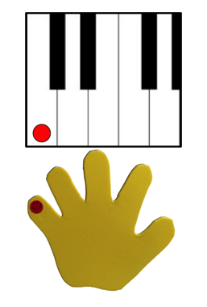Note: In counting the Math Way on the piano, students see the number of fingers increase as they count from 1 to 5, moving from left pinky to thumb without interruption. This provides a foundation for understanding the number path and number line, on which numbers also increase from left to right. Internalization of the number line develops multiple areas of number sense and will facilitate future work in operations.

After a brief review, practice counting as described in Part 1 of the Concept Development of Lesson 17.

Note: Realize that other methods of finger counting should not be discouraged outside of this activity. Students now have a special Math Way to add to their repertoire.

Application Problem (2 minutes)

Invite four students at a time to be baby chicks while an adult serves as the mother hen. Have the baby chicks follow the mother hen in a single-file line (one by one). Then, instruct the two chicks at the end of the line to move up next to the first two, thus creating pairs (2 × 2). Count each pair of students, 1, 2. Now, have them create a line again, with the two chicks originally at the front of the line moving to the back. Continue moving between the line and the pair arrangement.

Note: This activity anticipates both work with arrays and the playful context of “baby chicks” in the Concept Development.

Concept Development (13 minutes)

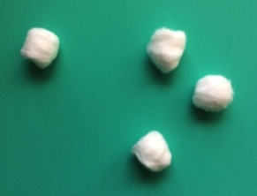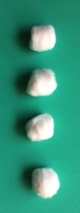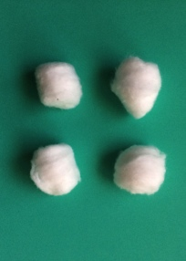

Part 1: Concept Introduction

Materials: (T) Bag with 4 cotton balls

1. Scatter 4 cotton balls on the carpet and tell students some baby chicks just hatched, and the mommy hen is looking for them. Ask, “How many chicks are there? Count with me.” Count chorally, “1, 2, 3, 4.”
2. Ask students, “How can we arrange the baby chicks so it’s easier for them to follow their mommy?” Guide students to see that they can arrange them in a line and the count is still the same.
3. Move the two chicks at the end of the line next to the first two, thus creating pairs (2 × 2 array). Say, “Sometimes, each chick follows the mommy with a partner. They make a pair.”
4. Separate the pairs of chicks (two groups of 2). Say, “Sometimes the pairs wander off together.” Count each pair, “1, 2.” Point out, “Look! I see partners that are also lined up!”
5. Push the pairs of chicks back together (2 × 2 array) to follow the mommy, “1, 2, 3, 4.”
6. Continue to ask *how many* questions.

Part 2: Practice

Materials: (T) Extra cotton ball for each student (S) Baggie with 4 cotton balls

Give each student a baggie with 4 cotton balls, and send them to tables.

|  |  |
| --- | --- |
|  | NOTES ON  MULTIPLE MEANS  OF REPRESENTATION: |

Students who are struggling with correctly forming the 2 × 2 array may benefit from a model to use as a reference. For example, provide a template to place the cotton balls when forming the array (see Template). As students progress they can use the template as a model and eventually form arrays without it.

1. Have children arrange and count their chicks in a line, “1, 2, 3, 4.” Ask, “How many chicks are there?”
2. Say, “Sometimes, the chicks walk to the henhouse with a partner. Make a pair of 2 chicks.”
3. Say, “Another pair of chicks decides to follow.” Tell students to move chicks so that each one has a partner. Be sure they arrange their pairs correctly (2 × 2 array) before touching and counting again.
4. Separate the pairs of chicks (two groups of 2). Say, “Two of the chicks stopped to nibble on some mealworms.” Have children count each pair, “1, 2.”

**MP.5**

5. Have students push the chicks back together (2 × 2 array) to continue to the henhouse. Invite partners to ask and answer a *how many* question.

6. Tell students to put the chicks in a line again. Give each student 1 additional cotton ball “chick” and have them add it to the line, counting, “1, 2, 3, 4, 5.”

7. Tell students to move them so that each chick is walking with a partner again. Point out what happens with the fifth chick, using parallel talk: “Becca is noticing that we can’t put them all into pairs when we have 5.” Or “Stephan said that one is left out; he needs a partner.”

Student Debrief (3 minutes)

**Lesson Objective:** Arrange and count 4 objects in an array configuration.

|  |  |
| --- | --- |
|  | CENTER CONNECTION: |
| Consider setting up a car in the dramatic play area using 4 chairs placed in a 2 × 2 array. Invite students to work the car into their play. Encourage them to count the number of seats in the car and the number of people in the seats. | |

The Student Debrief is intended to invite reflection and active processing of the total lesson experience. It is also an opportunity for informal assessment. Consider taking anecdotal notes or using a simple checklist to note each child’s progress towards meeting the lesson objective.

As students complete the Practice portion of the Concept Development, listen for misconceptions or misunderstandings that can be addressed in the Debrief. You may choose to use any combination of the questions below to help students express ideas, make connections, and use new vocabulary.

* What was the same about the pairs of chicks today?
* (Arrange 4 cotton balls in a line and 4 in a 2 × 2 array.) How many chicks are there in each group? How can I count them?
* What happened when we tried to add another chick to our group of 4? Could we make another pair? Did the chick have a partner?

|  |  |
| --- | --- |
| [1] |  |
|  |  |
|  |  |

1. array template (see UDL box)