Lesson 17
Objective: Count fingers on the left hand from 1 to 5.

Suggested Lesson Structure
 Fluency Practice (7 minutes)
 Concept Development (14 minutes)
 Student Debrief (4 minutes)
Total Time (25 minutes)
Fluency Practice (7 minutes)
- 1, 2, 3, 4, Pass PK.CC.3a (3 minutes)
- Hop-Hop PK.CC.2 (4 minutes)
1, 2, 3, 4 Pass (3 minutes)
Materials: (S) 4-dot 5-group strip (Fluency Template)
Note: This activity anticipates touching and counting up to 4 objects. Aligning the dots for the students on a strip ahead of time eliminates the need to organize objects into linear configuration. Conduct activity similarly to 1, 2, Pass in Lesson 5, using the 4-dot strip. Students again use the same index finger to move from dot to dot. Replace the verse with “1, 2, 3, 4, slide those dots across the floor!”
T/S: 1 (touch the first dot), 2 (touch the second dot), 3 (touch the third dot), 4 (touch the fourth dot). Slide those dots across the floor! (All pass their strips to the person to their right.)
Repeat until the teacher gives a signal to stop. Again, do this efficiently and delightfully by having one student place her dot cards in a basket until all dot cards are in the basket.
Be sure that students point to each dot individually, rather than slide. Using the analogy of pushing buttons may prove helpful.
This game is inspired by the Ghanaian rock-passing game Obwisana.
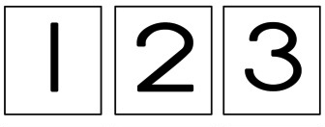
Hop-Hop (4 minutes)
Materials: (T) Bowl filled with numeral cards 1, 2, and 3 (1 card per student, Lesson 12 Template 2)
Note: This fluency activity is intended to maintain students’ ability to count and match quantities with numerals up to 3.
Hold a bowl filled with numeral cards 1, 2, and 3. Have one student pick a card and hop the number of times written on the card. The other children count the hops and say the numbers. The student shows the class the number, then keeps the card and sits back down.
T: Count Jenny’s hops.
S: 1, 2, 3.
T: How many hops did Jenny make in all?
S: 3!
Continue around the circle until every student has had a turn. (If the class is large, have two or three students hop at one time.)
To close, you might have all students holding the digit 1 card stand up, hop one time, and then sit back down. Repeat with 2 and 3. Collect the cards.
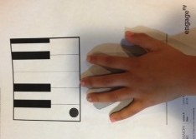
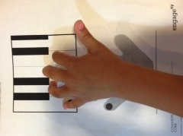
Concept Development (14 minutes)
Part 1: Concept Introduction
Materials: (T) 1 Piano mat (Template), stickers for each child’s left pinky (S) Piano mat (Template)
- Distribute a piano mat to each student and name the piano. Place a sticker on each child’s left pinky to mark where they will begin their count.
- (Teachers should turn their back towards children, so they can match their left hand to the teacher’s left hand.) Instruct students to match their left hand to the picture of the left hand. Then, have students slide their left hand up so their fingers match the piano keys.

NOTES ON
MULTIPLE MEANS
FOR ACTION AND EXPRESSION:
Provide a variety of ways for students to interact with the Piano Template. Students with visual–spatial or fine motor delays would benefit from an enlarged template or the template being placed on an inclined plane, for example, a three-ring binder. If the classroom has a piano or keyboard of any kind, of course have the students come up and use their four fingers to play four consecutive white keys! Many young children have never played a keyboard. It will fascinate them.
- Guide students to start with their pinkies and “play” 1, (tapping finger on key). Then, play 1, 2, 3, 4.
- Tap a rhythm with an object as students say and play, “1, 2, 3, 4” on their piano mats.
- Ask, “How many fingers played? Show me!”
- Instruct students to play piano in the air, moving each finger while counting, “1, 2, 3, 4.” Tell students, “You just counted up to 4 the Math Way!”
- Invite thumbs to join in, counting up to 5 the Math Way. (Repeat Steps 3─6.)

Part 2: Practice
Materials: (S) Per pair: baggie with a set of 10 dot cards with 1–5 dots (5-group formation, Lesson 16 Template 2), Piano mat (Template)
- Pair students and send them to tables with a baggie and a piano template.
- Tell Partner A to hold up a dot card and ask, “How many dots are there?”
- Tell Partner B to count the dots, e.g., “1, 2, 3, 4.” Guide him to answer in a complete sentence: “There are….”
- Guide Partner B to count to 4 the Math Way on the piano.
- Partners switch roles. As the students work, circulate and comment, e.g., “I heard you answering a how many question,” or “Wow! You’re counting to 5 the Math Way!”
Student Debrief (4 minutes)
Lesson Objective: Count fingers on the left hand from 1 to 5.
The Student Debrief is intended to invite reflection and active processing of the total lesson experience. It is also an opportunity for informal assessment. Consider taking anecdotal notes or using a simple checklist to note each child’s progress towards meeting the lesson objective.
As students complete the Practice portion of the lesson, listen for misconceptions or misunderstandings that can be addressed in the Debrief. You may choose to use any combination of the questions below to help students express ideas, make connections, and use new vocabulary (the Math Way).

CENTER CONNECTION:
If a keyboard is available, add it to the dramatic play center. Invite students to count to 5 while pressing on the keys. For some students, this auditory connection will support counting and provide incentive to practice the muscle movements needed to count the Math Way.

- Teach me how to count to 5 the Math Way. Where do I start?
- (Show 4 fingers.) Ask me a how many question about my fingers.
- (Hold up a 5-dot card. Point and count.) How many dots? Show me 5 with your fingers. What is special about 5 fingers?

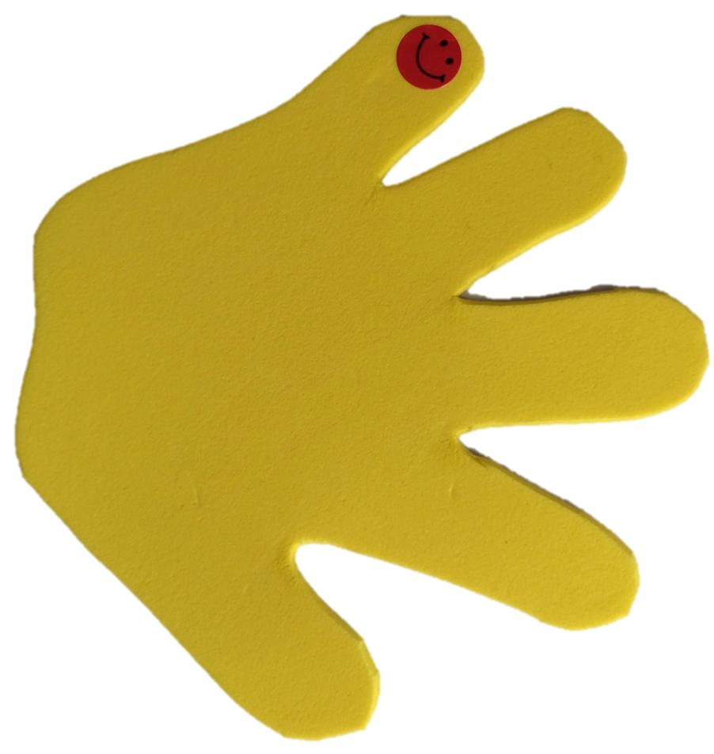
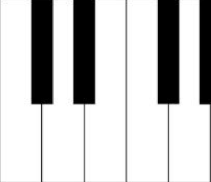

4-dot 5-group strip
piano mat

