Lesson 16
Objective: Arrange and count up to 5 objects in scattered and linear configurations.

Suggested Lesson Structure
 Fluency Practice (6 minutes)
 Application Problem (3 minutes)
 Concept Development (13 minutes)
 Student Debrief (3 minutes)
Total Time (25 minutes)
Fluency Practice (6 minutes)
- Dot Path Parking Lot PK.CC.3a (3 minutes)
- Number Cha-Cha to 5 PK.CC.1 (3 minutes)
Dot Path Parking Lot (3 minutes)
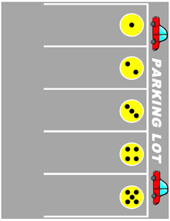
Materials: (S) Per pair: dot path parking lot (Lesson 11 Fluency Template), up to 5 toy cars
Note: In this activity, students practice one-to-one correspondence within a familiar context, preparing them for counting in a linear configuration in today’s lesson.
Conduct the activity as described in Lesson 11, with students putting each car in its own space while counting, but now use 3, 4, or 5 spaces, depending on students’ abilities. The template can be folded or covered to show the desired number.

Number Cha-Cha to 5 (3 minutes)
Note: Students increase speed and accuracy in the counting sequence by engaging kinesthetic and musical modalities.
Conduct as outlined in Lesson 15, but now have students compare today’s practice with yesterday’s. Ask them if they got better. Guide them to realize that yesterday they had to work hard just to learn the movements and follow directions, whereas today they were able to focus more on counting smoothly. Doing the same activity two days in a row allows students to see immediate growth.

Application Problem (3 minutes)
Select 4 students to be fish swimming in the middle of the circle. After a few seconds of swimming, have the fish freeze. Ask the other children to count and tell how many there are. Have the fish line up to get fish food. Ask the other children to tell how many fish are in the line. Select 5 new students and repeat.
Note: Some students may begin to show conservation for the second count, realizing that the number of fish doesn’t change based on the arrangement. If this is happening, give a few volunteers an opportunity to share how they knew how many. Students benefit from hearing more than one strategy.
Concept Development (13 minutes)
Part 1: Concept Introduction
Materials: (T) Chart with 2─5 dot configurations drawn across the top, baggie with pictures of different families (students’ own or Template 1), tape
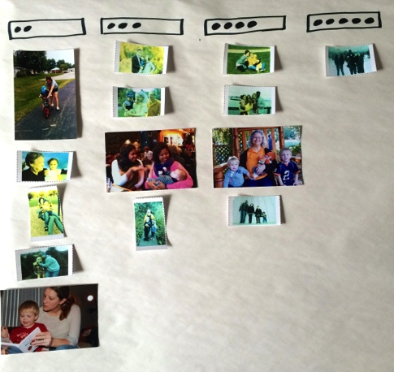
Note: Use the Module 1 Second Half Family Math Newsletter to request family pictures from students.
1. Reach into baggy and hold up a family picture. Ask, “How many people are in this family? Let’s count.”
2. Point to each person, as students count chorally, “1, 2, 3, 4.”
3. Guide students to respond, “There are ____ people in that family.”
4. Call a student forward to match the number of family members to the correct dot configuration, and affix the picture under it.
5. Repeat Steps 1─4 with various family pictures (with 2─5 family members), matching each one to a dot configuration.

NOTES ON
MULTIPLE MEANS
FOR ENGAGEMENT:
Pairing students based on ability for this task can provide an opportunity for differentiation. Students who are ready could use family pictures with more than five members and ask questions such as “How many are girls?” or “How many are grown-ups?” This will provide a challenging extension and allow for all students to have their family pictures included in the activity.
Part 2: Practice
Materials: (S) Per pair: baggie with 8 dot cards 2─5 (Template 2 cut up), baggie with family picture cards (students’ own or Template 3)
Guide students through the following steps:
- Send student pairs to tables to match their family pictures to dot cards.
- Guide partners to ask and answer questions about their pictures, e.g., “How many people are in this family?” “How many dots?”
MP.6
- As students work, circulate and describe what they are doing, using parallel talk, e.g., “Vanessa counted 4 people in the line. She matched this family with 4 dots.”
MP.6
Student Debrief (3 minutes)
Lesson Objective: Arrange and count up to 5 objects in scattered and linear configurations.
The Student Debrief is intended to invite reflection and active processing of the total lesson experience. It is also an opportunity for informal assessment. Consider taking anecdotal notes or using a simple checklist to note each child’s progress towards meeting the lesson objective.
As students complete the Practice portion of the Concept Development, listen for misconceptions or misunderstandings that can be addressed in the Debrief. You may choose to use any combination of the questions below to help students express ideas, make connections, and use new vocabulary.
- (Show a family picture.) Ask a how many question about this picture.

CENTER CONNECTION:
Invite students to draw or paint pictures of their families at the art center. Ask them to count the number of people in their family. If there are more than five people in a family, support students in counting beyond 5.

- (Show two family pictures of 4 or point to the column of 4 on your chart.) The families in these pictures are different, but what is the same?
- (Have 5 students stand in a line, then scatter around the room.) How many friends are in this line? How many friends are scattered throughout the room? Which group was easier to count?
__________________
large family pictures

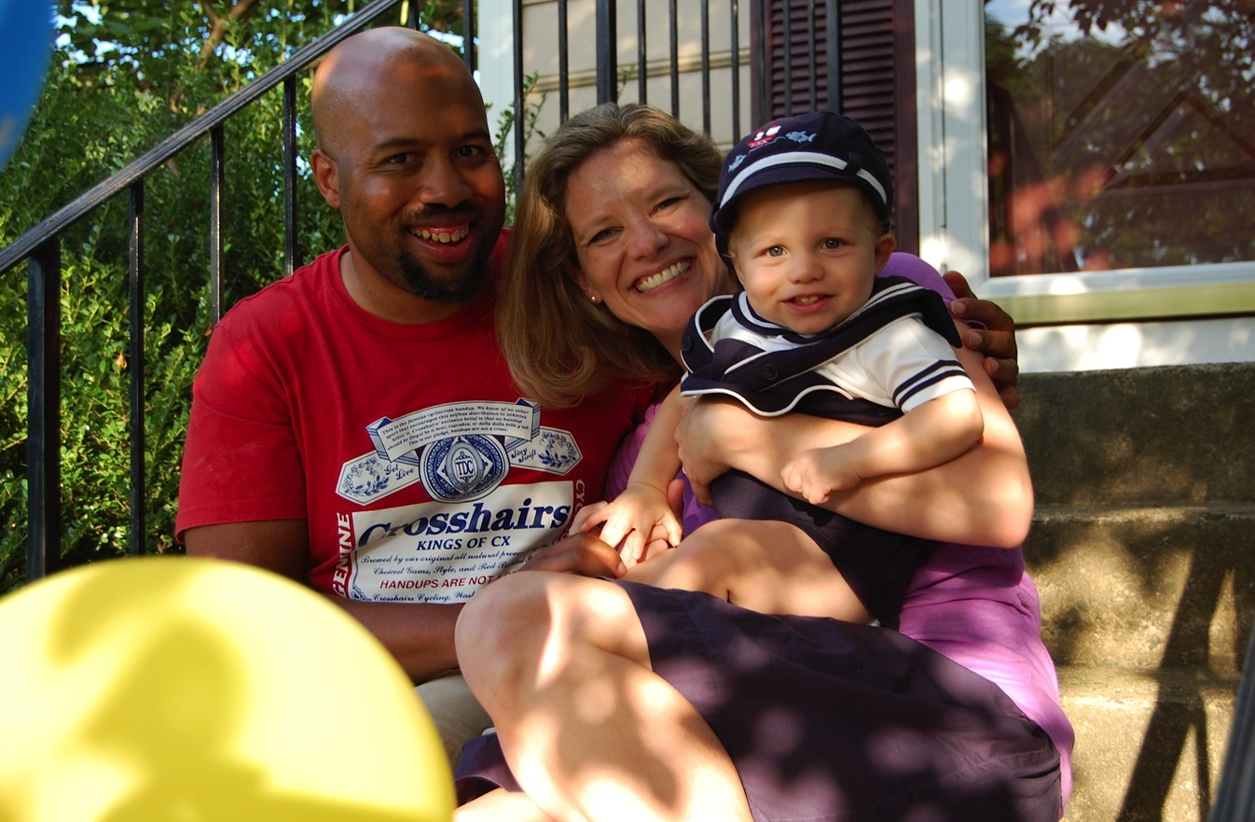
__________________
large family pictures

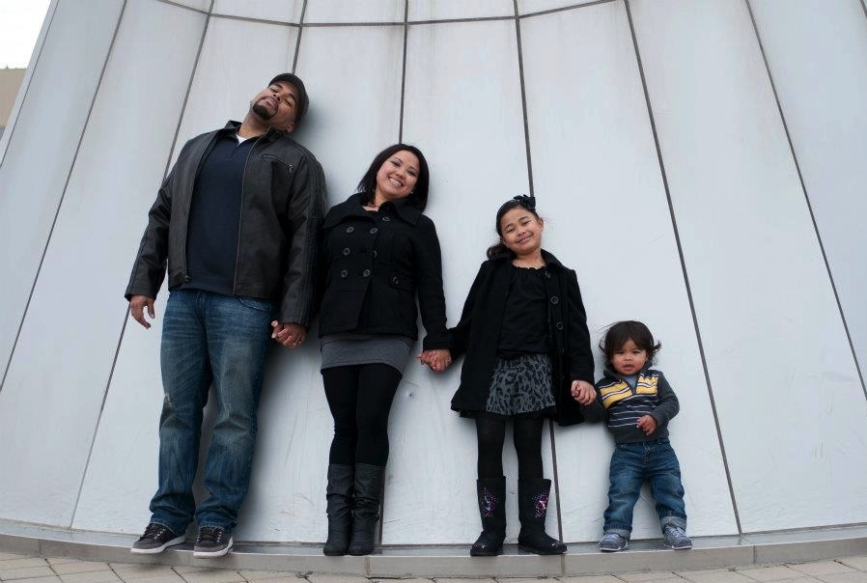
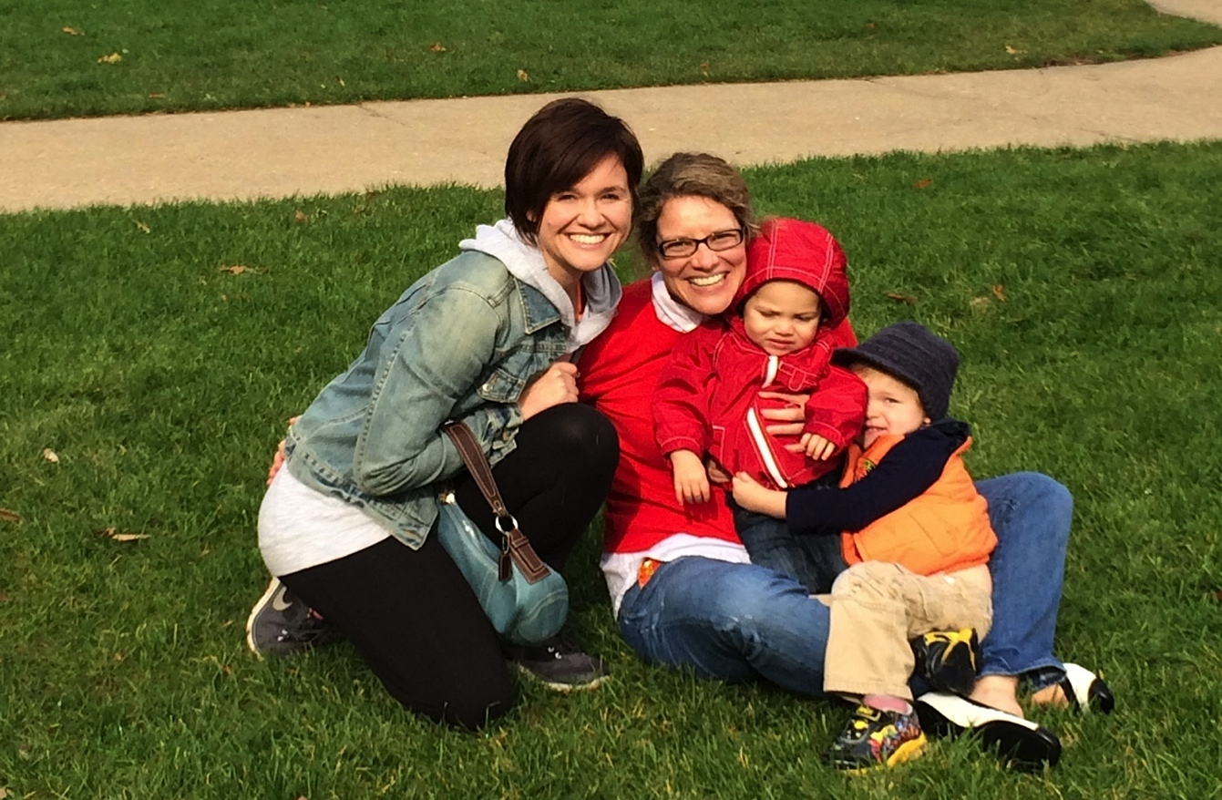
__________________
large family pictures

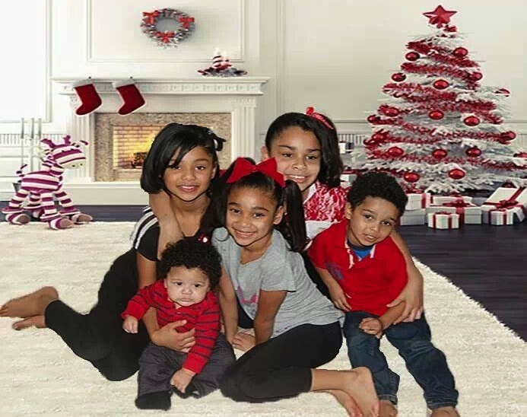
__________________
large family pictures

Dot Cards
(dice configuration)

Note: Consider making laminated sets on cardstock, as dot cards will be used in multiple lessons.

Dot Cards
(5-group formation)

Note: Consider making laminated sets on cardstock, as dot cards will be used in multiple lessons.

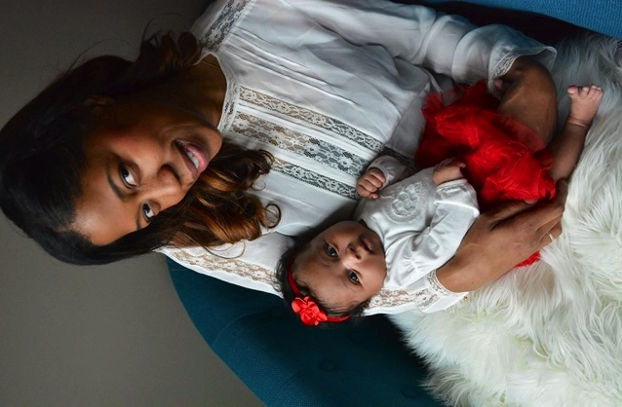 | 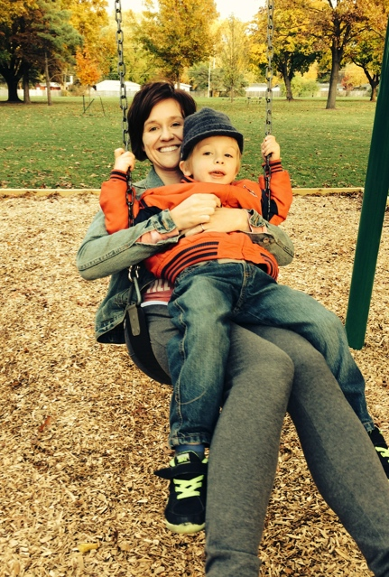
 | 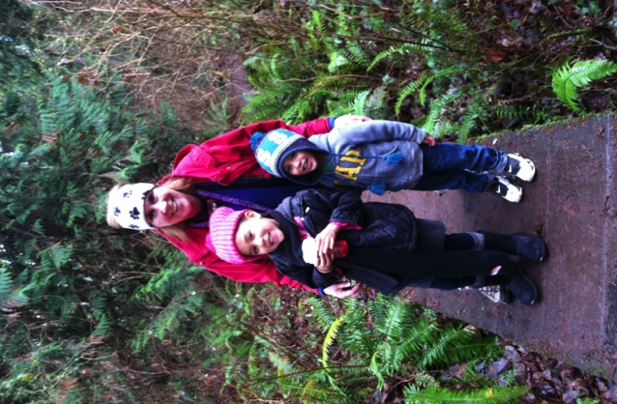
 | 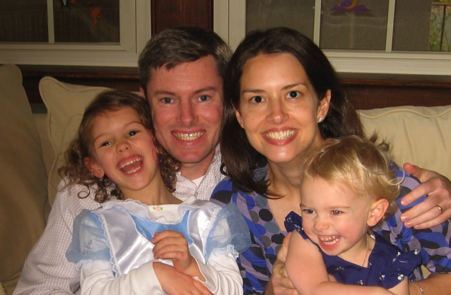
___________________
family picture cards

