Lesson 15

Objective: Arrange and count up to 5 objects in scattered and linear configurations.

Suggested Lesson Structure

|  |  |
| --- | --- |
|  | A NOTE ON  FLUENCY PRACTICE: |
| With the Mid-Module Assessment completed, students’ needs for challenge and remediation have likely surfaced by this point in the school year. When students struggle, revisit earlier fluency activities from Module 1, and when they are ready for a challenge, look ahead to the Fluency Practice in Module 2. Adjust the Fluency Practice to meet the needs of the class, and look for ways to differentiate for individual students with independent and partner fluency practice. | |

 Fluency Practice (6 minutes)

 Application Problem (3 minutes)

 Concept Development (13 minutes)

 Student Debrief (3 minutes)

**Total Time (25 minutes)**

Fluency Practice (6 minutes)

* Peek-a-Boo Counting **PK.CC.3b** (2 minutes)
* Number Cha-Cha to 5 **PK.CC.1** (4 minutes)

Peek-a-Boo Counting (2 minutes)

Materials: (T) 3 large objects (e.g., book and 2 teddy bears),   
2 manila file folders with ends stapled together to form a screen

Note: This variation subtly guides students to recognize 2 and 1 embedded in the group of 3, anticipating future work with embedded numbers.



Conduct activity as described in Lesson 10, but now leave a substantial gap between objects (see picture on right) to show 3 as 2 and 1, and vice versa.

Number Cha-Cha to 5 (4 minutes)

Materials: (T) Instrumental music with a cha-cha beat (optional)

Note: This activity extends students’ rote counting skills, and challenges them to develop fluidity in the counting sequence. Although it is not essential that students master the movements, it will facilitate memorization and tap into a variety of learning styles.

T: I want to teach you a new counting dance. I call it the Number Cha-Cha. First, let’s learn the steps. Put one hand out to the side, like this (demonstrate).

S: (Mimic the teacher’s movement.)

T: Now, the other hand.

S: (Again, follow the teacher’s example.)

T: Now, here comes the cha-cha…. It’s just three quick little steps, like this: cha-cha-cha (while stepping in place, rhythmically).

S: (Again, follow the teacher’s example.)

T: Let’s put it together now! Hand, hand, cha-cha-cha (while doing the dance steps).

S: Hand, hand, cha-cha-cha (while doing the dance steps).

T: (Continue until students are reasonably comfortable with the steps.) You’re getting good at this! Now, this time instead of saying “hand” we’ll say “1, 2.” So, it goes, “1, 2, cha-cha-cha.” Try it!

S: 1 (one hand out to the side), 2 (the other hand out to the side), cha-cha-cha (stepping in place rhythmically).

This is a possible stopping point for today. If students show mastery, proceed to the next part.

T: Wow, I think you’re ready to count to 5! So, instead of saying “cha-cha-cha,” this time, we’ll say “3*,* 4, 5.” Like this: 1 (hand out), 2 (other hand out), 3, 4, 5 (stepping in place, rhythmically).

S: (Continue the counting and movement.)

*Hand Hand Cha-cha-cha*

*1 2 3, 4, 5!*

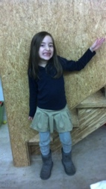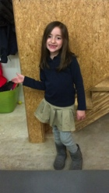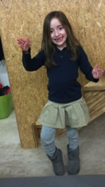

Application Problem (3 minutes)

Materials: (T) Underwater mat (Template 1), Goldfish crackers (3 per student), 3-dot 5-group strip (optional, Lesson 6 Fluency Template)

Note: Based on the dietary needs or food allergies of your classroom, adjust the materials as needed. A possible substitution for the Goldfish crackers could be paper or plastic fish counters.

If possible, complete in groups of 10 or fewer to save time and maintain student engagement.

Place some goldfish on the underwater mat. Invite each student to count out three goldfish for a snack, while the class counts along. Students should only touch the fish they are going to eat, so they must be careful to stop at 3. Use a 3-dot 5-group strip to help students who still need to match one-to-one to count out a group of 3 (they can place one goldfish on each black dot).

Note: Children review how to count out a group of 3 and also prepare to work with Goldfish crackers in the upcoming lesson. Providing an opportunity for children to eat three fish now will help most students use the fish as math tools during the Concept Development.

Concept Development (13 minutes)

Part 1: Concept Introduction

Materials: (T) Underwater mat (Template 1), 5 Goldfish crackers, plastic shark (or shark from Template 2)

1. Gather students in a circle around the underwater mat. Place 4 Goldfish crackers in a scattered configuration on the mat.
2. 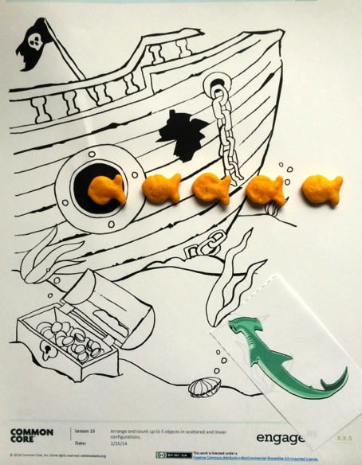Describe what you are seeing using self-talk: “I see some fish playing tag. This guy is *it.* The others are swimming away. Look! One is next to the rock. Two are over the plant.” Lead students in counting, “1, 2, 3, 4.”

|  |  |
| --- | --- |
|  | NOTES ON  MULTIPLE MEANS  OF REPRESENTATION: |
| Circulate and listen to all students count their goldfish, checking for one-to-one correspondence. Assist students who are having difficulty by guiding a finger as they point to each goldfish and count 1, 2, 3, 4, 5. | |

1. Ask students, “How many fish are playing tag?” Guide them to answer in a complete sentence: “There are….”
2. Add another fish to the game. Lead students in counting: “1, 2, 3, 4, 5.” Repeat Step 3.
3. Say, “Oh no, a shark is coming! These fish need to line up so they can swim through this little window to get away from the shark.” Ask students, “What should the fish do: line up or swim in a circle?” Students respond, “Line up!”
4. Invite a student forward to line up the fish and to lead the class in a choral count to 5 again. Guide students to see that there are still 5 fish, just arranged differently.
5. Quicken the pace. Say, “Let’s have them play tag again!” Move the fish into the scattered configuration and count. Then say, “Let’s have them line up quickly!” Move the fish into a line and count again. Repeat.

Part 2: Practice

Materials:(S) Underwater mat (Template 1), small cup of Goldfish crackers

1. Pair students and send them to tables with a cup of Goldfish crackers and underwater mats.
2. Say, “Let your 4 fish play tag! Tell your partner where your fish are swimming.” Encourage students to use position words.
3. Instruct partners to take turns counting and asking a *how many* question.
4. Say, “Uh oh, the shark is coming. Now have them line up!”
5. Again, instruct partners to take turns counting and asking a *how many* question.
6. Repeat Steps 2 and 3 with 5 fish.

Student Debrief (3 minutes)

**Lesson Objective:** Arrange and count up to 5 objects in scattered and linear configurations.

The Student Debrief is intended to invite reflection and active processing of the total lesson experience. It is also an opportunity for informal assessment. Consider taking anecdotal notes or using a simple checklist to note each child’s progress towards meeting the lesson objective.

As students complete the Practice portion of the Concept Development, listen for misconceptions or misunderstandings that can be addressed in the Debrief. You may choose to use any combination of the questions below to help students express ideas, make connections, and explore new concepts.

|  |  |
| --- | --- |
|  | CENTER CONNECTION: |
| Practice counting to 5 in different configurations in the block center. Select 5 blocks, have children playfully mix them up, and count how many. Then, ask the children to line up the blocks and count again. Finally, ask them to stack the blocks and count. Some students use conservation to understand that the number of blocks does not change when the blocks are rearranged. | |

* (Use two underwater mats, one with 5 fish in a scattered configuration, one with 5 fish in a line.) Which group is easier for you to count? Why?
* What happened when we moved the fish from playing tag to lining up? Did we have the same number of fish?
* (Place 4 fish on mat.) Watch as I touch and count these fish: 1, 2, 3 (point to same object twice), 4, 5. What mistake did I make?



**[1]**

|  |  |
| --- | --- |
| [2] |  |
|  |  |
|  |  |
|  |  |

1. underwater mat
2. sharks