Topic E
How Many Questions with 4 or 5 Objects
PK.CC.3ab, PK.CC.4, PK.CC.1, PK.MD.2
Focus Standard: | PK.CC.1 | Count to 20.
 | PK.CC.3 | Understand the relationship between numbers and quantities to 10; connect counting to cardinality.  - When counting objects, say the number names in the standard order, pairing each object with one and only one number name and each number name with one and only one object.  - Understand that the last number name said tells the number of objects counted. The number of objects is the same regardless of their arrangement of the order in which they were counted.
 | PK.CC.4 | Count to answer "how many?" questions about as many as 10 things arranged in a line, a rectangular array, or a circle, or as many as 5 things in a scattered configuration; given a number from 1–10, count out that many objects.
Instructional Days: | 6
Coherence -Links to: | GK─M1 | Numbers to 10
 | GK─M5 | Numbers 10–20 and Counting to 100
Having counted as many as 3 objects in prior topics, children now move on to groups of as many as 5 objects, and answer how many questions in the context of play (PK.CC.4).
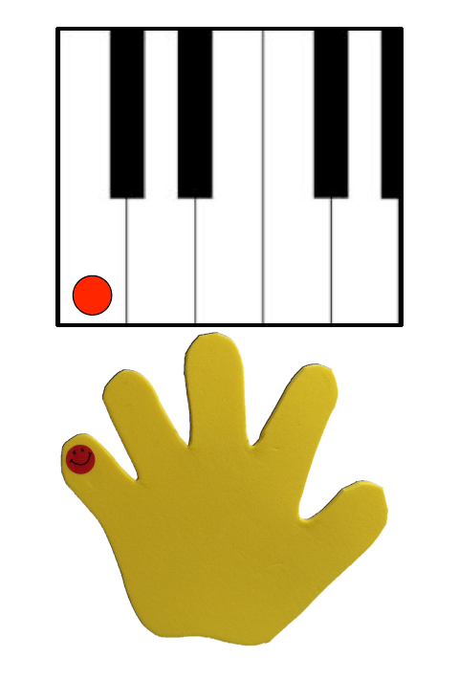
In Lessons 15 and 16, children extend their ability to count up to 5 objects in both scattered and linear configurations (PK.CC.3ab). They use fun contexts for making and counting a line of objects as they did in Topic D (e.g., a line of fish swimming through a small window in a sunken pirate ship). Because it is also important for students to move beyond the concrete, Lesson 16 moves to the pictorial, where students tell how many family members are shown in photos (PK.CC.4).
In Lesson 17, they tap and count to 4 and 5 on their left hand from pinky to thumb (i.e., the Math Way), using a piano template. This naturally flows from their previous work with linear configurations and prepares students to understand the number path and number line models in subsequent grades. At this point in the Pre-K year, most children will find it easiest to count the Math Way using the piano template which allows them to drop fingers rather than holding the targeted counting fingers up while trying to hold other fingers down. When asking students to show a number by raising their fingers, expect and accept different patterns based on fine motor skill development levels and cultural norms. (There are several different methods used throughout the world.)

Lesson 18 asks students to count 4 and 5 objects arranged in an array configuration. This provides a natural entry point for finding decompositions, or embedded numbers in Lesson 19 (e.g., “Look! I have a group of 4. I found two groups inside 4!”). With the children these embedded numbers are referred to as partners or numbers “inside” bigger numbers.
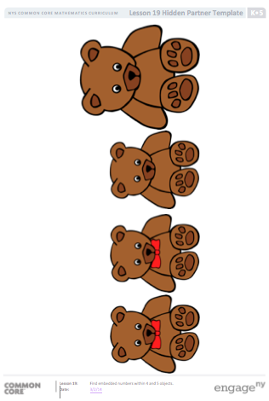
At the concrete level, Lesson 19 asks students to find pairs of embedded numbers within groups of 4 and 5 objects by breaking apart a tower of linking cubes to make 2 smaller towers, e.g., a tower of 5 linking cubes is broken into 2 smaller towers of 2 and 3. During Concept Development Practice, students work with pictures to decompose into two groups and recompose to find the original whole, e.g., a group of bears with bowties and a group of bears with no bowties are “inside” a group of 4: “When I put the smaller groups back together, I have 4 bears again” (PK.CC.1–4).
In the final lesson of Topic E, students learn strategies to count a group of 5 objects in a circular configuration. Circular configurations are tricky, because it is easy to forget the starting point and thus continue counting around the circle. Children will identify ways to mark their starting point to ensure an accurate count.
Throughout Topic E Fluency Practice, students work on touching and counting to 5 in the context of chants, games, and movement. The new Hop Hop game helps children maintain their ability to count and match quantities with numerals up to 3. Children will continue to practice counting on their fingers the Math Way during Fluency Practice throughout the module.

A Teaching Sequence Towards Mastery of How Many Questions with 4 or 5 Objects
Objective 1: Arrange and count up to 5 objects in scattered and linear configurations.
(Lessons 15─16)
Objective 2: Count fingers on the left hand from 1 to 5.
(Lesson 17)
Objective 3: Arrange and count 4 objects in an array configuration.
(Lesson 18)
Objective 4: Find embedded numbers within 4 and 5 objects.
(Lesson 19)
Objective 5: Arrange and count 5 objects in a circular configuration.
(Lesson 20)

