Lesson 13
Objective: Make a group of up to 3 objects and match the numeral (concrete to abstract).

Suggested Lesson Structure
 Fluency Practice (6 minutes)
 Application Problem (3 minutes)
 Concept Development (13 minutes)
 Student Debrief (3 minutes)
Total Time (25 minutes)
Fluency Practice (6 minutes)
- Dot Path Parking Lot PK.CC.3a (4 minutes)
- On 5 We Jive Chant PK.CC.1, PK.CC.3a (2 minutes)
Dot Path Parking Lot (4 minutes)
Materials: (S) Per pair: dot path parking lot (Lesson 11 Fluency Template), up to 5 toy cars
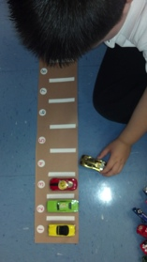
Note: In this activity, students practice one-to-one correspondence within a familiar context.
T: In a parking lot, each car gets its own space, just like each student has his own chair in our classroom.
See full description in Lesson 11. Differentiate by folding the dot path to show 3 dots, 4 dots, or use the entire strip of 5. Replace the dots with numerals as students show mastery.
On 5 We Jive Chant (2 minutes)
Note: This fluency activity anticipates the need for students to be comfortable rote counting to 5 before counting 5 objects in Topic E.
1, 2, tie my shoe (act out tying shoe).
3, 4, close the door (act out closing a door).
On 5, we jive (count 5 fingers and shake hips).
On 5, we jive (count 5 fingers and shake hips).
Repeat chant.
Application Problem (3 minutes)
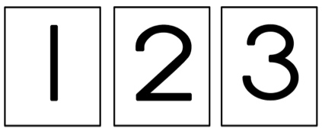
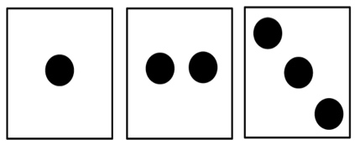
Materials: (T) Dot cards 1─3 (Lesson 10 Template 3) (S) Baggie with numeral cards 1–3 (Lesson 12 Template 2)
Hold up a dot card showing 1, 2, or 3 (one at a time) and ask the students, “Which number matches these dots?” Have students find the matching number card and hold it up. Make sure to tell them the number so they can hear the number and visualize 1, 2, or 3 dots while they are matching the numeral. Ask students to then look around the classroom for numerals. Ask them to match the numeral with the number of objects that were counted if they can.
Note: This Application Problem reviews the numerals learned in the last lesson, which students will use in the upcoming Concept Development.
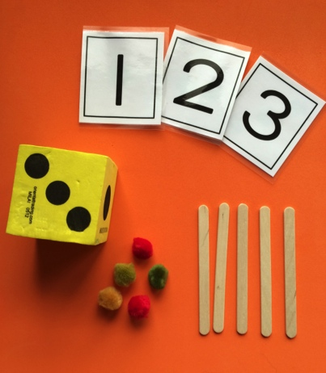
Concept Development (13 minutes)
Part 1: Concept Introduction
Materials: (T) 5 cotton puffballs, 5 craft sticks, die with dots 1─3 (place tape over some of the dots on the 4, 5, and 6 faces if needed), numeral cards (Lesson 12 Template 2) or foam numerals
1. Display the numerals 1, 2, and 3.
2. Roll the die and ask students, “How many dots do you see?”
3. Example after students respond:
- Touch and chorally count each dot, “1, 2, 3.”

NOTES ON
MULTIPLE MEANS
FOR ACTION AND EXPRESSION:
Some students may struggle to create a group of 3. Invite them to place their puffballs directly on top of the dots on the die as they count, placing one puffball on each dot.
Challenge students who are ready by adding in numerals. Put numerals and dot configurations on their die, or provide foam numerals for them to match to their quantities.

- Have students point to the matching numeral.
- Have students count as you lay down 3 puffballs.
- Ask students, “How many puffballs are in this group?” Lead them to respond, “There are 3 puffballs.”
- Count out 3 sticks to match the 3 puffballs.
4. Repeat Steps 2–3.
5. Guide students to see that what is the same about the dots, the group of puffballs, and the group of sticks is the number 3; the number 3 tells how many objects are in each group.

Part 2: Practice
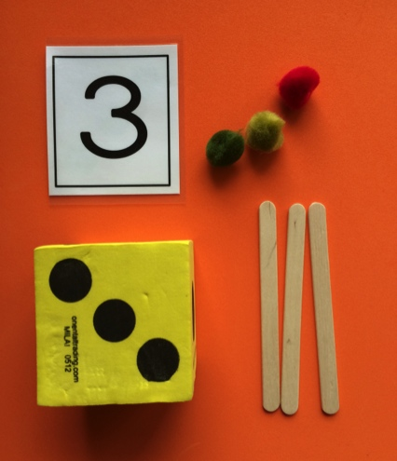
Materials: (S) Per pair: tray with 5 cotton puffballs, 5 craft sticks, die with dots 1–3, foam numbers 1–3 or numeral cards (Lesson 12 Template 2)
1. Pair students and send them to tables with a tray.
2. Instruct students to take turns rolling the die, counting how many, and making groups with the same number of puffballs and sticks.
3. Instruct students to point to the matching numeral.
MP.6
4. Encourage students to ask and answer how many questions. Circulate and use parallel talk: “I hear Aleem asking, ‘How many sticks are in your group?’”
3. Check that the number in each group matches the dot configuration and numeral, and that students are moving their puffballs and sticks into new groups as they count.
Student Debrief (3 minutes)
Lesson Objective: Make a group of up to 3 objects and match the numeral (concrete to abstract).
The Student Debrief is intended to invite reflection and active processing of the total lesson experience. It is also an opportunity for informal assessment. Consider taking anecdotal notes or using a simple checklist to note each child’s progress towards meeting the lesson objective.
As students complete the Practice portion of the Concept Development, listen for misconceptions or misunderstandings that can be addressed in the Debrief. You may choose to use any combination of the questions below to help students express ideas, make connections, use new vocabulary, and explore new concepts.

CENTER CONNECTION:
The kitchen center is a perfect place to practice making groups of 3 or less. The “diners” can show how many meatballs they want by picking a dot card. The “chef” can count out the right number of meatballs for each plate using the dot cards to match.

- What tools did we use to count in our lesson today?
- How did you know how many puffballs or sticks to put in a group?
- (Show student tray with die, puffballs, and sticks matching.) Let’s look at Sitiyana and Tashawn’s work. What is the same about the dots, the puffballs, and the sticks? What number tells how many are in each group?
- I’m showing some fingers. Who can ask a how many question about my number of fingers?

