Lesson 10

Objective: Arrange and count up to 3 objects in scattered and linear configurations.

Suggested Lesson Structure

 Fluency Practice (4 minutes)

 Application Problem (5 minutes)

 Concept Development (13 minutes)

 Student Debrief (3 minutes)

**Total Time (25 minutes)**

Fluency Practice (4 minutes)

* Peek-a-Boo Counting **PK.CC.3b** (2 minutes)
* 1, 2, 3, 4, Touch the Floor **PK.CC.1** (2 minutes)

Peek-a-Boo Counting (2 minutes)

Materials: (T) 3 large objects (e.g., book, banana, and teddy bear), 2 manila file folders with ends stapled together to form a screen

Note: In this activity, students develop the ability to visualize a quantity and strengthen their memory to answer *how many* questions to 3. Students are encouraged to subitize, but do give wait time so that those who wish to count may do so.

T: (Prior to beginning the activity, have 1 object placed on a desk or table, behind the screen.) Peek-a-Boo! (Raise and lower the screen.) Peek-a-Boo! (Again.) There is something behind this screen. Did you see it? (Lift and replace the screen.)

T: How many things did you see?

S: 1!

T: Very good. Let’s play Peek-a-Boo again. This time there could be 1 thing, 2 things, or 3 things. (Place 2 objects behind the screen and lift the screen.)

T: (Replace the screen.) When I give the signal, tell how many things you saw that time.

S: 2!

Continue in this manner to 3, then in random order. As students show mastery, see if they can hold the number in mind for a slightly longer period of time. This improves their ability to visualize a quantity and match it to a number.

1, 2, 3, 4, Touch the Floor (2 minutes)

Note: This fluency activity was selected in anticipation of future lessons. Students need to be comfortable rote counting to 4 before they work with a quantity of 4.

Count, “1, 2, 3, 4,” then say, “Touch the floor!” and have the students touch the floor. Repeat the count and add the following actions: Point to the door, start to snore, give a roar, swim to shore. To add excitement, count slowly and say the action rapidly.

Application Problem (5 minutes)

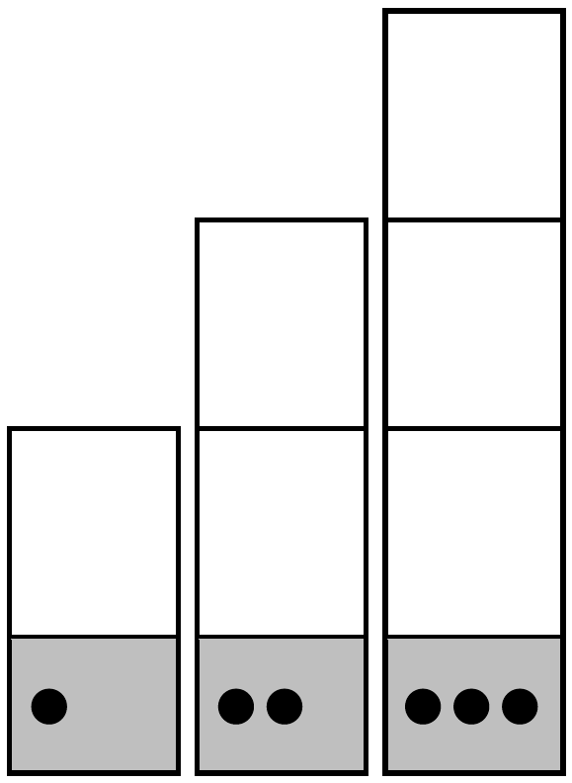

Materials: (T) 1–3 column template (Lesson 9 Template 1) drawn on large butcher paper with enough space for students to stand on empty boxes, musical instruments in quantities 1–3 (e.g., 1 xylophone, 2 tambourines, 3 shakers)

Ask students how they organized Old MacDonald’s animals yesterday. (In a line). Give the instruments to a set of children. Have the others direct the members of the band into the correct lines by counting each type of instrument and matching it to 1, 2, or 3 dots.

Invite the band to play along as the class sings “Old MacDonald Had a Farm.”   
  
Note: This problem allows students to practice a familiar skill, counting up to 3 objects arranged in a linear configuration and matching the count with a dot configuration. Singing “Old MacDonald Had a Farm” previews some of the farm animals they will use in the lesson. Use images of the animals while singing to support language learners.

Concept Development (13 minutes)

Part 1: Concept Introduction

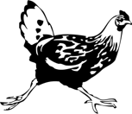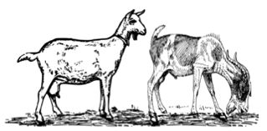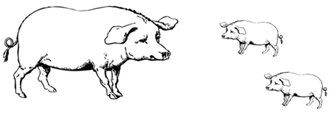

Materials: (T) Chart paper with 1-, 2-, and 3-dot configurations along the side, 3 farm animal pictures (Template 1), tape

1. Display chart paper with dot configurations. Tell students, “Let’s look at some animals you might see on Old MacDonald’s farm.”

2. Show the picture of a chicken and ask, “How many chickens can you count?” Call a student to touch and count, “1.”

3. Ask students where to put the chicken on the chart. Invite a student to tape the chicken next to 1 dot.

4. Guide students to say, “The number 1 tells how many.”

5. Repeat the process with the pictures of 2 goats and 3 pigs. Repeat Steps 2–4, guiding students to match the number of animals with the correct number of dots.

Part 2: Practice

Materials: (S) Per pair: 1 tray with a baggie of 6 farm animal cards (Template 2), 1 baggie of 6 dot cards with 2 each of numerals 1, 2, and 3 (Template 3)

1. Pair students and send them to prepared tables to count the animals on Old McDonald’s Farm. Partner A takes the farm animal card baggie. Partner B takes the dot card baggie.

|  |  |
| --- | --- |
|  | NOTES ON  MULTIPLE MEANS  OF ENGAGEMENT: |
| To encourage effort and persistence, provide concrete representations of the animals to pair with the pictures to help students who may have difficulty moving from the concrete to the pictorial representations. | |

1. Partner A chooses a picture, touching and counting the animals.
2. Guide Partner B to ask, “How many _______ (cows, pigs, etc.) can you count?” Partner A responds, “I can count….”
3. Partner B finds the card with the number of dots that matches the count, placing it next to the picture card.
4. Once they have matched all the picture and dot cards, partners switch roles.

Student Debrief (3 minutes)

|  |  |
| --- | --- |
|  | CENTER CONNECTION: |
| Invite students to recreate Old MacDonald’s Farm in the dramatic play center. They can practice counting groups of animals as they play and as they line up to eat. The difficulty of counting moving animals will help children see the benefit of counting objects in a line. | |

Lesson Objective: Arrange and count up to 3 objects in scattered and linear configurations.

The Student Debrief is intended to invite reflection and active processing of the total lesson experience. It is also an opportunity for informal assessment. Consider taking anecdotal notes or using a simple checklist to note each child’s progress towards meeting the lesson objective.

As students complete the Practice portion of the Concept Development, listen for misconceptions or misunderstandings that can be addressed in the Debrief. You may choose to use any combination of the questions below to help students express ideas, make connections, and use new vocabulary.

* Which animals on Old MacDonald’s Farm were in a line? Was it easier to count them?
* (Discuss the farm animal cards.) Which group of animals matched with 1 dot, 2 dots, 3 dots?
* (Place 3 toy animals on a tray in a scattered configuration.) How can we arrange these in a line? How many animals are there now? Is it the same number?

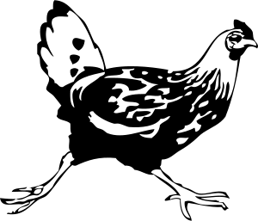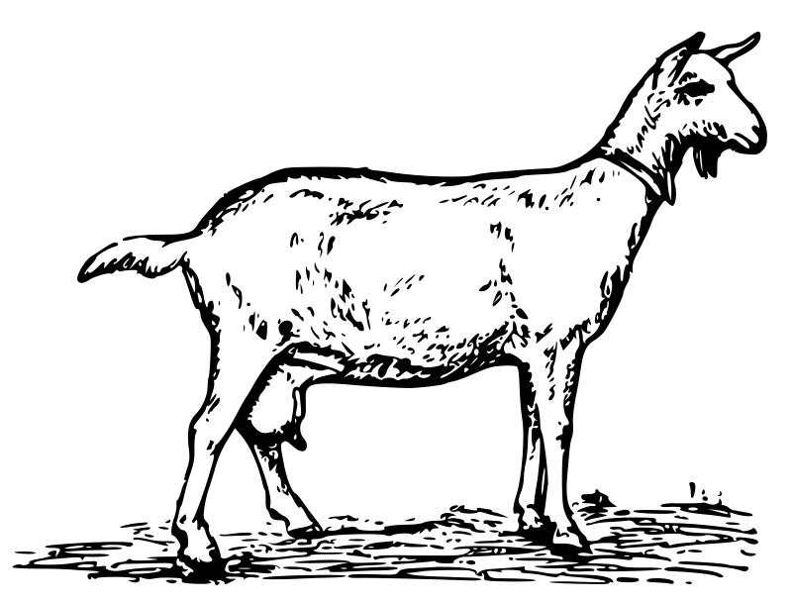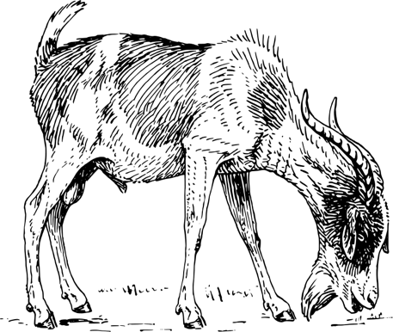

[1]

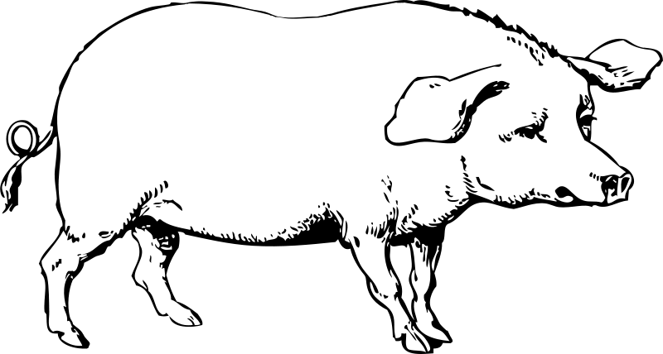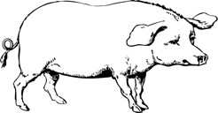



[2]

|  |  |
| --- | --- |
| [3] |  |
|  |  |
|  |  |

1. farm animal pictures
2. farm animal cards
3. dot cards