Lesson 8
Objective: Count up to 3 objects.

Suggested Lesson Structure
 Fluency Practice (4 minutes)
 Application Problem (4 minutes)
 Concept Development (12 minutes)
 Student Debrief (5 minutes)
Total Time (25 minutes)
Fluency Practice (4 minutes)

NOTE ON
LITERACY CONNECTION:
This lesson uses characters and items from the classic children’s tale, “Goldilocks and the Three Bears.” Many children may be familiar with this story, but some may not be. Read the story ahead of time to make this lesson more engaging and to provide a fun link to literacy.

- Count and Clap PK.CC.1 (4 minutes)
Count and Clap (4 minutes)
Note: Now that students have counted to 3 by rote, their counting skills grow as they combine the rote counting with an action. This leads to being able to touch and count objects.
Demonstrate each step in I do, you do format. Check to be sure that the movements are said precisely with each number word, so that one word corresponds to one action just as students pair one number word with one object in today’s lesson.

- Clap 1 time and count 1 at the same time.
- Clap 2 times and count to 2 at the same time.
- Clap 3 times and count to 3 at the same time.

- Stomp 1 time and count 1 at the same time.
- Stomp 2 times and count to 2 at the same time.
- Stomp 3 times and count to 3 at the same time.

Repeat the process but with different actions.

Application Problem (4 minutes)
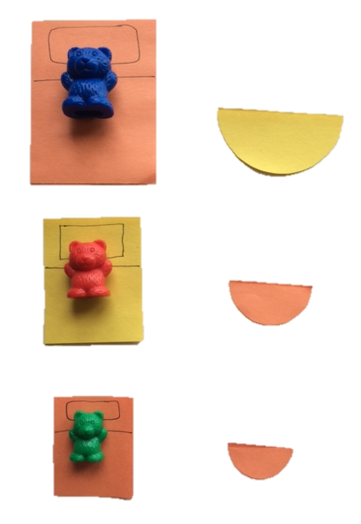
Materials: (T) 2 sorting mats (Lesson 5 Template), 3 bears, 3 rectangle beds cut from construction paper (2 orange, 1 yellow), 3 semi-circle bowls cut from construction paper (2 orange, 1 yellow)
Ask children to recall how they sorted items yesterday in more than one way (by color, shape, size, type, use).
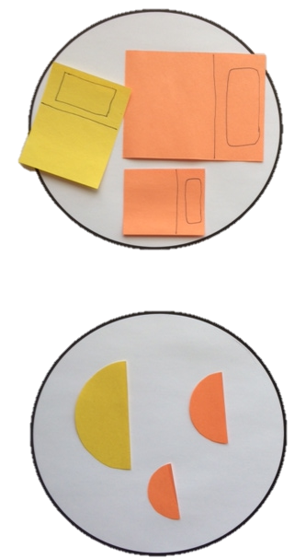
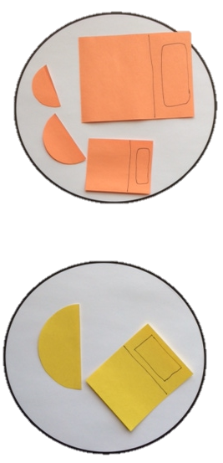
Introduce students to the Three Bears one at a time, matching each bear’s bed and bowl as pictured to the right. Next, ask students to sort the items first by type (put the bowls on one mat and the beds on the other). Then, have them sort the bowls and beds by color as pictured below. Have students talk about the similarities and differences of objects in each group.
Note: This Application Problem reviews sorting one set of items into two given groups and provides groups of 3 that can be counted in the Concept Development. The two colors work not only as an attribute for sorting, but also as a subtle way for students to begin to see that 1 and 2 are embedded in a quantity of 3.
Concept Development (12 minutes)
Part 1: Concept Introduction
Materials: (T) Girl doll, 3 paper bowls, 3 chairs (e.g., doll furniture), 3 paper beds, 3 bears
Note: Use “Goldilocks and the Three Bears” as a playful context for counting to 3. Limit the details of the story so that counting remains the primary objective.
1. Hold up a doll. Say, “This is Goldilocks. One day she found a cozy cottage in the forest, and she walked right in.”

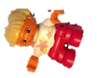
2. Show the bowls. Say, “She saw bowls of porridge and decided to try them. One big bowl was too hot. One middle-sized bowl was too cold. One tiny bowl was just right.”
3. Ask students, “How many bowls are there?”
4. Say, “Let’s touch each bowl and count together, 1, 2, 3.”
5. Use self-talk, “Three is the last number I said, so there are 3 bowls.”
6. Guide students to use the sentence stem, “There are… (3 bowls).” Repeat chorally.

NOTES ON
MULTIPLE MEANS
OF ENGAGEMENT:
Students who are struggling with cardinality may continue to count each item, 1, 2, 3 when asked how many. Guide them to understand that the last number tells how many. Continue the lesson pattern to provide students an opportunity to practice this concept.

7. Continue the Goldilocks story, stopping after each part (chairs, beds, bears) to ask students a how many question. (Repeat Steps 3–5 above.) As students begin to use the sentence stem independently, reduce prompting.
Part 2: Practice
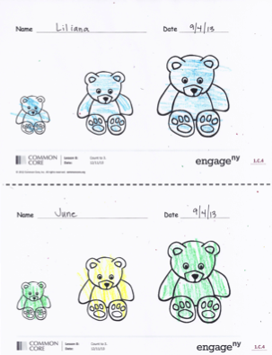
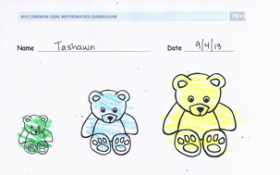
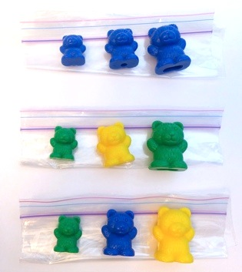
Materials: (S) Problem Set, crayons, baggie containing 3 bears: 1 small, 1 medium sized and one large (make some baggies with 3 of the same color bears, some with 2 the same and 1 different, and some with all 3 different)
1. Choose two students to model the activity, as shown in the sample vignette.
T: Matty and Carlito, will you be my helpers? (Give them each a baggie.)
T: Matty, take your bears out and place them on the table. (Allow student time to place bears.) Carlito, you are going to ask a very important question, “How many bears are there?”
S: How many bears are there?
T: Matty, touch and count your bears while Carlito watches and listens carefully to your counting. (Allow students time to count and listen.) Right! Now, you switch jobs.
2. Pair students at tables, and give one baggie to each student.
3. Allow partners time to practice asking “How many…?” while touching and counting objects.
4. Hand each child a Problem Set. Instruct students to touch and count the bears for their partner.
5. Show children how to color the Problem Set to match a baggie of bears. Provide work time.
6. Circulate as students work and ask, “How many bears have you colored?”
Student Debrief (5 minutes)
Lesson Objective: Count up to 3 objects.
The Student Debrief is intended to invite reflection and active processing of the total lesson experience. It is also an opportunity for informal assessment. Consider taking anecdotal notes or using a simple checklist to note each child’s progress towards meeting the lesson objective.
Have children bring their completed Problem Sets to the circle. As students complete the Practice portion of the Concept Development, listen for misconceptions or misunderstandings that can be addressed in the Debrief. You may choose to use any combination of the questions below to help students express ideas, make connections, and use new vocabulary (how many, count).
- How did we count objects today? (Notice if children describe touching and counting the bears.)

CENTER CONNECTION:
The dramatic play center is a perfect place for children to practice counting to 3 while reenacting the story. Have sets of three objects (bowls, chairs, beds) ready for students who are working to master one-to-one correspondence and cardinality. Other students may be ready to start counting out 3 bowls to match with 3 bears.

- What important question did you ask your partner about his or her bears?
- (Display student Problem Sets that show 3 bears colored in different ways: 3, 2 + 1, 1 + 1 + 1. Have students count the bears on each Problem Set.) What is the same or different about these groups?
- (Show a Problem Set with 2 bears in one color and 1 in another color.) How many bears are in this group? How many green bears? How many yellow bears?

Name Date

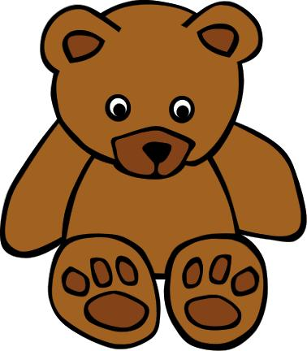

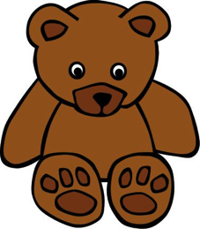

Name Date

