Topic C
How Many Questions with 1, 2, or 3 Objects
PK.CC.1, PK.CC.3ab, PK.CC.4, PK.MD.2
Focus Standard: | PK.CC.1 | Count to 20.
 | PK.CC.3ab | Understand the relationship between numbers and quantities to 10; connect counting to cardinality.  - When counting objects, say the number names in the standard order, pairing each object with one and only one number name and each number name with one and only one object.  - Understand that the last number name said tells the number of objects counted. The number of objects is the same regardless of their arrangement of the order in which they were counted.
 | PK.CC.4 | Count to answer "how many?" questions about as many as 10 things arranged in a line, a rectangular array, or a circle, or as many as 5 things in a scattered configuration; given a number from 1–10, count out that many objects.
Instructional Days: | 4
Coherence -Links to: | GK–M1 | Numbers to 10
 | GK–M5 | Numbers 10–20 and Counting to 100
In Topic C, students build on their knowledge of sorting objects and counting to 3 as they learn to answer how many questions with objects in varying configurations (PK.CC.4). Throughout these lessons, students gain experience counting small sets (up to 3), which supports their understanding of one-to-one correspondence and cardinality.
In Lesson 8, children count to 3 and answer how many questions about “Goldilocks and the Three Bears.” For instance, children point to and count 3 bears, bowls, chairs, and beds. As students touch and count the bears, they practice one-to-one correspondence by pairing each object with only one number name (PK.CC.3a).
In Lessons 9 and 10, students count up to 3 objects in different configurations. In Lesson 9, students sort animals into three groups and count each group, determining that the last number name said tells the number of objects counted (PK.CC.3b). They move the animals into lines for lunch and find that the number of animals stays the same in the new arrangement. They build upon this knowledge in Lesson 10, where they practice counting pictured objects in scattered and linear configurations.
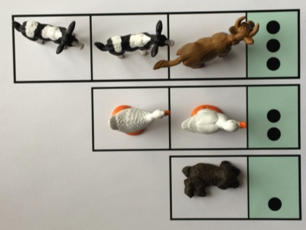
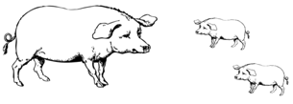

Finally, in Lesson 11, students put their new counting skills to work as they play a game, counting on dot cards to determine how many bears to put on the game board.
Please note that numerals 1, 2, and 3 are introduced in Topic D. The pre-written numerals are introduced in Topic D so that students have had plenty of time to touch and count before matching the count to the abstract numeral.
Throughout Topic C, students continue to work on touching and counting to 3 in the context of chants, games, and movement during Fluency Practice. The new Peek-a-Boo Counting game begins asking children to subitize (recognize without counting) quantities of 1, 2, and 3. Research shows that most children have an innate neurological ability to recognize small quantities without counting. Fluency activities in Topic C also anticipate future Module 1 work, introducing children to rote counting to 4 and counting forward and backward to 3.
A Teaching Sequence Towards Mastery of How Many Questions with 1, 2, or 3 Objects
Objective 1: Count up to 3 objects.
(Lesson 8)
Objective 2: Arrange and count up to 3 objects in scattered and linear configurations.
(Lessons 9–10)
Objective 3: Arrange and count up to 3 objects to play a game.
(Lesson 11)

