Lesson 7
Objective: Sort the same group of objects in two different ways.

Suggested Lesson Structure
 Fluency Practice (5 minutes)
 Application Problem (3 minutes)
 Concept Development (14 minutes)
 Student Debrief (3 minutes)
Total Time (25 minutes)
Fluency Practice (5 minutes)
- Count to 3 Chant PK.CC.1 (2 minutes)
- 1, 2, 3 Pass PK.CC.3a (3 minutes)
Count to 3 Chant (2 minutes)
Materials: (S) 5-group strip (3-dot, Lesson 6 Fluency Template)
Note: This fluency activity anticipates the need for students to be secure in rote counting before they practice touch and count in future lessons.
Conduct the activity as described in Lesson 6. If students have mastered the chant, call on students to lead new actions (e.g., 1, 2, 3, swim with me, stomp with me, etc.).
1, 2, 3, Pass (3 minutes)
Materials: (S) 5-group strip (3-dot, Lesson 6 Fluency Template)
Note: This activity anticipates the need to touch and count. Having the dots aligned on a strip organizes objects into a linear configuration.
Conduct the activity as described in Lesson 6.
The repetition of these activities from one lesson to the next is valuable. The first time, students are focused on learning the steps to a new activity, but by the second time, they are able to do it with ease and efficiency.

Application Problem (3 minutes)
Materials: (T) 2 cups or vases, 2 sorting mats (Lesson 5 Template) (S) 2 different types of flowers (real or plastic)
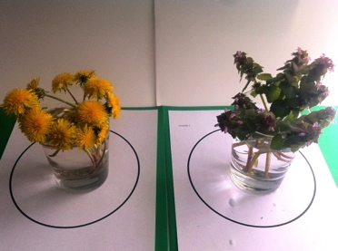
Place a vase or cup on each sorting template. Give a flower to each student. Ask them to help create two groups of flowers (bouquets) for two teachers at school. Start by placing a dandelion in one container and a purple flower in the other one. Invite students to put their flower with its group. Ask students to tell how the items in each group are the same and how they are different.
Note: In this Application Problem, students build upon their work from previous lessons on sorting (where they sorted objects into two groups). Now, they practice sorting two different types of flowers, and then explain how they made a group.
Concept Development (14 minutes)
Part 1: Concept Introduction
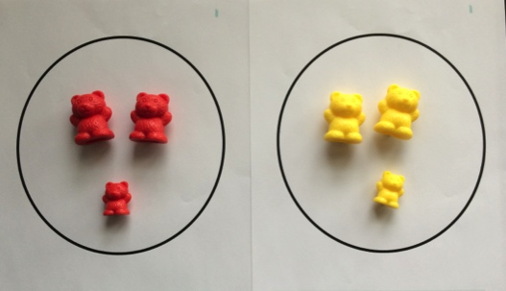
Materials: (T) 2 sorting mats (Lesson 5 Template), baggie with items that can be sorted into two groups by more than one attribute (e.g., 6 little people toys that can be sorted by gender and size, 6 teddy bear counters that can be sorted by color or size, etc.)
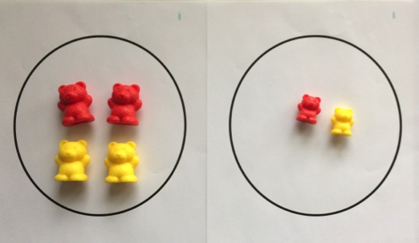
1. Show students a bag containing 2 big red bears, 2 big yellow bears, 1 little red bear, and 1 little yellow bear. Place the sorting mats on the rug.
2. Instruct the students to sort the bears into two different groups on the mats, first by color.
3. Ask students, “What groups did we make?”
4. Guide students to say, “We made a group of _____ (red or yellow) bears.”
5. Ask students, “How did we sort our groups?”
6. Guide students to say, “We sorted by color.”
7. Repeat Steps 2–7, instructing students to sort the bears into two different groups by size.

Part 2: Practice

NOTES ON
MULTIPLE MEANS
OF REPRESENTATION:
Some children will need to practice sorting into two groups with varied attributes using the exact same materials used for the whole class demonstration in Part 1. Advanced students may want to choose their own categories for sorting. Create baggies that are differentiated so that the needs of different students can be met.

Materials: (S) Per pair: differing baggies of items that can be sorted into 2 groups by more than 1 attribute (e.g., bears, vehicles, flowers, leaves, pine cones), 2 sorting mats (Lesson 5 Template)
- Pair students at tables to sort objects.
- Tell partners the category they will use to sort items, e.g., big or little, hard or soft, green or yellow. For example, “Sort the toys by size, big or little.”
- Guide partners to ask one another questions as they sort objects into the predetermined groups: “What groups did you make?”
4. Guide students to answer the questions using sentence stems such as, “I made a group of _______ (big or little cars).”
MP.3
5. Tell partners a second sorting category, e.g., “Sort the toys by color, green or yellow.”
6. Use parallel talk to model language as students communicate with each other about the items they are sorting, e.g., “Ethan is making a group of little things. Ethan is sorting by size.”
Student Debrief (3 minutes)
Lesson Objective: Sort the same group of objects in two different ways.
The Student Debrief is intended to invite reflection and active processing of the total lesson experience. It is also an opportunity for informal assessment. Consider taking anecdotal notes or using a simple checklist to note each child’s progress towards meeting the lesson objective.

CENTER CONNECTION:
The library center is a great place to practice sorting the same set of books in different ways. Depending on children’s experience with the books, try any of the following ways to sort:
- About people or about animals
- Pictures only or words and pictures
- I have read or I haven’t read
- About Curious George or about another character

As students complete the Practice portion of the Concept Development, listen for misconceptions or misunderstandings that can be addressed in the Debrief. You may choose to use any combination of the questions below to help students express ideas, make connections, and use new vocabulary.
- What did we sort today?
- How did you sort objects with your partner? (Provide sentence stem, “We sorted by _______.”)
- Can objects be sorted in more than one way? Explain.
- Let’s think about ways that we could sort our shoes. (Use student suggestions, such as sorting by laces or Velcro, size, sneakers or non-sneakers.)

