Lesson 5
Objective: Make one group with a given attribute.

Suggested Lesson Structure
 Fluency Practice (7 minutes)
 Application Problem (3 minutes)
 Concept Development (12 minutes)
 Student Debrief (3 minutes)
Total Time (25 minutes)
Fluency Practice (7 minutes)
- 1, 2, Pass PK.CC.3a (3 minutes)
- Pop Up 3 Game PK.CC.3ab (4 minutes)
1, 2, Pass (3 minutes)
Note: This activity anticipates the action of touching and counting. Having the dots aligned on the 5-group strip eliminates the need to organize objects.
5-Group Strip (2 Dots)
Materials: (S) 5-group strip (2-dot, Fluency Template)
- Seat students in a circle, with a 2-dot strip on the floor in front of each of them.
- Signal students to touch and count the dots on the 2-dot strip with an index finger as they say the chant, then pass the strip to the right.
- Possibly give a start and stop signal to the chant at first, in order to keep the movement and phrasing rhythmic.
- Chant with students, “1 (touch the first dot), 2 (touch the second dot). I count 2, and pass it on to you.” (All pass their strips to the person to their right.)
The game can be efficiently and delightfully closed by having one student place the strips in a basket rather than passing them forward. This game is inspired by the Ghanaian rock-passing game Obwisana.
Pop Up 3 Game (4 minutes)
Note: This fluency activity introduces counting to 3.
Begin with all students seated in a circle, or around the rug. Children will be counting around the circle in the following way:
Student A: 1 (remains seated).
Student B: 2 (remains seated).
Student C: 3 (stands, or pops up).
The next student starts the counting sequence again at 1. Students who have already popped up (standing) do not say a number again. Continue the process until all students are standing.
Application Problem (3 minutes)

NOTES ON
MULTIPLE MEANS
OF REPRESENTATION:
Check frequently for comprehension of vocabulary. English language learners should have multiple exposures to new vocabulary coupled with the real objects. Provide an opportunity for students to explore the objects in the bag and learn their names before the lesson.

Display 4 of the objects used in Lesson 4’s Concept Development, and have students match the objects to help them recall how the objects were sorted (items that are used together). Ask them to look around the classroom and identify 2 items that are used together (e.g., chair and desk, white board and marker, book and bookcase, cookie cutter and playdough, etc.).
Note: In this activity, students match items that are used together in anticipation of creating a group of 3 objects that go together in the Concept Development.
Concept Development (12 minutes)
Part 1: Concept Introduction
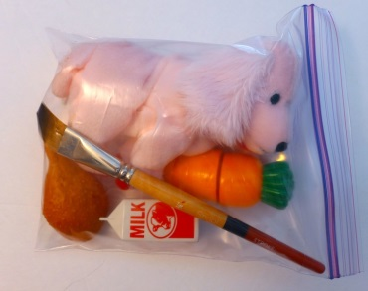
Materials: (T) Sorting mat (Template), prepared baggie with plastic food items and non-food items (e.g., a carrot, stuffed animal, paintbrush, piece of chicken, milk, fork, napkin, etc.), lunchbox
Note: Children begin to sort things naturally at a very young age (e.g., they easily sort into two groups at meal times: food I like and food I don’t like). This Concept Development simply formalizes something that they create naturally and gives it a name, group.
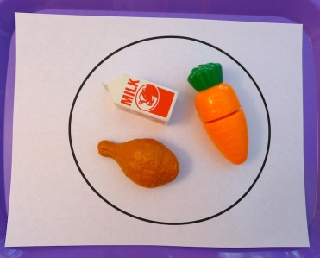
1. Place plastic food items and non-food items in the middle of the circle. Place the sorting mat next to the objects.
2. Call on students to find the food items and put them on the mat.
3. As students pick objects, use parallel talk with descriptive language: “Shawna picked a yummy piece of chicken! Devon picked a crunchy, delicious carrot!”
4. Pick up a non-food item, e.g., a paintbrush, and ask, “Does this paintbrush belong in our food group?”
5. After all the food items are on the mat, say, “We made one group.” Everything in this group is food, so let’s put all the food in my lunchbox!”
6. Show another set of mixed items, including non-food items, such as a fork or napkin. Invite students to make a new group of objects, pretending they are a mom or a dad packing lunch for her or his child.
7. Ask questions, such as, “How did you match these?” “How are they the same?” “What is different about the objects in the group?”
8. Encourage students to describe what they are packing and, when they are finished, to say, “I made one group.”
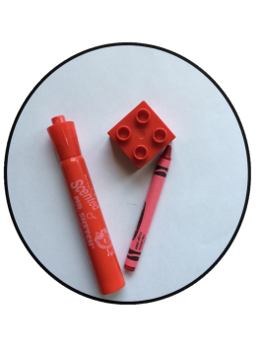
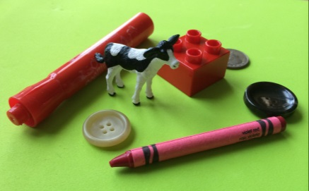
Part 2: Practice
Materials: (S) Prepared sets of objects in trays or baskets (e.g., 2 buttons, 1 coin, plastic animal, red marker, red crayon, red Lego piece), sorting mat (Template) in each tray or basket
1. Pair students at tables with prepared sets of objects and the sorting mat.
2. Tell students, “Let’s make one group!” Have partners make a group of objects that match a given attribute, e.g., shape, size, color, or use.
3. Use parallel talk, describing the groups students are making, e.g., “David and Brea made a group of buttons and coins, since they are all circles.” “Liliana and Jahsir are putting all the red objects in a group.”
MP.3
4. Ask questions such as, “How did you match these?” “How are they the same?” “What is different about the objects in the group?”
5. Guide students to repeat the questions to their partners.
Student Debrief (3 minutes)

CENTER CONNECTION:
Centers clean-up is an excellent time to emphasize making a group. “Let’s put all the dolls in a group in this basket. Put the paint brushes in a group on the shelf.”

Lesson Objective: Make one group with a given attribute.
The Student Debrief is intended to invite reflection and active processing of the total lesson experience. It is also an opportunity for informal assessment. Consider taking anecdotal notes or using a simple checklist to note each child’s progress towards meeting the lesson objective.
As students complete the Practice portion of the Concept Development, listen for misconceptions or misunderstandings that can be addressed in the Debrief. You may choose to use any combination of the questions below to help students express ideas, make connections, and use new vocabulary (group).
- What did you make today?
- How did you make a group?
- What was the same about the things in your group? What was different? (Color, size, shape, use.)

5-group strip (2 dot)
sorting mat

