Topic B
Sorting
PK.MD.2, PK.CC.1
Focus Standard: | PK.MD.2 | Sort objects into categories; count the numbers of objects in each category (limit category counts to be less than or equal to 10).
Instructional Days: | 3
Coherence -Links to: | GK–M1 | Numbers to 10
In Topic A, students learned to pair objects based on shared attributes and explain the reasons for the match. In Topic B, they carry forward this reasoning to form groups of more than 2 objects, laying the foundation for understanding, forming, and counting sets of objects.
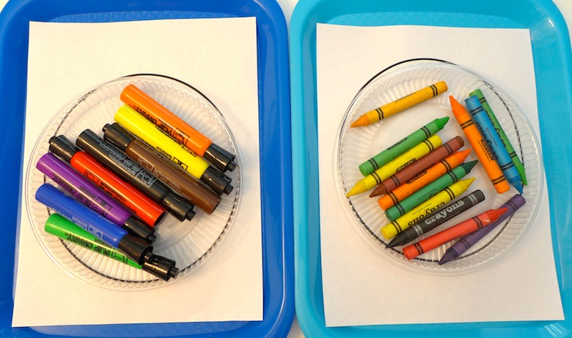
In the first lesson of Topic B, students make a group of objects that share a common attribute. The attribute is defined by the teacher in both Pre-Kindergarten (PK.MD.2) and Kindergarten (K.MD.3). In these grades, students are not expected to select an attribute but rather sort by a given attribute. In Lesson 6, students advance to making two groups rather than just one. Given a mixed collection of crayons and markers, students are directed to sort them into a group of crayons and a group of markers and explain their thinking as they do. Finally, in Lesson 7, students expand their understanding of sorting by sorting the same set of objects in two different ways: first sorting bears by color and then by size.

Students continue their playful work with counting during Fluency Practice. With teacher support, they practice counting a group of 3. Topic B is foundational to students understanding the relationship between quantities and counting objects up to 3, and prepares students to answer how many questions in Topic C (PK.CC.3ab, PK.CC.4).
A Teaching Sequence Towards Mastery of Sorting
Objective 1: Make one group with a given attribute.
(Lesson 5)
Objective 2: Sort into two groups.
(Lesson 6)
Objective 3: Sort the same group of objects in two different ways.
(Lesson 7)

