Lesson 4
Objective: Match 2 objects that are used together.

Suggested Lesson Structure
 Fluency Practice (4 minutes)
 Application Problem (5 minutes)
 Concept Development (11 minutes)
 Student Debrief (5 minutes)
Total Time (25 minutes)
Fluency Practice (4 minutes)
- I Have 2 Chant PK.CC.3a (4 minutes)
I Have 2 Chant (4 minutes)
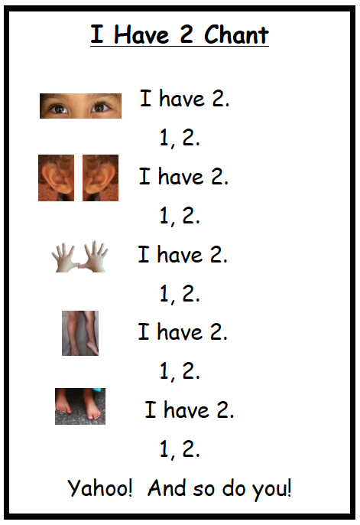
Note: In this activity, students extend their understanding of matching to recognize that they have two parts of their body that are the same, but.... The chart is provided as an optional resource to help students recall the sequence of the chant.
Materials: I Have 2 Chant (Fluency Template)
T: Let me hear you count to 2.
S: 1, 2.
T: Are you getting better at counting to 2?
S: Yes!
T: We can also count the parts of our body that come in pairs. We can count our eyes, like this: 1, (point carefully to one eye), 2 (then, the other eye), I have 2 (both). You try it.
S: 1, (point carefully to one eye), 2 (then, the other eye), I have 2 (both).
Repeat with ears, hands, legs, feet, and the last line.

Application Problem (5 minutes)
Materials: (T) Set of new and used crayons (with a matching pair for each student)
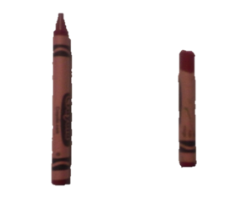
Place the crayons in the middle of the circle. Separate into smaller piles around the circle to make it easier for children to participate, if necessary. Ask students to find two crayons that match. Ask students to tell how their crayons match, using the language they are the same, but….
Note: This problem gives students an opportunity to match two objects that are the same, but… while considering attributes such as color, size, and shape.
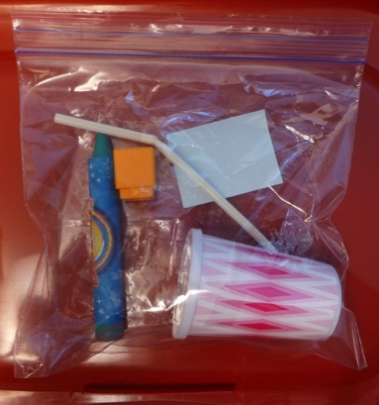
Concept Development (11 minutes)
Part 1: Concept Introduction
Materials: (T) Prepared baggie with 4 objects related by function (e.g., crayon and paper, straw and cup) and an unrelated counter (e.g., cube), matching mat (Lesson 1 Template) (S) Individual baggies like teacher’s (optional to vary the contents of the individual baggies, but make sure that the matching items are related to each other by function)
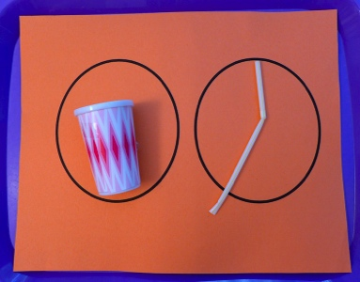
- Hold up the cup and straw, then put them on the mat. Say, “Hmmm…. I’m thinking of a way the cup and straw can be matched together. But, they don’t look the same at all. Who can guess what I’m thinking? How do they match?”
- Guide students to see that although they are different, they are used together.
3. Guide students to use the sentence stem, “They match because I use them together to….”
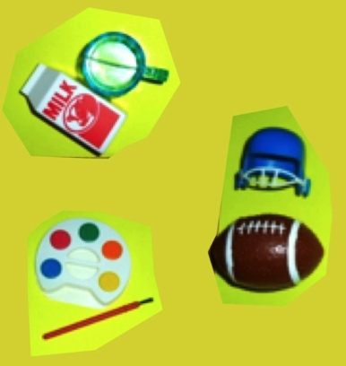
4. Pass out individual baggies. Have students find two objects that match by use and hold them up.
5. Ask, “Are your two objects the same?”
6. Encourage students to talk about why their two objects match even though they are not the same.
7. Guide them to use the sentence stem, “They match because I use them together to….”

Part 2: Practice
Materials: (S) Matching mat (Lesson 1 Template), tables prepared with matching items used together (e.g., milk carton and cup, paintbrush and paint, other matching items taken from students' baggies), Problem Set
1. Hold up the milk carton and cup, then put them on the matching mat. Ask, “How do they match?”

NOTES ON
MULTIPLE MEANS
OF REPRESENTATION:
When choosing items for baggies, some students will benefit from beginning with objects that they have experienced in the classroom setting. This prevents misconceptions about matching based on function, as objects can have a variety of functions within different households and cultures.
For other students, consider adding a challenging extension by placing 3 items in the baggie that could be used together in different combinations. For example, an envelope, pencil, and paper. One student might match the envelope with the paper, while another might match the paper with the pencil, or see a connection between all 3 objects.

2. Guide students to use the sentence stem, “They match because I use them together to….”
3. Pair students with partners to play at tables.
4. Tell students, “Match two items that are used together, and put them on your mat.”
5. Encourage students to talk about how the items match: “They match because I use them together to….”
6. Distribute a Problem Set to each student and read the directions. Emphasize using the words they match because I use them together to….
Student Debrief (5 minutes)
Lesson Objective: Match 2 objects that are used together.
The Student Debrief is intended to invite reflection and active processing of the total lesson experience. It is also an opportunity for informal assessment. Consider taking anecdotal notes or using a simple checklist to note each child’s progress towards meeting the lesson objective.

CENTER CONNECTION:
Encourage children to find objects that are used together in familiar centers. The kitchen center is a great place to find matches of this type (e.g., plate and fork, peanut butter and jelly, etc.). Support children’s language development as they share how the items are used together.

As students complete the Practice portion of the Concept Development, listen for misconceptions or misunderstandings that can be addressed in the Debrief. You may choose to use any combination of the questions below to help students express ideas, make connections, and use new vocabulary.
- How did we match things today?
- Do you see any other things in our classroom that are used together?
- What are some of the ways we’ve matched objects?
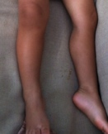
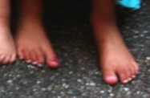
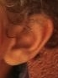
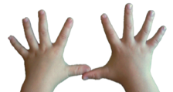
I Have 2 Chant

I have 2.
1, 2.
I have 2.
1, 2.
I have 2.
1, 2.
I have 2.
1, 2.
I have 2.
1, 2.
Yahoo! And so do you!

Name Date
Point to the objects that match by making a line with your finger. Tell your partner how you use them together.
