Lesson 2
Objective: Match 2 objects that are the same, but….

Suggested Lesson Structure
 Fluency Practice (5 minutes)
 Application Problem (4 minutes)
 Concept Development (12 minutes)
 Student Debrief (4 minutes)
Total (25 minutes)
Fluency Practice (5 minutes)
- Count to 2 Chant PK.CC.3a (5 minutes)
Count to 2 Chant (5 minutes)
Note: Practicing the chant from Lesson 1 again prepares students for the matching activities in today’s lesson. Like yesterday, use this time to build students’ understanding of the routines of math class.
Conduct activity as outlined in Lesson 1.
1, 2, I count 2 (no motions).
1 (one index finger), 2 (the other index finger), I count 2.
1 (clap), 2 (clap), I clap 2.
1, 2, me and you. (Link arms with a partner.)
Application Problem (4 minutes)

NOTES ON
MULTIPLE MEANS
FOR ACTION AND EXPRESSION:
Provide less verbal children and English language learners a variety of ways to participate in activities that require oral responses. Students can use gestures, picture cards, or sentence frames to ask or answer questions.

Materials: (T) 4 balls (2 should be exactly the same)
Show students the 4 balls, and ask them to find the ones that are exactly the same. Ask students to tell a friend how the balls are the same. If language support is needed, lead them to use the sentence stem, “They are both ___.” Invite volunteers to share their thoughts about how the balls are exactly the same.
Note: Guiding students to recall how they matched 2 of the same items yesterday sets the stage for matching 2 objects that are the same, but slightly different. They will use two of the balls to talk about the same, but… in the Concept Development.
Concept Development (12 minutes)
Part 1: Concept Introduction
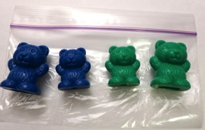
Materials: (T) Matching mat (Lesson 1 Template), baggie containing 4 matching counters (e.g., teddy bears) that can be sorted in different ways (e.g., color, size, shape)
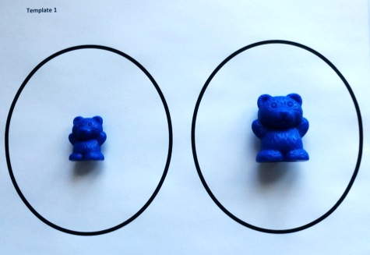
Open the baggie and place 2 matching objects on the matching mat, guiding the students to understand that the objects can be sorted in different ways.
1. Show students two similar, but not identical, objects (e.g., teddy bear counters that are the same color but different sizes).
2. Describe to students what you see using self-talk, e.g., “Here are two bears! They are the same color, but one is little and one is big. The size of the bears is different, so they are not exactly the same."
3. Show students another pair of related objects that are not identical (e.g., teddy bear counters that are the same size but different colors).
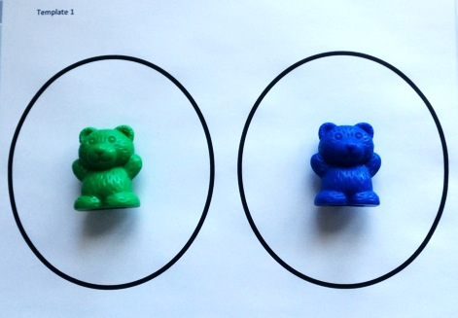
4. Use open questions to prompt students to talk about the objects, e.g., “What can you tell me about these counters? How are they the same?”
5. Ask students, “Are they exactly the same?”
6. Guide students to use the sentence stem, “They are the same, but ___.”
If time permits, return to the set of 4 bears, and invite students to find a different match and explain why the bears are the same. Encourage students to use the words they are the same, but….
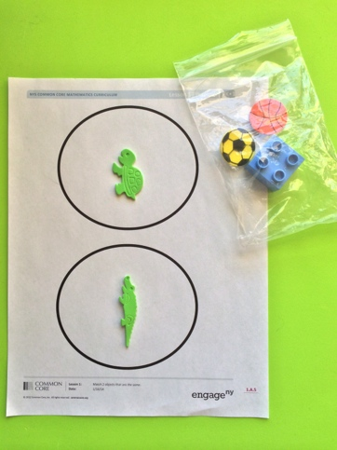
Note: While pre-fabricated classroom materials such as bear counters are an excellent resource, whenever possible, use natural and real world objects (e.g., leaves, sticks, coins) so that students can see connections to math in the real world as well. For example, “Look at these two leaves! They are the same, but one is a little cracked. They are the same, but one has more green.”
Part 2: Practice
Materials: (T) 2 balls from the Application Problem (e.g., large bouncy ball, tennis ball) (S) Per pair: matching mat (Lesson 1 Template), baggie containing 5 objects with 2 sets of matching objects (e.g., 2 green stickers—alligator and turtle, 2 sports stickers—basketball and soccer ball, 1 Lego piece)
1. Hold up two balls, one big bouncy ball and one small tennis ball.
2. Use open questions to prompt students to describe the balls. For example, “What can you tell me about these balls? How are they the same?”
3. Use repetition to model language structure and call out interesting attributes. For example, “Ooh! Tessa says they are both round! Henry says they both roll!”
4. Ask students, “Are they exactly the same, or are they the same but…?”
5. Guide students to use the sentence stem, “They are the same, but ___.”
6. Group students into partners to play at tables, giving each pair a baggie and a matching mat. Have students choose objects that are the same and put them on their mats. Ask students to talk about how the objects are the same, but….
Student Debrief (4 minutes)
Lesson Objective: Match 2 objects that are the same, but….
The Student Debrief is intended to invite reflection and active processing of the total lesson experience. It is also an opportunity for informal assessment. Consider taking anecdotal notes or using a simple checklist to note each child’s progress towards meeting the lesson objective.
As students complete the Practice portion of the Concept Development, listen for misconceptions or misunderstandings that can be addressed in the Debrief. You may choose to use any combination of the questions below to help students express ideas, make connections, use new vocabulary, and explore new concepts (exactly the same; the same, but…; size).

CENTER CONNECTION:
Encourage children to find objects that are the same, but… in familiar centers. For example, students may find two hats in the dramatic play center. Support students as they tell how the hats are the same, but….

- Were the objects in your baggie exactly the same? (If students say yes, follow up with scaffolded questions about same size, same color, and same shape.)
- (Hold up a big and a little red bear.) Finish my sentence: These two bears are not exactly the same ______. (Size.)
- How was matching today different from matching yesterday?
- Can we make 2 claps and 2 taps that are the same, but…?

