Lesson 1
Objective: Match 2 objects that are exactly the same.

Suggested Lesson Structure
 Fluency Practice (5 minutes)
 Concept Development (15 minutes)
 Student Debrief (5 minutes)
Total Time (25 minutes)

NOTES ON
FLUENCY PRACTICE:
Think of fluency as having three goals:
1. Maintenance—staying sharp on previously learned skills.
2. Preparation—targeted practice for the current lesson.
3. Anticipation—skills that ensure that students will be ready for the in-depth work of upcoming lessons. (For example, students must be secure in rote counting to 5 before they can count with one-to-one correspondence.)

Fluency Practice (5 minutes)
- Count to 2 Chant PK.CC.3a (5 minutes)
Count to 2 Chant (5 minutes)
Note: Modeling the number 2 with index fingers on each hand, clapping, and linking arms with a partner prepares students for the matching activities in today’s lesson. Only one fluency activity is included in today’s lesson to allow for ample time to teach the new activity and build routines for math.
T: I want to teach you a counting chant. Listen: 1, 2,
I count 2. Let me hear you say that.
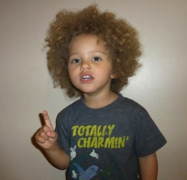
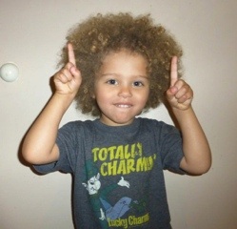
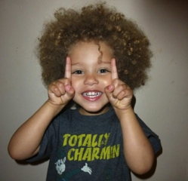
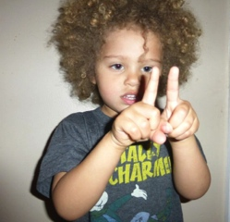
S: 1, 2, I count 2 (no motions yet).
T: Very good. Now, let’s use our fingers, like this: 1 (show one index finger), 2 (show the other index finger), I count 2.
S: 1 (one index finger), 2 (the other index finger), I count 2.
T: Great! Here’s the next step: 1 (clap), 2 (clap), I clap 2.
S: 1 (clap), 2 (clap), I clap 2.
T: We end our chant like this: 1, 2, me and you. (Demonstrate how to link arms with the person beside you.)
S: 1, 2, me and you. (Link arms with a partner.)
T: Let’s put it all together now.
T/S: 1, 2, I count 2 (no motions).
1 (one index finger), 2 (the other index finger), I count 2.
1 (clap), 2 (clap), I clap 2.
1, 2, me and you. (Link arms with a partner.)
Repeat the chant a few more times.
Concept Development (15 minutes)
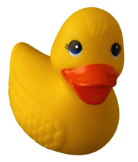
Part 1: Concept Introduction

NOTES ON
SUPPORTING
LANGUAGE DEVELOPMENT:
Pre-K children are learning vocabulary at a rapid rate. New math vocabulary is highlighted as it is introduced; however, students may need support with foundational vocabulary (e.g., size, color names). Use concrete objects or motions when developing vocabulary with young children.

Materials: (T) 2 pairs of identical objects
Seat children in a circle on the rug.
1. Show two identical objects, such as a pair of rubber ducks.
2. Describe to students what you see using self-talk: “Look at these! I see two ducks. They are both yellow. They are both little. They are exactly the same! They match!”
3. Lead students in repeating, “They are exactly the same.”
4. Encourage students to think of other ways the objects are exactly the same. If needed, draw their attention to size, color, and shape.
5. Repeat this process, showing two more identical objects, such as teddy bear counters. Ask students, “What can you tell me about these?” and lead them to use the sentence stem, “They are both....”
Part 2: Practice
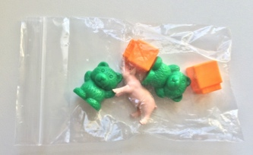
Materials: (T) 2 unsharpened pencils, matching mat (Template)
(S) Per pair: matching mat (Template), baggie containing 5 objects with 2 sets of identical objects (e.g., 2 orange linking cubes, 2 teddy bear counters, 1 farm animal)
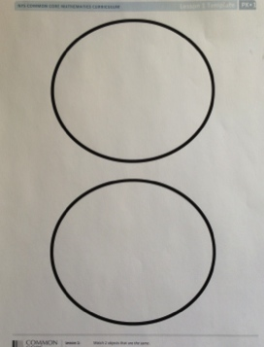
In the circle, before sending children to tables, place the matching template on the rug with a bag of 5 objects.
1. (Hold up 2 unsharpened pencils, then place them on the matching mat. Ask students how the pencils are the same, and lead them to use the sentence stem, “They are both...” (e.g., yellow, long, skinny).
2. Match students with partners to play at tables, and give each pair a baggie and a mat.
3. Ask partners to match objects that are exactly the same and put them on their mat.
MP.3
4. Ask partners to tell how the objects are exactly the same, using the sentence stem.
5. As the students work, circulate and describe what they are doing using parallel talk, e.g., “Mario matched the two bears. He says they are both blue. Priya says they are both little.”
MP.3
Circulate and observe. Support children as they work with partners to sort matching objects. After the students have matched the objects on their mat, call them to the circle for the Student Debrief.

NOTES ON
MULTIPLE MEANS
OF REPRESENTATION:
Provide scaffolds for partners who may be having difficulty finding matching objects within a larger set by limiting the number in each set. Partners experiencing difficulty may start with a set of three objects that contains two identical objects and one that is different. Gradually increase the number in the set as students experience success.

Student Debrief (5 minutes)
Lesson Objective: Match 2 objects that are exactly the same.
The Student Debrief is intended to invite reflection and active processing of the total lesson experience. It is also an opportunity for informal assessment. Consider taking anecdotal notes or using a simple checklist to note each child’s progress towards meeting the lesson objective.
As students complete the Practice portion of the Concept Development, listen for misconceptions or misunderstandings that can be addressed in the Debrief. You may choose to use any combination of the questions below to help students express ideas, make connections, and use new vocabulary (exactly the same, match).

CENTER CONNECTION:
Encourage children to find objects that are exactly the same in familiar centers. For example, students may find matching blocks in the block center or two matching plates in the kitchen center. Support children’s language development as they share how the items are exactly the same.

- How did you choose things that were exactly the same?
- Do you see any things in our classroom that match?
- (Invite 2 girls to stand.) Are these 2 students exactly the same?
- (Hold up 2 matching counters and place them on a mat. Have students complete your sentence.) These counters are _________. They are both _________.

matching mat

