Topic A
Matching Objects
PK.MD.2, PK.CC.1
Focus Standard: | PK.MD.2 | Sort objects into categories; count the numbers of objects in each category (limit category counts to be less than or equal to 10).
Instructional Days: | 4
Coherence -Links to: | GK–M1 | Numbers to 10
 | GK–M3 | Comparison of Length, Weight, Capacity, and Numbers to 10
In Topic A, children learn to match concrete objects with common attributes. By observing an object’s attributes, children can begin to explore similarity between two objects. In the first lesson, children match two items that are exactly the same.
Lessons 2 and 3 introduce the concept of the same, but…, as children expand their understanding of matching. In Lesson 2, children match 2 bears that are the same color but different sizes. Using the same set of bears, they then match bears that are the same size but different colors. Lesson 3 pushes this thinking forward as students match images that are the same, but…, pairing a small glass of orange juice with a tall glass of cranberry juice.
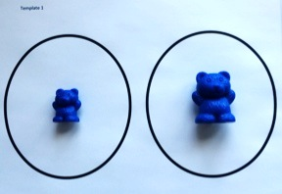
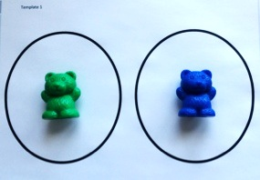

In the final lesson, students extend their understanding of matching to include items that are used together. As children make pairs based on given attributes, they describe how the objects match using their new vocabulary and math words (PK.CC.3, PK.MD.2). This lays the foundation for later work with geometry and attributes.
Throughout Topic A, children develop fluency with counting to 2 and matching objects. The use of engaging chants and simple games with movement allows children to count small quantities with excitement and success.

A Teaching Sequence Towards Mastery of Matching Objects
Objective 1: Match 2 objects that are exactly the same.
(Lesson 1)
Objective 2: Match 2 objects that are the same, but….
(Lessons 2–3)
Objective 3: Match 2 objects that are used together.
(Lesson 4)

