Table of Contents
GRADE PK • MODULE 1
Counting to 5

Module Overview i

Family Math Newsletters 1

Topic A: Matching Objects 1.A.1

Topic B: Sorting 1.B.1

Topic C: How Many Questions with 1, 2, or 3 Objects 1.C.1

Topic D: Matching 1 Numeral with up to 3 Objects 1.D.1

Topic E: How Many Questions with 4 or 5 Objects 1.E.1

Topic F: Matching 1 Numeral with up to 5 Objects 1.F.1

Topic G: One More with Numbers 1 to 5 1.G.1

Topic H: Counting 5, 4, 3, 2, 1 1.H.1

Module Assessments 1.S.1

Grade PK • Module 1

Counting to 5
OVERVIEW
Module 1 capitalizes on the energy and excitement young students have as they enter their first day of Pre-K by providing a playful and active, yet carefully sequenced structure through which children progress.
In this module, we set up a friendly learning environment in which children have sustained interaction with four core ideas, collectively referred to as the number core (PK.CC.1–4):
- Rote counting (the number word list, i.e., one, two, three…)
- One-to-one correspondence (one object paired with one number word)
- Cardinality (how many in a set)
- Written numerals
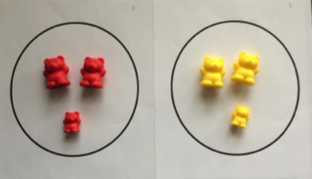
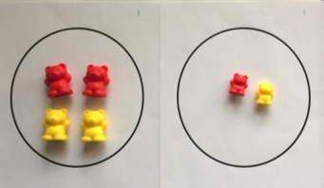
Throughout the module, children have experiences that help them make critical connections between these four understandings.
In Topics A and B, students begin exploring the number word list and one-to-one correspondence with quantities to 3. However, their primary learning in these topics is a series of matching and sorting activities that allows them to focus on the attributes of objects (MP.6) and articulate their observations (MP.3). In Topic A, children match concrete objects in multiple ways using specific vocabulary, e.g., exactly the same, the same, but…, to describe their thoughts. In Topic B, children sort objects into groups using given attributes such as color, shape, size, and texture (PK.MD.2). This topic lays the foundation for understanding, forming, and counting sets of objects, which leads to the how many questions introduced in Topic C.
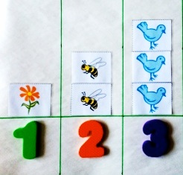
Topics C and D support children in making connections between the four aspects of the number core. Topics A and B ask students to say the number names in standard order when counting, pairing each object with one and only one number name (PK.CC.3a). Topic C’s how many questions require students to incorporate cardinality, understanding that the last number name said tells the number of objects counted (PK.CC.3b). Children begin to generalize this knowledge as they use one-to-one correspondence to count a set of 3 objects in scattered and linear configurations (PK.CC.4).
In Topic D, children begin to match quantities of 1 to 3 objects to a numeral (PK.CC.2). They work with prewritten numerals as they build the fine motor skills necessary to start writing numerals in later modules. Children also practice counting out a specified number of objects (up to 3) by matching them to an existing set. Initially, they do this by counting a group of craft sticks to match a group of dots. This practice prepares them to count out a group of objects by hearing or seeing the numeral (PK.CC.4). The Mid-Module Assessment is given after Topic D, during which each child is interviewed and observed to determine how well she understands sorting, making groups, and counting to 3.
Topics E and F mimic Topics C and D, extending children’s understanding of the number core to quantities of 4 and 5. They practice strategies for counting array, circular, and scattered configurations, tracking their counting paths to ensure one-to-one correspondence (PK.CC.4).
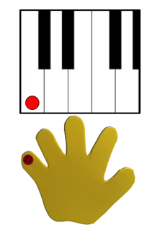
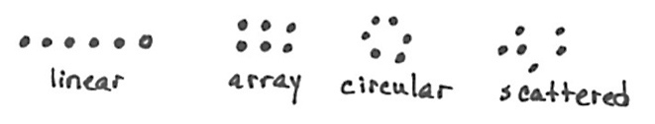
They also learn to count the Math Way, starting with the left pinky finger and moving toward the thumb, using a piano template (shown on right). Playing the piano in this way prepares them to count 6, 7, 8, 9, 10, beginning with the right thumb and continuing to the right pinky. Also, in counting the Math Way on the piano, students see the number of fingers increase as they count from 1 to 5, moving from left pinky to thumb without interruption. This provides a foundation for understanding the number path and number line, on which numbers also increase from left to right. Internalization of the number line develops multiple areas of number sense and facilitates future work with operations.

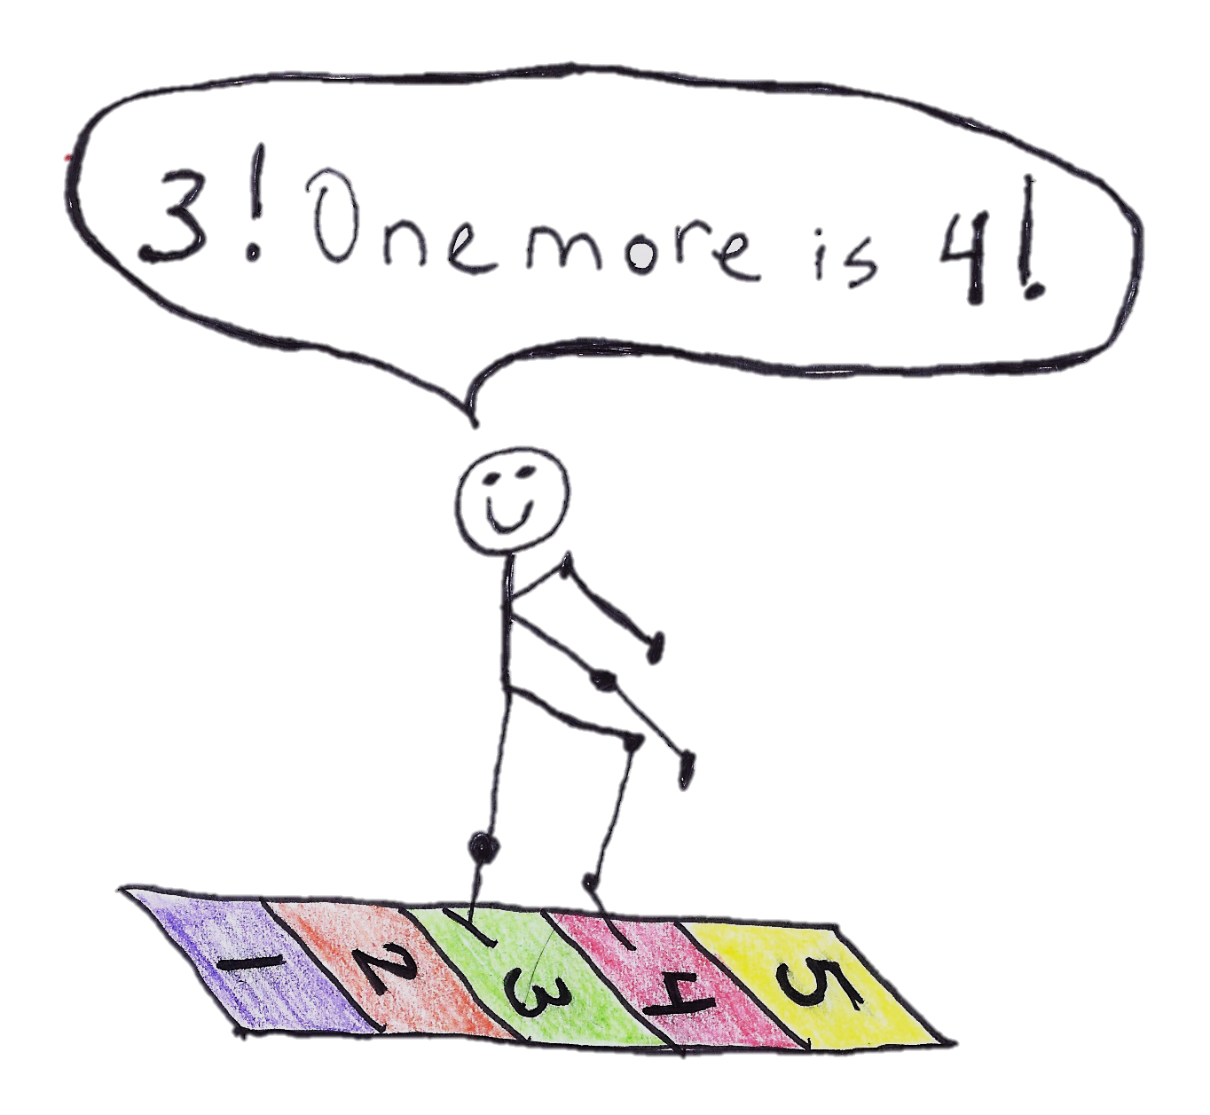
Throughout Topics E and F, children have opportunities to find smaller numbers embedded within larger numbers (e.g., 1 and 3 are inside 4). This precursor to composition and decomposition of numbers prepares students to work with addition and subtraction later in the year.
In Topic G, students use their skill with rote counting and their subsequent knowledge of number names to find the pattern of 1 more as they build number stairs for quantities 1–5, recognizing that each successive number name refers to a quantity that is one larger (PK.CC.4d). They learn to look at the numbers 1–4 and to answer "What is 1 more?" and "What comes after?" (PK.CC.1–4, PK.OA.2). This also enables the students to connect counting sequences to quantities and to understand the 1 more pattern using concrete objects.
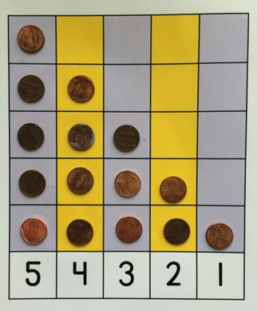
In Topic H, children break down a tower of 5, removing one cube at a time while counting backwards (PK.OA.2). Topics G and H help students build an understanding of the relationships between numbers and the pattern embedded in the counting sequence. These important insights will serve as the basis for counting on in Grade 1.

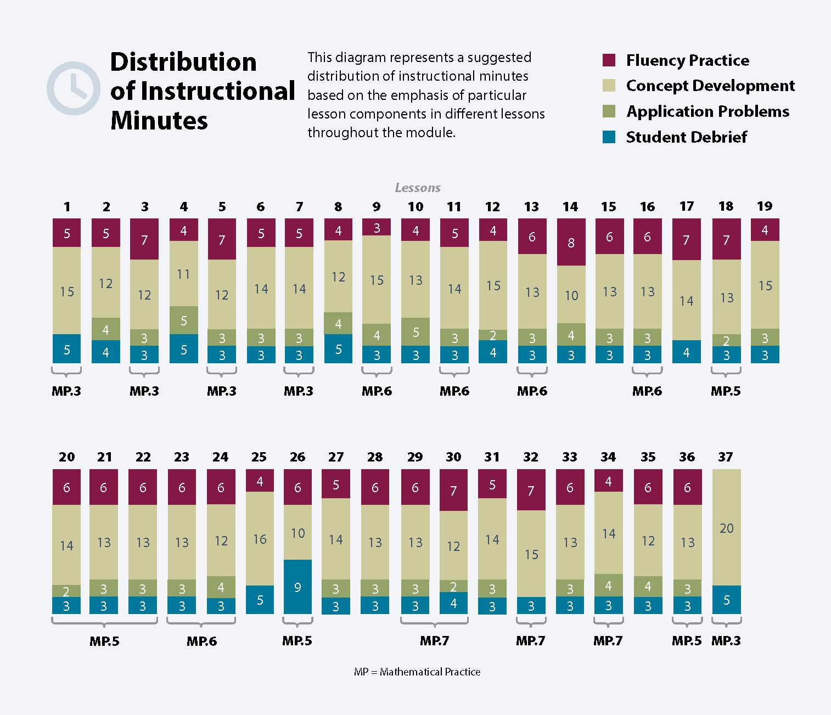
Focus Grade Level Standards
Know number names and the count sequence.
PK.CC.1 Count to 20.
PK.CC.2 Represent a number of objects with a written numeral 0–5 (with 0 representing a count of no objects).

Count to tell the number of objects.
PK.CC.3 Understand the relationship between numbers and quantities to 10; connect counting to cardinality.
- When counting objects, say the number names in the standard order, pairing each object with one and only one number name and each number name with one and only one object.
- Understand that the last number name said tells the number of objects counted. The number of objects is the same regardless of their arrangement or the order in which they were counted.
- Understand that each successive number name refers to a quantity that is one larger.
PK.CC.4 Count to answer "how many?" questions about as many as 10 things arranged in a line, a rectangular array, or a circle, or as many as 5 things in a scattered configuration; given a number from 1–10, count out that many objects.
Understand simple patterns.
PK.OA.2 Duplicate and extend (e.g., what comes next?) simple patterns using concrete objects.
Sort objects and count the number of objects in each category.
PK.MD.2 Sort objects into categories; count the number of objects in each category (limit category counts to be less than or equal to 10).
Focus Standards for Mathematical Practice
MP.3 Construct viable arguments and critique the reasoning of others. Children begin to describe their choices for matching and sorting. They can briefly articulate the reasons why objects match or belong in a particular group.
MP.5 Use appropriate tools strategically. Children use objects to model situations, and then count to tell how many.
MP.6 Attend to precision. Children hone their observation skills by attending to and describing the specific characteristics shared by members of a group. Through repeated practice, they become more precise in describing the cardinality of a group and counting out a specific number of things.
MP.7 Look for and make use of structure. Students notice that as they build number stairs for numbers 1–5, there is 1 more cube in each successive number. They also notice the pattern of 1 less as they count backward from 5, removing one cube at a time.
Overview of Module Topics and Lesson Objectives
Standards | Topics and Objectives |  | Days
PK.MD.2  PK.CC.1 | A | Matching Objects  Lesson 1: Match 2 objects that are exactly the same.  Lessons 2–3: Match 2 objects that are the same, but….  Lesson 4: Match 2 objects that are used together. | 4
PK.MD.2  PK.CC.1 | B | Sorting  Lesson 5: Make one group with a given attribute.  Lesson 6: Sort into two groups.  Lesson 7: Sort the same group of objects in two different ways. | 3
PK.CC.1  PK.CC.3ab  PK.CC.4  PK.MD.2 | C | How Many Questions with 1, 2, or 3 Objects  Lesson 8: Count up to 3 objects.  Lessons 9–10: Arrange and count up to 3 objects in scattered and linear configurations.  Lesson 11: Arrange and count up to 3 objects to play a game. | 4
PK.CC.2  PK.CC.3ab  PK.CC.4  PK.CC.1 | D | Matching 1 Numeral with up to 3 Objects  Lesson 12: Match the numerals 1, 2, and 3 to quantities.  Lesson 13: Make a group of up to 3 objects and match the numeral (concrete to abstract).  Lesson 14: Look at a numeral and count out a group of objects to match (abstract to concrete). | 3
 |  | Mid-Module Assessment: Topics A–D (interview style assessment, 4 days) | 4
PK.CC.3ab  PK.CC.4  PK.CC.1  PK.MD.2 | E | How Many Questions with 4 or 5 Objects  Lessons 15–16: Arrange and count up to 5 objects in scattered and linear configurations.  Lesson 17: Count fingers on the left hand from 1 to 5.  Lesson 18: Arrange and count 4 objects in an array configuration.  Lesson 19: Find embedded numbers within 4 and 5 objects.  Lesson 20: Arrange and count 5 objects in a circular configuration. | 6
PK.CC.2  PK.CC.3ab  PK.CC.4 | F | Matching 1 Numeral with up to 5 Objects  Lesson 21: Count up to 4 objects and match the numerals.  Lesson 22: Count up to 5 objects and match the numerals.  Lesson 23: Make a group of up to 5 objects and match the numeral (concrete to abstract).  Lesson 24: Look at a numeral and count out a group of objects to match (abstract to concrete).  Lessons 25–26: Represent numbers 1–5 using objects, pictures, and numerals.  Lesson 27: Play a game involving numbers to 5. | 7
PK.CC.3c  PK.OA.2  PK.CC.2  PK.CC.5 | G | One More with Numbers 1 to 5  Lesson 28: Count 1, 2, 3, 4, 5 with stories.  Lesson 29: Find 1 more.  Lesson 30: Build a tower by putting 1 more cube or block at a time.  Lesson 31: Build number stairs showing 1 more with cubes.  Lesson 32: Count up: What comes after? | 5
PK.CC.3c  PK.OA.2  PK.CC.2  PK.CC.5 | H | Counting 5, 4, 3, 2, 1  Lessons 33–34: Build descending number stairs at the concrete and pictorial levels.  Lessons 35–36: Count 5, 4, 3, 2, 1 using a story.  Lesson 37: Culminating task—sort objects by use and count each group; represent one group with a number tower and numeral. | 5
 |  | End-of-Module Assessment: Topics E–H (interview style assessment, 4 days) | 4
Total Number of Instructional Days |  |  | 45

Fluency
New Fluency Topics Appearing in Module 1 Instruction
- Rote count to 5
- Count one-to-one within 5
- Count 1–5 in different formations
- Make a group of 1 to 5 objects
- Within 5, find 1 more or 1 less

Terminology
New or Recently Introduced Terms
- 1 less (e.g., 1 less than 4 is 3)
- 1 more (e.g., 1 more than 4 is 5)
- After (position word)
- Count (with reference to use of number core)
- Counting the Math Way (count fingers from left pinky to right pinky)
- Different (way to analyze objects to match or sort)
- Exactly the same (way to analyze objects to match or sort)
- Group (objects sharing one or more attributes)
- How many (with reference to counting quantities or sets)
- Line (with reference to counting configuration)
- Mark (with reference to starting point for count)
- Match (group items that are the same or that have the same given attribute)
- Number (numeral)
- Partners (embedded numbers)
- The same, but… (way to analyze objects to match or sort)
- Size (generalized measurement term)
- Sort (group objects according to a particular attribute)

Suggested Tools and Representations
5-group Strip
Piano Mat
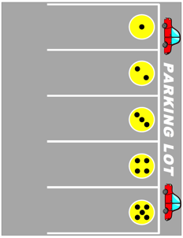
- 5-group strips
Parking Lot Template
- Concrete materials
(e.g., linking cubes, blocks, bear counters, plastic animals, pennies, etc.)
- Dot cards, 1–5
- Large dice with dots, 1–5
- Matching mat
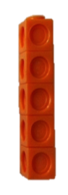
- Number stairs
Number Tower
Sorting Mat
Number Stairs
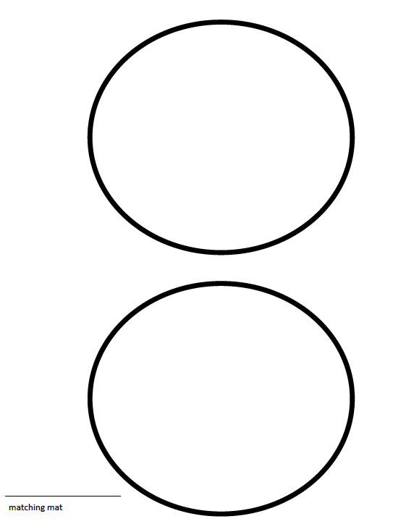
- Number tower
Matching Mat
- Numeral cards, 1–5
- Parking lot template
- Piano mat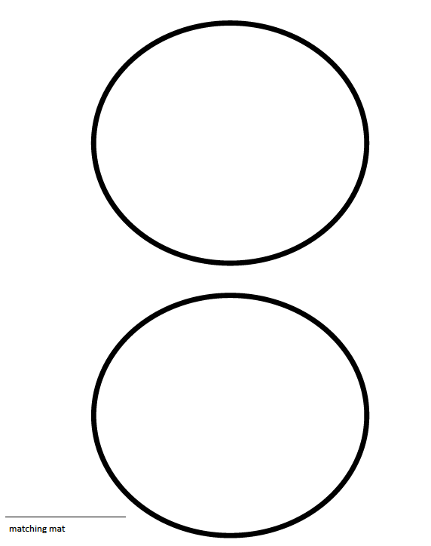
- Sets of numerals to 5 (cardboard, foam, etc.)
- Sorting mat
Suggested Methods of Instructional Delivery
Aligning A Story of Units Math Modules with ELA Domains
The sequence of learning in A Story of Units is carefully constructed to develop deep understanding of the key foundational math content for each grade, as described by the Common Core State Standards. Research in early mathematics learning suggests teaching and learning paths appropriate for early childhood programs. The Pre-K math modules are sequenced based on this research. Where appropriate, math instruction incorporates aspects of the domains of the Pre-K Core Knowledge Language Arts. However, the primary driver of the curriculum is the sequence of math learning that will prepare children for success in subsequent grades.
Language Facilitation in Math
Language development occurs throughout the Pre-K day, and math time is no exception. The Pre-K math modules utilize the language stimulation and support techniques described in “Core Knowledge Language Arts Pre-K General Overview” to support consistency in language development.
- Comments: Effective use of teacher comments can stimulate discussion. “You have three yummy green grapes.” “You drew your tally marks next to each other.”
- Self-Talk: Teachers tell students what they are doing, observing, or thinking to model the types of language and vocabulary needed for specific math situations. “I need to count these bears. I’m going to put them in a line so they are easier to count: 1, 2, 3, 4, 5.”
- Labels and Object Descriptions: Children need support naming and describing objects and actions used in math instruction. “This group has large bears. That group has small bears.”
- Open Questions: With appropriate scaffolding, open questions give children an opportunity to express their own thoughts about math. Responses comprised of complete sentences are welcome, but not demanded. “Can objects be sorted in more than one way?” “Yes!” “Yes! We sorted by color and by size.”
- Parallel Talk: Describe what children are saying or doing to model language and vocabulary appropriate to the situation. “Ethan is making a group of things to take to school. He is sorting by use.”
- Expansion: By expanding a child’s idea into a sentence or phrase, teachers help children build the capacity to express complete ideas. Child: “3.” Teacher: “You have 3 bears?”
- Repetition: Teachers use repetition to help children understand the rules of language (articulation, pronunciation, vocabulary, syntax, and grammar). Child: “The twiangle has three pointy parts.” Teacher: “Yes, the triangle has three corners.”
- Modeling: In A Story of Units, teachers ask children to repeat key questions and phrases or provide sentence stems to help children express mathematical ideas. Guide Partner B to ask, “How many _______ (cows, pigs, etc.) did you count?” Partner A responds, “I counted 4 _______ (cows, pigs, etc.).”

Scaffolds
The scaffolds integrated into A Story of Units give alternatives for how students access information as well as express and demonstrate their learning. Strategically placed margin notes are provided within each lesson elaborating on the use of specific scaffolds at applicable times. They address many needs presented by English language learners, students with disabilities, students performing above grade level, and students performing below grade level. Many of the suggestions are organized by Universal Design for Learning (UDL) principles and are applicable to more than one population. To read more about the approach to differentiated instruction in A Story of Units, please refer to “How to Implement A Story of Units.”

Assessment Summary
Assessment Type | Administered | Format | Standards Addressed
Mid-Module Assessment Task | After Topic D | Interview with rubric | PK.CC.1  PK.CC.2  PK.CC.3ab  PK.CC.4  PK.MD.2  *Numbers 1–3
End-of-Module Assessment Task | After Topic H | Interview with rubric | PK.CC.1  PK.CC.2  PK.CC.3abc  PK.CC.4  PK.OA.2  *Numbers 1–5
Culminating Task | Lesson 37 | Sort objects by use and count each group; represent one group with a number tower and numeral. | PK.CC.2  PK.CC.3abc  PK.CC.4  PK.MD.2

Within 5.
The National Research Council’s Mathematics Learning in Early Childhood: Paths Toward Excellence and Equity describes teaching–learning paths appropriate for children from age two through Grade 1.
Students with disabilities may require Braille, large print, audio, or special digital files. Please visit the website www.p12.nysed.gov/specialed/aim for specific information on how to obtain student materials that satisfy the National Instructional Materials Accessibility Standard (NIMAS) format.

