Pre-Kindergarten Mid-Module 1 Assessment Instructions (Administer after Topic D)
Purpose: These assessments inform daily planning, enhance parent conferences with specific documentation of students’ skill development, and provide valuable information about a student to his next teacher.
Materials Needed: Linking cubes as pictured on each page, Module 1 assessment picture cards, crayon, scissors, apple, dish, paper, yellow items, green items, paper plate, craft sticks, and numerals 1–3.
Preparation: This may be a pre-kindergarten student's first assessment experience, so it is critical to make it a positive one. Greet the child warmly, and sit beside her rather than opposite. Tell the child that it is time to play some number games.
Procedure: Use the specific language of the assessment, translating as necessary for non-English speakers. Use the second hand of the classroom clock to assure there is ample wait time, and note when there is a significant delay (i.e., more than 20 seconds) in response. Record the student's results in two ways, (1) the narrative documentation and (2) the overall score per topic. It is key to allow the child to explain his reasoning in his primary language.
Initial Assessment: Use the rubric to determine at what step the student is performing.

STEP 1  Little evidence of reasoning without a correct answer.  (1 point) | STEP 2  Evidence of some reasoning without a correct answer.  (2 points) | STEP 3  Evidence of some reasoning with a correct answer or evidence of solid reasoning with an incorrect answer.  (3 points) | STEP 4  Evidence of solid reasoning with a correct answer.  (4 points)

If the student is unable to get the correct answer on any part of the assessment, his score cannot exceed Step 3. However, if the student is unable to use his words to explain what he did, do not count that against him quantitatively. (Be aware of the difference between a native English speaker’s and a non-English speaker’s ability to articulate something.) If the student asks for or needs a hint or significant support, provide either, but automatically lower the score. This is to ensure that the assessment provides a true picture of what a student can do independently.
Repeated Assessment: If a student scores at Step 1 or 2, repeat that task at two-week intervals, noting the date of the reassessment in the space at the top of the student’s record sheet. Document progress on this form. If the student is very delayed in his response but completes it, reassess after two weeks to see if there is a change in the time elapsed.
Documentation Availability: Keep the assessments in a three-ring binder or student portfolio. There are two assessments (mid and end) per module for each student. Use the Class Record Sheet following the rubric for an at-a-glance look at students’ strengths and weaknesses and follow-up lesson planning.

 | Date 1 | Date 2 | Date 3
Topic A
Topic B
Topic C
Topic D
Student Name _________________________
Topic A: Matching Objects
Rubric Score: ___________ Time Elapsed: ____________

Materials: (S) 4 linking cubes (2 yellow, 1 red, 1 green), Module 1 assessment picture cards (cut out), paper, apple (toy or real), scissors, crayon, and dish
1. Here are some linking cubes (give separated cubes to the student). Show me two matching cubes that are exactly the same. How are they exactly the same?
2. (Show Module 1 assessment picture cards.) Show me two things that are the same and use your words, “They are the same, but…” to tell me about the two things.
3. (Present a piece of paper, apple, scissors, crayon, and dish.) Show me two objects that are used together. Tell me how they are used together. (There is more than one answer, e.g., paper and scissors, crayon and paper, apple and dish.)

What did the student do? | What did the student say?

Topic B: Sorting
Rubric Score: ___________ Time Elapsed: ____________
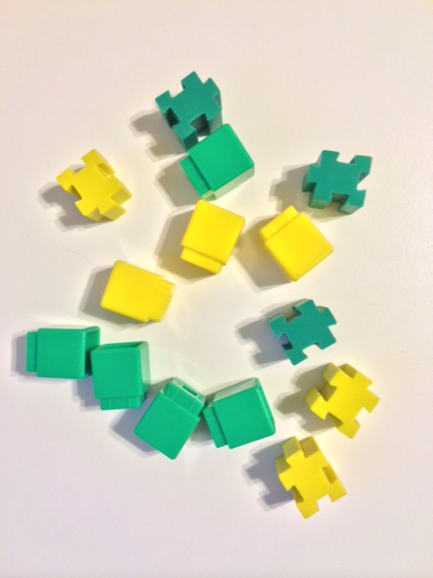
Materials: (S) Module 1 assessment picture cards (cut out), 5 green cubes, 3 yellow cubes, 3 yellow items (e.g., erasers), 3 green items
1. (Show the Module 1 assessment picture cards.) Mama cat is looking for her kittens. Can you help me make a group of kittens?
2. Here are some linking cubes and erasers (place items in front of the student). Sort these things by color.
3. (Point to the yellow group.) Use your words, “They are the same, but…” to tell me about this group.
4. Help me mix them up again. (Mix the two groups.) Now, sort them into two groups: a cube group and an eraser group.

What did the student do? | What did the student say?

Topic C: How Many Questions with 1, 2, or 3 Objects
Rubric Score: ___________ Time Elapsed: ____________
Materials: (S) 3 different color linking cubes, paper plate
1. (Put 3 unconnected cubes in a straight horizontal line on the plate.) Touch and count the cubes. How many are there?
2. Move the cubes close together. (Student moves the cubes.) How many are there?
3. Move the cubes far apart on the plate. (Student moves the cubes.) How many are there?
4. (Show 2 cubes on the plate.) How many cubes are there?
5. (Put 1 cube on the plate.) How many cubes are there?
Note: If a child is unable to count 3 objects with one-to-one correspondence (one object paired with one number word), ask her to rote count to 3. Rote counting (PK.CC.1) is a precursor to counting with one-to-one correspondence (PK.CC.3a).

What did the student do? | What did the student say?
5.

Topic D: Matching 1 Numeral with up to 3 Objects
Rubric Score: ___________ Time Elapsed: ____________
Materials: (S) 3 linking cubes, 5 craft sticks, numerals 1–3
1. Count to 3 on your fingers (any 3 fingers will do).
2. I will help you put these hats on top of your 3 fingers (assist child). How many hats do you have?
3. Use your sticks to show that number. How many sticks are in the group?
4. (Show numerals 1–3.) Which number shows how many sticks are in your group?
5. (Show 1 craft stick.) What number shows how many craft sticks are in this group?
6. (Show 2 cubes.) What number shows how many cubes are in this group?

What did the student do? | What did the student say?

Mid-Module Assessment Task  Standards Addressed | Topics A–D
Know number names and the count sequence.
PK.CC.1 Count to 20.
PK.CC.2 Represent a number of objects with a written numeral 0–5 (with 0 representing a count of no objects).
Count to tell the number of objects.
PK.CC.3 Understand the relationship between numbers and quantities to 10; connect counting to cardinality.
a. When counting objects, say the number names in the standard order, pairing each object with one and only one number name and each number name with one and only one object.
b. Understand that the last number name said tells the number of objects counted. The number of objects is the same regardless of their arrangement of the order in which they were counted.
PK.CC.4 Count to answer "how many?" questions about as many as 10 things arranged in a line, a rectangular array, or a circle, or as many as 5 things in a scattered configuration; given a number from 1–10, count out that many objects).
Sort objects and count the number of objects in each category.
PK.MD.2 Sort objects into categories; count the numbers of objects in each category (limit category counts to be less than or equal to 10).
Evaluating Student Learning Outcomes
A Progression Toward Mastery is provided to describe and quantify steps that illuminate the gradually increasing understandings that students develop on their way to proficiency. In this chart, this progress is presented from left (Step 1) to right (Step 4). The learning goal for each student is to achieve Step 4 mastery. These steps are meant to help teachers and students identify and celebrate what the student CAN do now, and what they need to work on next.

A Progression Toward Mastery
Assessment  Task Item | STEP 1  Little evidence of reasoning without a correct answer.  (1 point) | STEP 2  Evidence of some reasoning without a correct answer.  (2 points) | STEP 3  Evidence of some reasoning with a correct answer or evidence of solid reasoning with an incorrect answer.  (3 points) | STEP 4  Evidence of solid reasoning with a correct answer.  (4 points)
Topic A  PK.MD.2 | The student shows little evidence of understanding how to match objects and identify or explain similarities, and is almost non-responsive. | The student shows evidence of beginning to identify matching objects by similarities and demonstrates early explanation skills, but with incomplete reasoning. | The student correctly matches objects by similarities, but only provides a partial explanation of how the objects match.  Or, the student provides a reasonable explanation of the categories, but sorts incorrectly. | The student correctly:  - Matches 2 cubes that are exactly the same color.  - Matches 2 cards that are the same, but… and explains how the two objects differ.  - Matches 2 objects that are used together and explains how they are used together.
Topic B  PK.MD.2 | The student shows little evidence of understanding how to sort objects into two groups, and is unable to explain the process. | The student shows a beginning understanding of sorting objects into two groups (with some misplaced items), and demonstrates early explanation skills, but with incomplete reasoning. | The student correctly sorts the objects, but cannot explain why the objects belong together.  Or, the student provides an explanation about the groups but mis-sorts. | The student correctly:  - Makes a group of 3 kittens.  - Sorts the cubes by color.  - Explains how items within a group are the same and how the two groups are different.
Topic C  PK.CC.1  PK.CC.3ab  PK.CC.4 | The student shows little evidence of understanding how to count objects in any configuration, is unable to count from 1 to 3 with one-to-one correspondence (one object paired with one number word), and does not recognize that the last number counted tells how many. Note if child is able to rote count to 3. | The student shows evidence of beginning to understand how to count objects in a line or scattered configuration, but has some difficulty understanding cardinality (e.g., repeats count when asked how many) or one-to-one correspondence (says more than one number for each object or skips an object). | The student is able to do two of the following:  - Arrange and count cubes in a line and in a scattered configuration correctly to 3.  - Demonstrate understanding of cardinality.  - Count with one-to-one correspondence. | The student correctly:  - Arranges and counts cubes in a line and in a scattered configuration correctly to 3 and begins to show conservation.  - Demonstrates understanding of cardinality (the last number said tells how many).  - Counts with one-to-one correspondence (one object paired with one number word).
Topic D  PK.CC.2  PK.CC.3ab  PK.CC.4 | The student shows little evidence of understanding how to match a numeral to a quantity, or is unable to make a group of a particular quantity. Child is unable to explain the process. | The student shows evidence of beginning to understand how to match a numeral to a quantity and how to create a group of a particular quantity. | The student demonstrates some understanding, but inaccurately or inconsistently does the following:  - Creates a group of 1–3 sticks.  - Matches the numerals 1–3 to the corresponding quantities. | The student correctly:  - Creates a group of 1–3 sticks.  - Matches the numerals 1–3 to the corresponding quantities.

Class Record Sheet of Rubric Scores: Mid-Module 1 Assessment
Student Names | Topic A: Matching Objects | Topic B: Sorting | Topic C:  How Many Questions with 1, 2, or 3 Objects | Topic D: Matching 1 Numeral with up to 3 Objects | Next Steps:

Module 1 Assessment Picture Cards

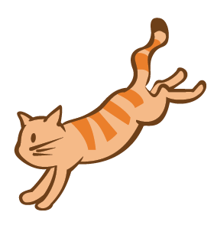 | 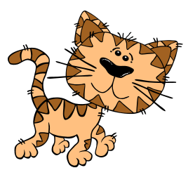 | 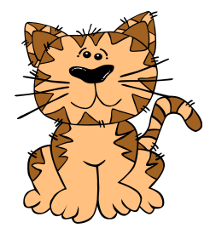

PK.CC.1 is assessed directly if a child is not able to demonstrate mastery of PK.CC.3a, since rote counting is embedded in counting with one-to-one correspondence.
Within 3./0*+

