Grade PK • Module 1 • Topics A–D
Family Math Newsletter
Welcome to the World of Pre-K Math!
Throughout the year, you will receive letters highlighting the age-appropriate mathematical ideas that your preschooler is learning. These ideas are foundational to the way we understand and analyze the world. Each letter includes a summary of what your child is learning, key vocabulary terms, and ways you can provide support and make connections at home.
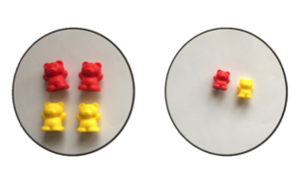
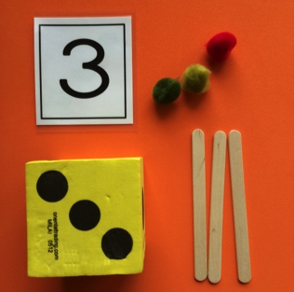
Sorting by size
This group has big bears. That group has small bears.
Words and Key Terms

How to Help at Home
- Have your child help with household chores that require matching or sorting, such as matching socks in the laundry, organizing shoes, or collecting utensils for meals. As your child matches objects, ask questions like, “How do they match?”
- Play I Spy together to continue developing vocabulary around size, shape, color, and texture. For instance, seeing a banana, you might say, “ I spy something yellow and smooth.”
- Identify and count parts of your body, noticing if there is a matching body part (1 ear, 2 ears) or just 1 body part (1 nose).
- Touch and count three objects together. At the grocery store, count, “1, 2, 3. We need 3 apples.”
Matching/Sorting
- Different
- Exactly the same
- Group
- Match
- Size
- Sort
- The same, but…
Other Vocabulary and Terms
- Count
- How many?
- Line
- Number

Key Standards
- Know number names and the count sequence.
- Count to tell the number of objects.
- Sort objects and count the number of objects in each category.
For more information about the New York State Prekindergarten Foundation for the Common Core, visit http://www.p12.nysed.gov/ciai/common_core_standards/pdfdocs/nyslsprek.pdf.

Numbers to 5
In the first half of Module 1, children match and sort objects based on their attributes (e.g., color, size, use). Along the way they are shown as many as three objects and asked, “How many?” Touching one object at a time, they count to find the total, and match the count to a numeral.
Sorting by size:
“This group has big bears. That group has small bears.”
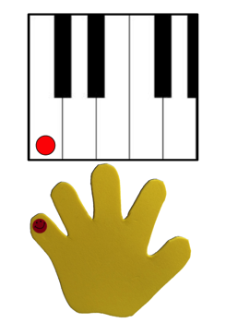
Spotlight on Math Models
A math model is a way to represent math concepts such as numbers, relationships between numbers, measurement, or geometry. In Pre-K, students use physical models, such as counting the Math Way on fingers, as well as math drawings to engage with math concepts in a way that is appropriate for young children.
A Story of Units has key mathematical models that will be used throughout a student’s elementary years. Introducing children to appropriate models in Pre-K sets a foundation for success in elementary school and beyond.

Sample Chant  (from Module 1, Lesson 4)  Students point to the parts of the body as they say the chant.  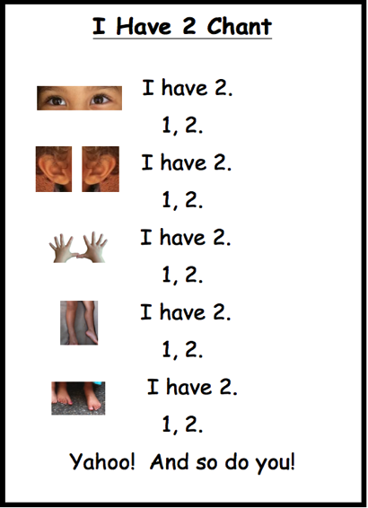  In this activity, students extend their understanding of matching to recognize that they have two parts of their body that are “the same but....” | Counting the Math Way  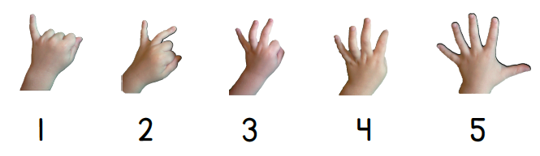  In the second half of Module 1, children learn to count from 1 to 5 the Math Way, starting with the left pinky finger and moving toward the thumb.  In counting the Math Way, students see the number of fingers increase as they count from 1 to 5, moving from left pinky to thumb without interruption. Counting in this way orients the count from left to right, in exactly the same way that the number line is usually drawn. Unfortunately, the traditional way of counting by starting with the index finger and ending with the thumb does not give a sense of direction consistent with written math conventions.  Counting the Math Way provides a foundation for understanding the number path and number line, which by convention, usually are drawn so that they increase from left to right. This builds number sense and prepares children for future work with addition and subtraction.  Children begin counting the Math Way using the piano template pictured above, dropping their fingers as they count. Throughout the year, students will learn to lift their fingers to count the Math Way.  In Module 3, students count from 6 to 10 the Math Way, beginning with the right thumb through to the right pinky. By the end of the year, Pre-K students count to 10 on their fingers, moving from the left pinky to the right pinky.

