Lesson 4

Objective: Represent equal groups with tape diagrams, and relate to repeated addition.

Suggested Lesson Structure

 Fluency Practice (12 minutes)

 Concept Development (32 minutes)

 Application Problem (6 minutes)

 Student Debrief (10 minutes)

**Total Time (60 minutes)**

Fluency Practice (12 minutes)

* Happy Counting by Fives **2.NBT.2** (3 minutes)
* Sprint: Adding Crossing Ten  **2.OA.2** (9 minutes)

Happy Counting by Fives (3 minutes)

Note: Students fluently skip-count by fives with an emphasis on crossing one hundred in anticipation of counting coins in Module 7 and telling time in Module 8.

T: Let’s count by fives, starting at 50. Ready? (Point up rhythmically until a change is desired. Close hand to indicate a stopping point. Point down to count in the opposite direction. Continue, periodically changing direction.)

|  |  |
| --- | --- |
|  | NOTES ON  MULTIPLE MEANS  OF ENGAGEMENT: |
| Invite a student to lead the class in Happy Counting, and participate with the students. Rotate this opportunity so students have the chance to lead and, therefore, to think more critically about the patterns involved in the counting. | |

S: 50, 55, 60, 65, 70 (switch) 65, 60 (switch) 65, 70, 75, 80, 85, 90 (switch) 85, 80, 75 (switch) 80, 85, 90, 95, 100 (switch) 95, 90, 85 (switch) 90, 95, 100, 105 (switch) 100, 95, 90 (switch) 95, 100, 105 (switch) 100, 95, 90, 85, 80, 75, 70.

T: Excellent! Try it for 30 seconds with your partner, starting at 50. Partner B, you are the teacher today.

Sprint: Adding Crossing Ten (9 minutes)

Materials: (S) Adding Crossing Ten Sprint

Note: Students add numbers within 20 to help gain mastery of the grade-level fluency standard.

Concept Development (32 minutes)

Materials: (S) Personal white board, counters

T: Let’s read this word problem together.

T: (Project or write the problem on the board.) There are 2 apples in Jane’s bag, 3 apples in Sam’s bag, and 1 apple in Juan’s bag. How many apples do the children have in all?

T: Use part–whole language to tell me how to solve.

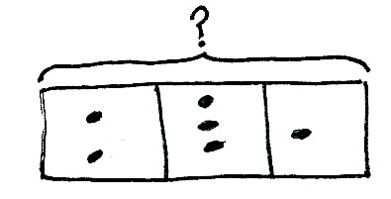S: We know the parts, so we add them together. 🡪 We add the parts, 2 + 3 + 1, to get the whole, which is 6.

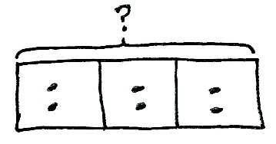T: Draw a tape diagram on your personal white board, and use your counters to model the problem. (Model on the board, drawing dots, as students do the same using counters.)

T: Now, talk with your partner. How would this model be different if there were equal groups of 2 apples in each bag? Show the change on your model.

S: You would put 2 counters in each box. 🡪 There are still 3 groups, but they are all equal. 🡪 Now, we have 3 groups of 2.

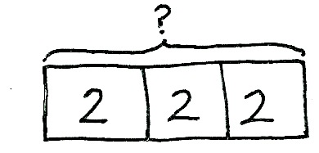T: You’ve noticed that the boxes represent the groups and that the counters inside are the number, or amount, in each group.

**MP.4**

T: Now, let’s change our model to show numbers instead of counters. What number should we write in each box?

S: 2.

T: Of course! Remove your counters, and write 2 in each box.

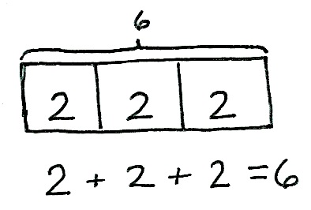T: What do we do when we know the parts?

S: We add to find the whole!

T: It’s easy to see the repeated addition, isn’t it? Write the repeated addition equation to find the total for this tape diagram. Read the equation.

S: 2 + 2 + 2 = 6.

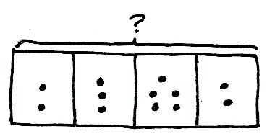T: So, we are adding twos! Just like we have added units of 1 or 10, we can also add units of two.

T: Let’s try another one! Draw a tape diagram that has 4 parts. (Model as students do the same.)

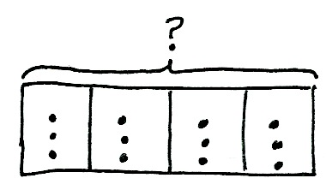T: Use your counters to show 2 in the first group, 3 in the next group, 5 in the next group, and 2 in the last group. (Model on the board.)

T: Are all of the groups equal?

S: No!

T: Move your counters to show equal groups of 3 in each part. (Model with dots as students rearrange their counters.)

T: Say it with me: We have 4 equal groups of 3. (Students repeat.)

T: Remove your counters and write the number in each group. What number will you write?

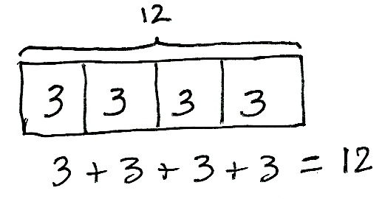S: 3.

T: Yes! Write the repeated addition equation that relates to this model, and then solve.

T: Read the equation.

S: 3 + 3 + 3 + 3 = 12.

T: Tell your partner how you added to find the answer.

S: 3 + 3 is 6. 6 + 3 is 9. 9 + 3 is 12. 🡪 I used doubles,   
so 3 + 3 = 6 and 3 + 3 = 6. Then, 6 + 6 = 12.

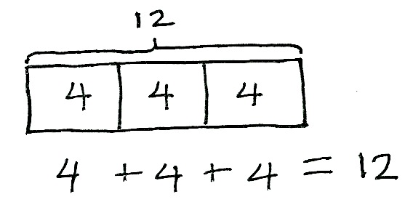T: So, 4 groups of 3 is…?

S: 12.

T: Talk with your partner: How would the tape diagram change if there were 3 groups of 4? Draw a tape diagram that shows 3 groups of 4 to explain your thinking.

Circulate to check for understanding, and call on students to share.

S: There are only 3 boxes, because there are 3 groups.   
🡪 We can write 4 in each box. 🡪 The repeated addition is 4 + 4 + 4. Before, it was 3 + 3 + 3 + 3. But they both equal 12.

|  |  |
| --- | --- |
|  | NOTES ON  MULTIPLE MEANS  OF REPRESENTATION: |
| Some students may benefit from writing the numerals within the groups and placing the counters on top of the written numeral. Then, have them remove the counters so they see only the abstract number. | |

T: Excellent reasoning! Let’s do one more before you work on the Application Problem. Draw a tape diagram that shows 4 groups of 5.

T: Explain to your partner which part of the tape diagram stands for the number of groups and which part represents the number in each group.

S: The 4 boxes are the 4 groups. 🡪 The number 5 is how many are in each group.

T: What repeated addition equation matches your diagram?

S: 5 + 5 + 5 + 5 = 20.

T: So, you added 4 groups of five, or 4 fives. What new unit did you repeatedly add?

S: 5.

Allow students who show comprehension to move on to the Problem Set. Continue working with students who struggle, using concrete objects such as counters or linking cubes to model the problem and draw the tape diagram.

Problem Set (10 minutes)

Students should do their personal best to complete the Problem Set within the allotted 10 minutes. For some classes, it may be appropriate to modify the assignment by specifying which problems they work on first. Some problems do not specify a method for solving. Students should solve these problems using the RDW approach used for Application Problems.

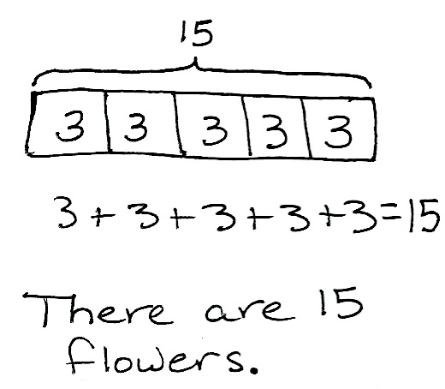Application Problem (6 minutes)

The flowers are blooming in Maria’s garden. There are 3 roses, 3 buttercups, 3 sunflowers, 3 daisies, and 3 tulips. How many flowers are there in all?

1. Draw a tape diagram to match the problem.
2. Write a repeated addition equation to solve.

Note: This problem is intended for independent practice. Students may write numbers or draw dots to represent the number of flowers in each group.

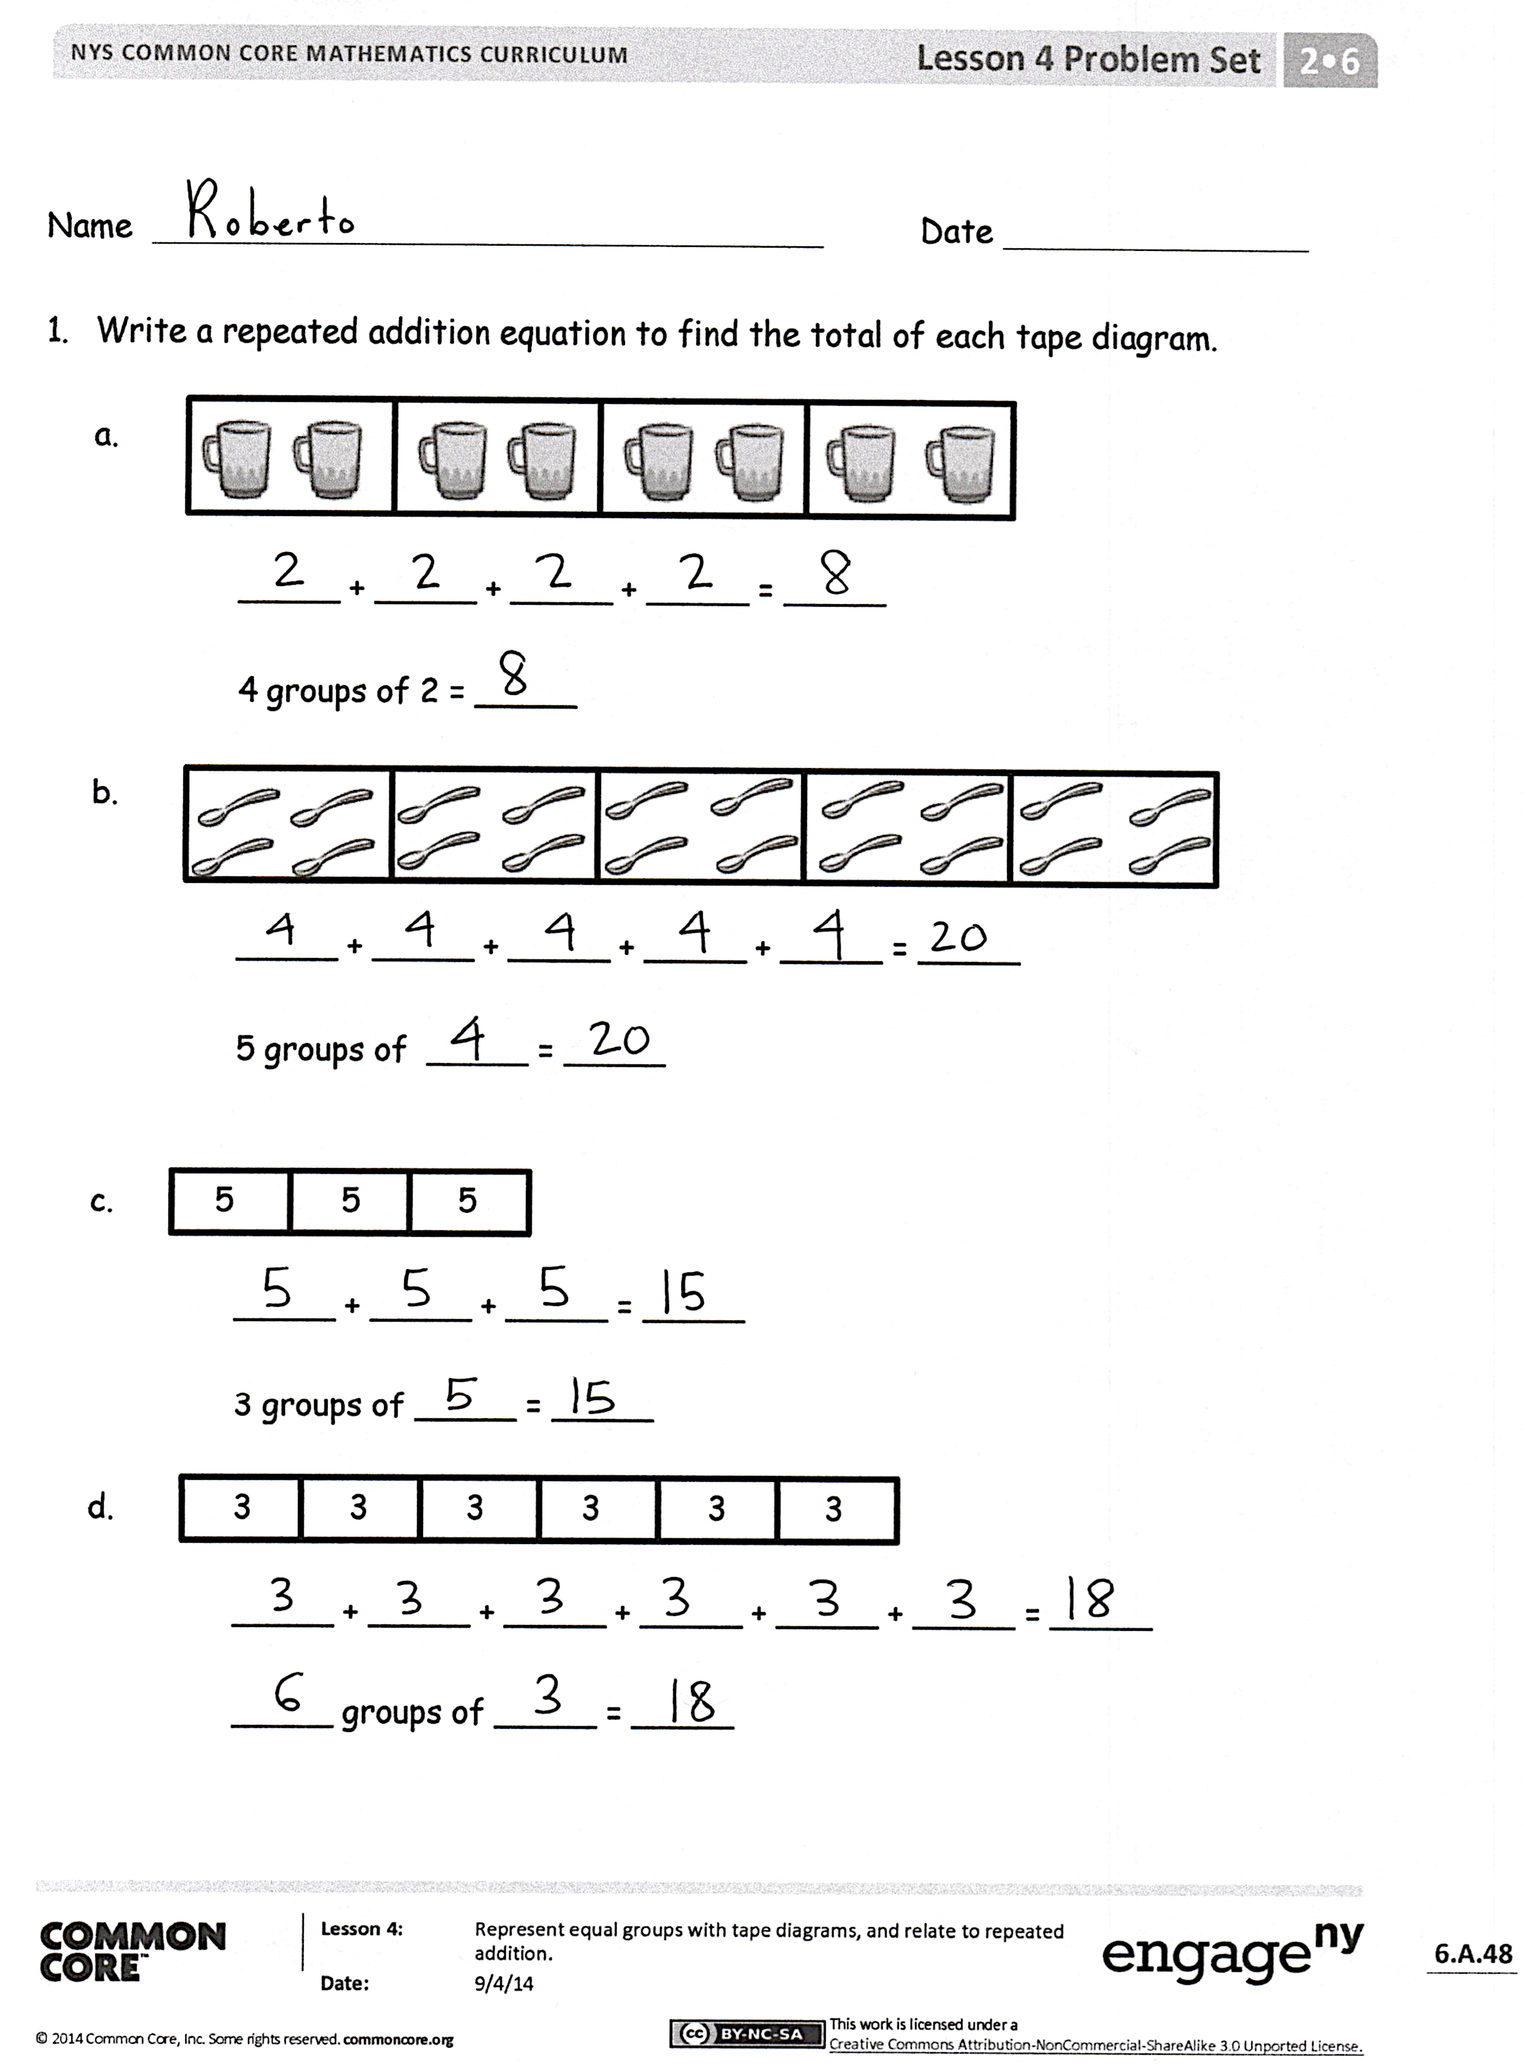Student Debrief (10 minutes)

**Lesson Objective:** Represent equal groups with tape diagrams, and relate to repeated addition.

The Student Debrief is intended to invite reflection and active processing of the total lesson experience.

Invite students to review their solutions for the Problem Set. They should check work by comparing answers with a partner before going over answers as a class. Look for misconceptions or misunderstandings that can be addressed in the Debrief. Guide students in a conversation to debrief the Problem Set and process the lesson.

Any combination of the questions below may be used to lead the discussion.

* For Problem 1(b), what does the number 4 represent? Why are there 5 addends? What addition strategy did you use to find the total?
* For Problem 1(c), what does the 5 represent in the tape diagram? What strategy did you use to find the total?
* 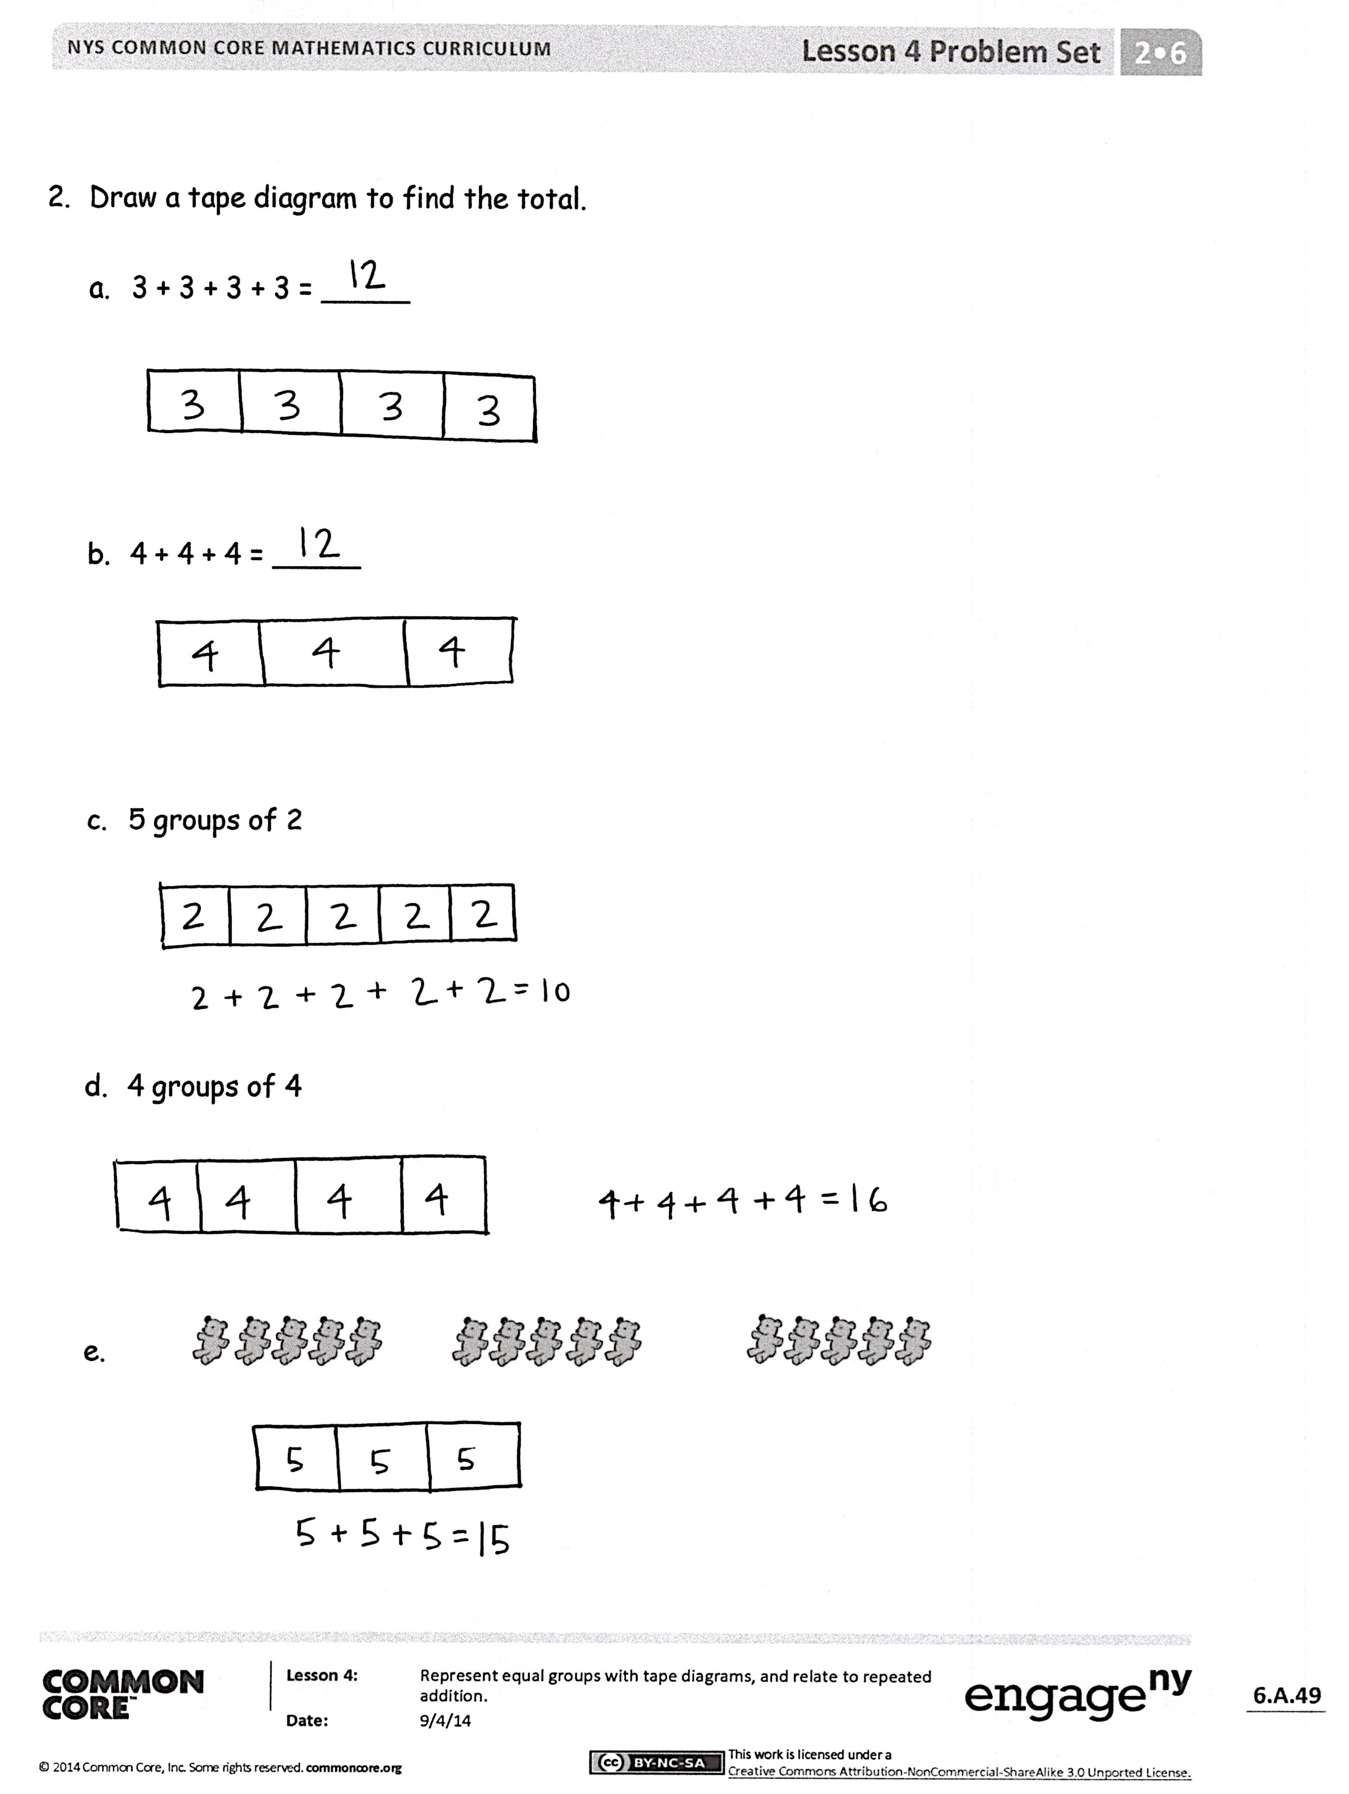For Problem 1(d), how many groups are there in the tape diagram? How many are in each group? What addition strategies could you use to find the total?
* For Problems 2(a) and (b), share your tape diagrams with a partner. What do you notice about these two problems? How are they the same and different?
* For Problems 2 (c), (d), and (e), share your tape diagrams with a partner. What steps did you take when drawing your tape diagrams? How did you show the number of groups? How did you show the number in each group?

Exit Ticket (3 minutes)

After the Student Debrief, instruct students to complete the Exit Ticket. A review of their work will help with assessing students’ understanding of the concepts that were presented in today’s lesson and planning more effectively for future lessons. The questions may be read aloud to the students.

Number Correct: _______

**A**

Adding Crossing Ten

|  |  |  |  |  |  |  |
| --- | --- | --- | --- | --- | --- | --- |
|  | 9 + 1 = |  |  |  | 7 + 3 = |  |
|  | 9 + 2 = |  |  |  | 7 + 4 = |  |
|  | 9 + 3 = |  |  |  | 7 + 5 = |  |
|  | 9 + 9 = |  |  |  | 7 + 9 = |  |
|  | 8 + 2 = |  |  |  | 6 + 4 = |  |
|  | 8 + 3 = |  |  |  | 6 + 5 = |  |
|  | 8 + 4 = |  |  |  | 6 + 6 = |  |
|  | 8 + 9 = |  |  |  | 6 + 9 = |  |
|  | 9 + 1 = |  |  |  | 5 + 5 = |  |
|  | 9 + 4 = |  |  |  | 5 + 6 = |  |
|  | 9 + 5 = |  |  |  | 5 + 7 = |  |
|  | 9 + 8 = |  |  |  | 5 + 9 = |  |
|  | 8 + 2 = |  |  |  | 4 + 6 = |  |
|  | 8 + 5 = |  |  |  | 4 + 7 = |  |
|  | 8 + 6 = |  |  |  | 4 + 9 = |  |
|  | 8 + 8 = |  |  |  | 3 + 7 = |  |
|  | 9 + 1 = |  |  |  | 3 + 9 = |  |
|  | 9 + 7 = |  |  |  | 5 + 8 = |  |
|  | 8 + 2 = |  |  |  | 2 + 8 = |  |
|  | 8 + 7 = |  |  |  | 4 + 8 = |  |
|  | 9 + 1 = |  |  |  | 1 + 9 = |  |
|  | 9 + 6 = |  |  |  | 2 + 9 = |  |

Number Correct: _______

Improvement: _______

**B**

**[KEY]**

Adding Crossing Ten

|  |  |  |  |  |  |  |
| --- | --- | --- | --- | --- | --- | --- |
|  | 8 + 2 = |  |  |  | 7 + 3 = |  |
|  | 8 + 3 = |  |  |  | 7 + 4 = |  |
|  | 8 + 4 = |  |  |  | 7 + 5 = |  |
|  | 8 + 8 = |  |  |  | 7 + 8 = |  |
|  | 9 + 1 = |  |  |  | 6 + 4 = |  |
|  | 9 + 2 = |  |  |  | 6 + 5 = |  |
|  | 9 + 3 = |  |  |  | 6 + 6 = |  |
|  | 9 + 8 = |  |  |  | 6 + 8 = |  |
|  | 8 + 2 = |  |  |  | 5 + 5 = |  |
|  | 8 + 5 = |  |  |  | 5 + 6 = |  |
|  | 8 + 6 = |  |  |  | 5 + 7 = |  |
|  | 8 + 9 = |  |  |  | 5 + 8 = |  |
|  | 9 + 1 = |  |  |  | 4 + 6 = |  |
|  | 9 + 4 = |  |  |  | 4 + 7 = |  |
|  | 9 + 5 = |  |  |  | 4 + 8 = |  |
|  | 9 + 9 = |  |  |  | 3 + 7 = |  |
|  | 9 + 1 = |  |  |  | 3 + 9 = |  |
|  | 9 + 7 = |  |  |  | 5 + 9 = |  |
|  | 8 + 2 = |  |  |  | 2 + 8 = |  |
|  | 8 + 7 = |  |  |  | 4 + 9 = |  |
|  | 9 + 1 = |  |  |  | 1 + 9 = |  |
|  | 9 + 6 = |  |  |  | 2 + 9 = |  |

Name Date

1. Write a repeated addition equation to find the total of each tape diagram.





_____ + _____ + _____ + _____ = _____

4 groups of 2 = _____



1. 



_____ + _____ + _____ + _____ + _____ = _____

5 groups of _____ = _____

1. 5 5 5

_____ + _____ + _____ = _____

3 groups of _____ = _____

1. 3 3 3 3 3 3

_____ + _____ + _____ + _____ + _____ + _____ = _____

_____ groups of _____ = _____

1. Draw a tape diagram to find the total.
   1. 3 + 3 + 3 + 3 = _____
   2. 4 + 4 + 4 = _____
   3. 5 groups of 2
   4. 4 groups of 4



e.

Name Date

Draw a tape diagram to find the total.

2. 3 groups of 3
3. 2 + 2 + 2 + 2 + 2

Name Date

1. Write a repeated addition equation to find the total of each tape diagram.



1. 

_____ + _____ + _____ + _____ = _____

4 groups of 3 = _____



1. 



_____ + _____ + _____ + _____ + _____ = _____

5 groups of _____ = _____

1. 4 4 4 4

_____ + _____ + _____ + _____= _____

4 groups of _____ = _____

1. 2 2 2 2 2 2

_____ + _____ + _____ + _____ + _____ + _____ = _____

_____ groups of _____ = _____

1. Draw a tape diagram to find the total.
   1. 5 + 5 + 5 + 5 = _____
   2. 4 + 4 + 4 + 4 + 4 = _____
   3. 4 groups of 2
   4. 5 groups of 3

e.