Topic B
Problem Solving with Coins and Bills
2.NBT.5, 2.MD.8, 2.NBT.2, 2.NBT.6
Focus Standard: | 2.NBT.5 | Fluently add and subtract within 100 using strategies based on place value, properties of operations, and/or the relationship between addition and subtraction.
 | 2.MD.8 | Solve word problems involving dollar bills, quarters, dimes, nickels, and pennies, using $ and ¢ symbols appropriately. Example: If you have 2 dimes and 3 pennies, how many cents do you have?
Instructional Days: | 8
Coherence -Links from: | G1–M6 | Place Value, Comparison, Addition and Subtraction to 100
-Links to: | G3–M1 | Properties of Multiplication and Division and Solving Problems with Units of 2–5 and 10
 | G3–M2 | Place Value and Problem Solving with Units of Measure
In Topic B, students solve problems involving coins and bills. They begin at the concrete level in Lesson 6, using play money to review the different coin values from Grade 1. Beginning with the largest coin value (often the quarter), students count the total value of a group of coins, applying their knowledge of addition strategies (2.NBT.5) and skip-counting by fives and tens when there are multiple nickels or dimes.
Lesson 7 builds upon this foundation as students find the total value of a group of coins in the context of simple addition and subtraction word problem types with the result unknown (2.MD.8). For example, “Carla has 2 dimes, 1 quarter, 1 nickel, and 3 pennies. How many cents does she have?” Likewise, “Carla has 53¢ and gives a dime to her friend. How many cents does she have left?” To solve the add to or take from with result unknown word problem types, students might use the RDW process to draw, write the corresponding number sentence, and write a statement with the solution, just as they have been doing throughout the year with word problems in varied contexts.
Similarly, in Lesson 8, students apply their understanding of place value strategies and skip-counting to find the total value of a group of bills within $100, again in the context of addition and subtraction word problems. As in Lesson 6, students arrange bills from greatest to least, count on to find the total, and write a number sentence to represent the total value of the bills, sometimes adding up to four two-digit numbers. They solve problems, such as “Raja has $85 in his pocket. Two $5 bills fall out. How many dollars are in his pocket now?” or “If Raja has 6 one-dollar bills, 4 ten-dollar bills, and 3 five-dollar bills, how many dollars does he have?” Students may write number sentences in any number of ways. One student might skip-count mentally and make a ten, thinking 4 tens make 40 and 3 fives make 15 and then write 40 + 15 + 6 = 40 + 20 + 1 = 61. Another might correctly write 10 + 10 + 10 +10 + 5 + 5 + 5 + 6 = 40 + 15 + 6 = 55 + 6 = 61. Students are encouraged to think flexibly and apply learned solution strategies.
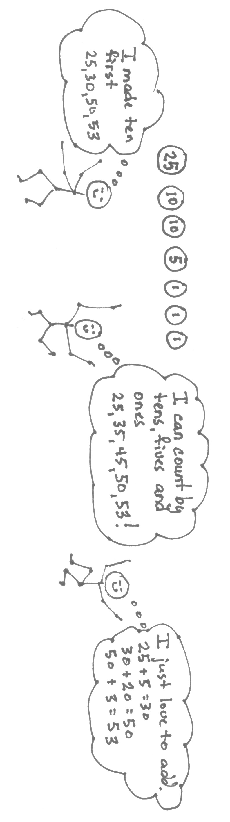
In Lessons 9 and 10, different combinations of coins are manipulated to make the same total value, for example, “Estella has 75¢ to buy a yo-yo. How many different ways could she pay for it?” Seventy-five cents might be recorded with 3 quarters or shown with 2 quarters, 2 dimes, and 5 pennies. Students work cooperatively to explain their reasoning and solution strategies. In Lesson 10, multiple ways are found to represent the same quantity, with the added complexity of using the fewest number of coins (e.g., 67¢ equals 2 quarters, 1 dime, 1 nickel, and 2 pennies). Students see that just as they changed 10 ones for 1 ten in Modules 4 and 5, they can also change coins of a lesser value for coins of a greater value (e.g., 2 nickels = 1 dime).
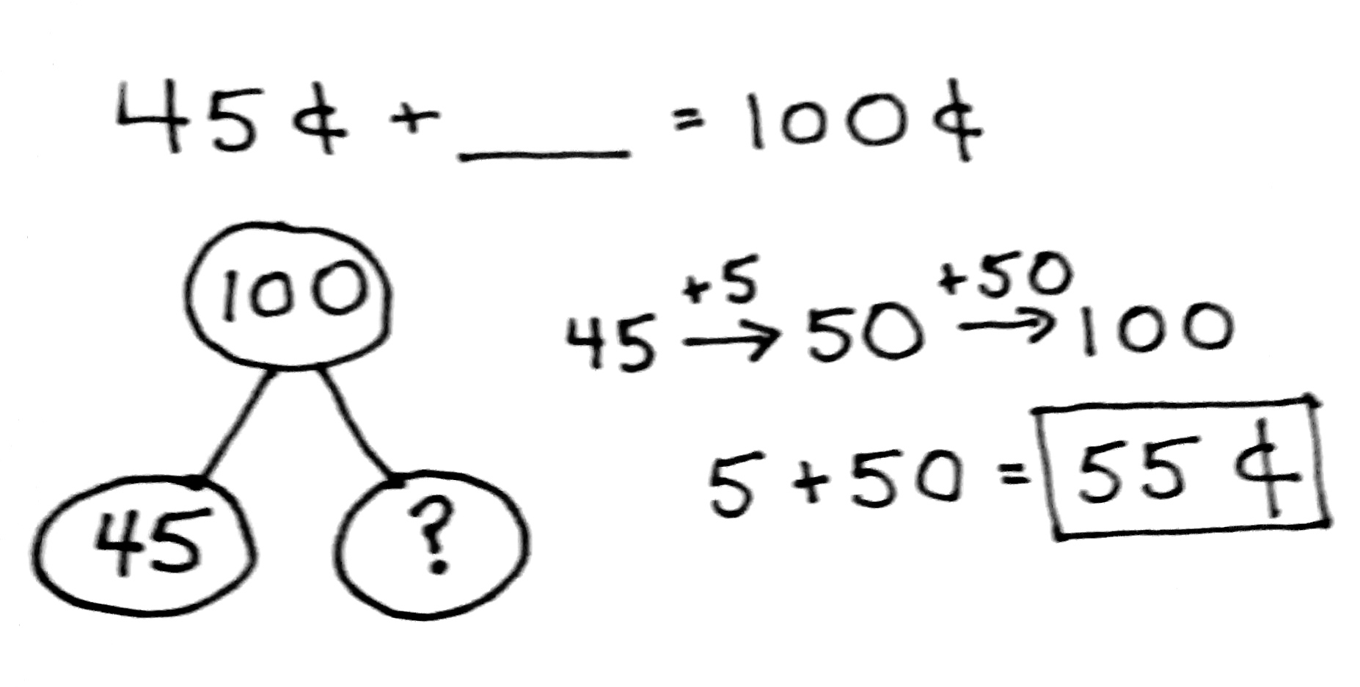
Students focus on making change from one dollar in Lessons 11 and 12, using the understanding that $1 has the same value as 100 pennies. In Lesson 11, students learn how to make change from one dollar using counting on, simplifying strategies (e.g., the arrow way), and the relationship between addition and subtraction. They represent the part–whole relationship using a number bond and by writing a number sentence, often using the related addition to solve (e.g., $1 – 45¢ = ____ or 45¢ + ____ = 100¢), as pictured at the right.
In Lesson 12, students solve one- and two- step word problems involving money. They use the RDW process, first reading the problem and then drawing a picture or model. With a partner, they discuss how their model matches the story. Next, students apply a strategy to solve, and then they share their solution strategy with a partner.
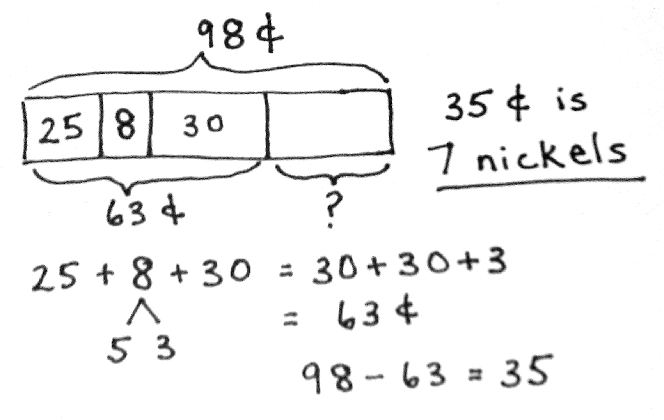
In the final lesson of Topic B, students solve two-step addition and subtraction word problems with abstract drawings and equations with the unknown in various positions. For example, “Devon found 98¢ in her piggy bank. She counted 1 quarter, 8 pennies, 3 dimes, and some nickels. How many nickels did she find?” After making a tape diagram, one student’s first step might involve adding the given coins from greatest to least and skip-counting, while another might bond the quarter with
5 pennies to make the next ten before counting on, as pictured on the right. Students synthesize their understanding of place value, making a ten, and skip-counting strategies to solve a variety of problem types embedded within the two-step problems.
A Teaching Sequence Toward Mastery of Problem Solving with Coins and Bills
Objective 1: Recognize the value of coins and count up to find their total value.
(Lesson 6)
Objective 2: Solve word problems involving the total value of a group of coins.
(Lesson 7)
Objective 3: Solve word problems involving the total value of a group of bills.
(Lesson 8)
Objective 4: Solve word problems involving different combinations of coins with the same total value.
(Lesson 9)
Objective 5: Use the fewest number of coins to make a given value.
(Lesson 10)
Objective 6: Use different strategies to make $1 or make change from $1.
(Lesson 11)
Objective 7: Solve word problems involving different ways to make change from $1.
(Lesson 12)
Objective 8: Solve two-step word problems involving dollars or cents with totals within $100 or $1. (Lesson 13)

