Topic C
Rectangular Arrays as a Foundation for Multiplication and Division
2.OA.4, 2.G.2
Focus Standards: | 2.OA.4 | Use addition to find the total number of objects arranged in rectangular arrays with up to 5 rows and up to 5 columns; write an equation to express the total as a sum of equal addends.
 | 2.G.2 | Partition a rectangle into rows and columns of same-size squares and count to find the total number of them.
Instructional Days: | 7
Coherence -Links from: | G1–M2 | Introduction to Place Value Through Addition and Subtraction Within 20
-Links to: | G2–M8 | Time, Shapes, and Fractions as Equal Parts of Shapes
 | G3–M4 | Multiplication and Area
Topic C naturally follows Topic B, where students composed and manipulated the rows and columns of an array. Topic C is designed to deepen students’ understanding of spatial structuring as they build and partition rectangles with rows and columns of same-size squares.
In Lessons 10 and 11, students compose a rectangle by making tile arrays with no gaps or overlaps. They use their prior knowledge of making equal groups and the spatial relationship between rows and columns to construct rectangular arrays. In Lesson 10, given a number of tiles (up to 25), students are asked to create rectangular arrays that show equal rows or columns (up to 5 by 5). In Lesson 11, students build upon this understanding, manipulating a set of 12 square tiles to compose various rectangles (e.g., 1 column of 12, 2 rows of 6, or 3 rows of 4). As students share their rectangles, they are encouraged to ask themselves, “How can I construct this differently?” They use repeated addition to find the total number of squares, alternating flexibly between the number in each row and the number in each column as the unit.
Lesson 12 introduces the added complexity of composing a rectangle by using math drawings. Once students have arranged square tiles into a specified rectangular array without gaps or overlaps, they trace to construct the same rectangle by iterating the square unit, much as they iterated a length unit in Module 2 to create a centimeter ruler. Next, students use the spatial reasoning developed up to this point in the module to draw the same rectangle without tracing, using their understanding of equal columns and equal rows.

After students compose rectangles, they decompose, or partition, them using tiles in Lesson 13. For example, when working with an array of 5 rows of 3 (and a total of 15), they see that if they remove a row of 3, they have 4 rows of 3 (and a total of 12). Alternately, they see that instead of 3 columns of 5, they have 3 columns of 4.
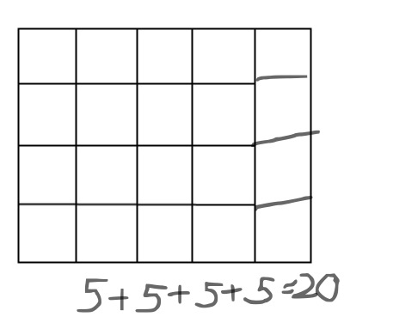
In Lesson 14, students are encouraged to think flexibly as they use paper models to further develop their ability to visualize arrays. Given three 2 by 4 rectangles, students cut the first rectangle into 2 rows of 4 squares and the second rectangle into 4 columns of 2 squares. They use these models to answer questions and to analyze similarities and differences. Next, they cut each row or column into individual square units.
As a result, they see that just as a rectangle is composed of equal rows or columns, each row or column is composed of squares, or iterated units. Students now have 16 same-size squares and can create different rectangular arrays with them (e.g., 1 by 16, 2 by 8, and 4 by 4). Finally, students cut out the squares from the third rectangle and create rectangular arrays using 24 square units.
Lesson 15 moves toward more abstract reasoning as students use math drawings to partition rectangles. With colored pencils and grid paper, students shade in rows or columns and relate them to the repeated addition equation (e.g., 5 rows of 3 squares = 3 + 3 + 3 + 3 + 3, or 5 threes). Then, given a rectangle with one row or one column missing, students draw in the remaining squares to complete the array (shown to the right) and find the total by relating their completed array to repeated addition.
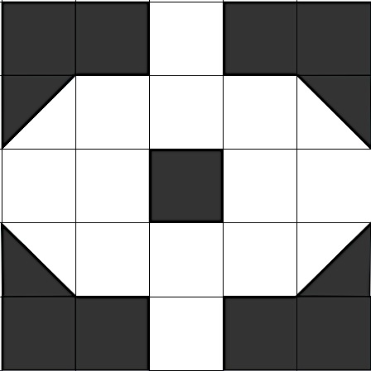
In Lesson 16, students practice spatial structuring skills by working with grids and diagrams. They copy designs using same-size squares and triangles (half of the squares) as manipulatives. Students create their copies on paper with grid squares of the same size as the manipulative square (shown to the right). To successfully create these, students must pay careful attention to which grid square to color and how many spaces to leave. Finally, students use grid paper to design a tessellation using a core square composed of a 3 by 3 array of same-size squares. They create designs by coloring the 9 squares and then iterating that core unit. This provides students with the opportunity to sharpen their spatial structuring skills because they must count rows and columns to successfully create a quilt of their designs.
A Teaching Sequence Toward Mastery of Rectangular Arrays as a Foundation for Multiplication and Division
Objective 1: Use square tiles to compose a rectangle, and relate to the array model.
(Lessons 10–11)
Objective 2: Use math drawings to compose a rectangle with square tiles.
(Lesson 12)
Objective 3: Use square tiles to decompose a rectangle.
(Lesson 13)
Objective 4: Use scissors to partition a rectangle into same-size squares, and compose arrays with the squares.
(Lesson 14)
Objective 5: Use math drawings to partition a rectangle with square tiles, and relate to repeated addition.
(Lesson 15)
Objective 6: Use grid paper to create designs to develop spatial structuring.
(Lesson 16)

