Topic A

Formation of Equal Groups
2.OA.4, 2.NBT.2, 2.NBT.6
Focus Standard: | 2.OA.4 | Use addition to find the total number of objects arranged in rectangular arrays with up to 5 rows and up to 5 columns; write an equation to express the total as a sum of equal addends.
Instructional Days: | 4
Coherence -Links from: | G2–M3 | Place Value, Counting, and Comparison of Numbers to 1,000
-Links to: | G3–M1 | Properties of Multiplication and Division and Solving Problems with Units of 2–5 and 10
Topic A begins at the concrete level as students use objects to create equal groups, providing a foundation for the construction of arrays in Topic B. In Lesson 1, for example, students are given 12 counters, such as teddy bears, pebbles, or beans, and they are asked to put them into groups of 3, thereby creating 4 equal groups of 3 objects.
Students then see that they can manipulate the same number of counters to make 3 equal groups of 4 objects. Finally, they are presented with unequal groups and challenged to make them equal.
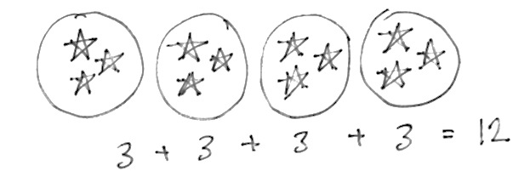
Lessons 2 and 3 move to the pictorial level, introducing math drawings to represent equal groups. In Lesson 2, students are asked to show groups: “Show me 3 stars, now 3 more. Add 3 more, now 3 more than that.” They then determine the total number of stars and write the corresponding repeated addition number sentence as shown at right (2.OA.4).
Lesson 3 extends this understanding as students look for and practice a more efficient way to add by bundling. They calculate repeated addition sums by grouping the addends into pairs and then adding.
For example, for 4 groups of 3, the student might say, “I bundled 2 pairs of three to make sixes, so 6 + 6 = 12.”
If there is an odd number of addends (e.g., 5 groups of 3), students group them into pairs and then add on the remaining quantity, such that (3 + 3) + (3 + 3) = 6 + 6 = 12, and then, 12 + 3 = 15. As students work with equal groups, they begin to see that they are adding units of 3.
This concept transitions into Lesson 4, where students understand that numbers other than 1, 10, and 100 can serve as units. At a more abstract level than Lesson 3, students represent the total of a given number of units with tape diagrams or using repeated addition (e.g., 2 + 2 + 2 + 2 = 8). This concept serves as a bridge to Topic B, wherein either a row or column of an array can be seen as the unit being counted—the foundation for building rectangular arrays (2.OA.4).
A Teaching Sequence Toward Mastery of Formation of Equal Groups
Objective 1: Use manipulatives to create equal groups.
(Lesson 1)
Objective 2: Use math drawings to represent equal groups, and relate to repeated addition.
(Lessons 2–3)
Objective 3: Represent equal groups with tape diagrams, and relate to repeated addition.
(Lesson 4)

