Topic B
Strategies for Composing Tens and Hundreds Within 1,000
2.NBT.7, 2.NBT.9
Focus Standard: | 2.NBT.7 | Add and subtract within 1000, using concrete models or drawings and strategies based on place value, properties of operations, and/or the relationship between addition and subtraction; relate the strategy to a written method. Understand that in adding or subtracting three-digit numbers, one adds or subtracts hundreds and hundreds, tens and tens, ones and ones; and sometimes it is necessary to compose or decompose tens or hundreds.
 | 2.NBT.9 | Explain why addition and subtraction strategies work, using place value and the properties of operations. (Explanations may be supported by drawings or objects.)
Instructional Days: | 5
Coherence -Links from: | G1–M6 | Place Value, Comparison, Addition and Subtraction to 100
-Links to: | G3–M2 | Place Value and Problem Solving with Units of Measure
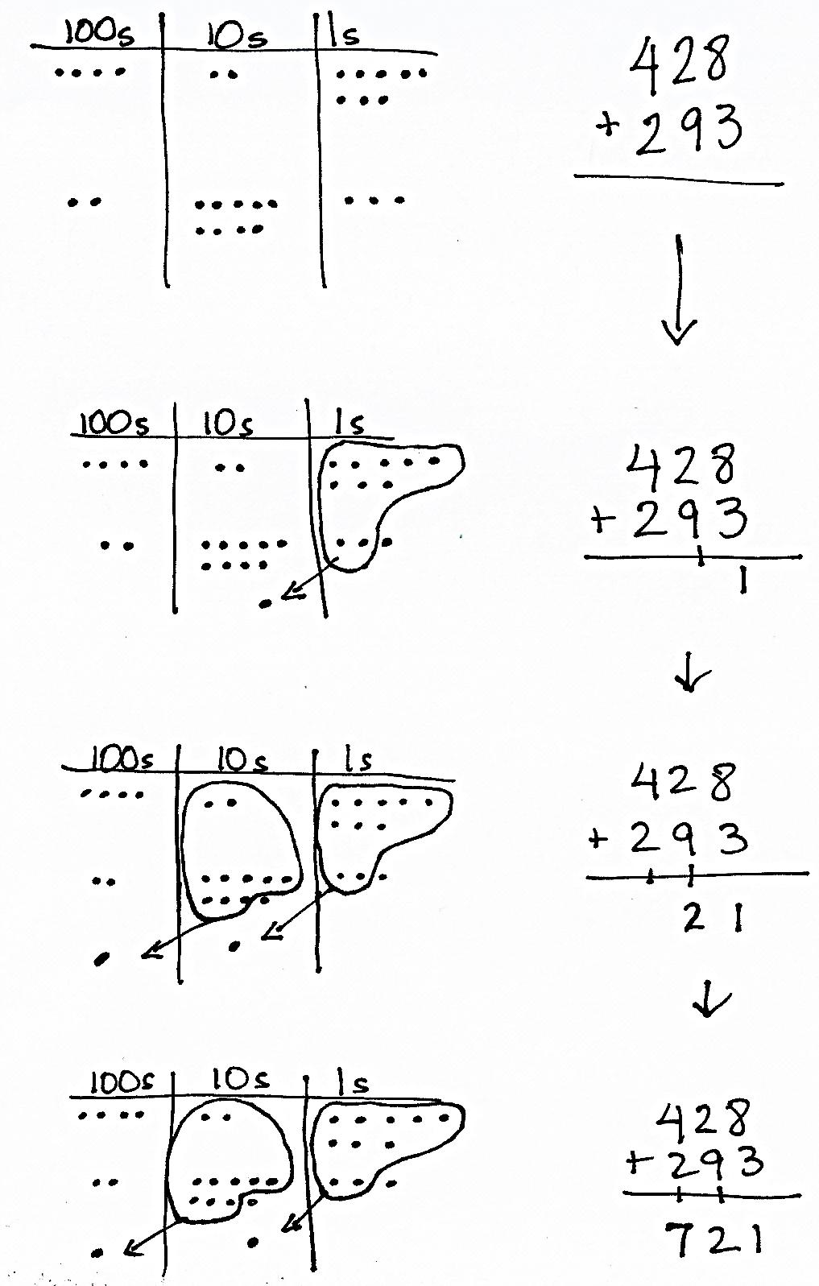
Module 5, Topic B extends the work of Module 4, Topic B. In Module 4, students composed tens while adding and subtracting within 200. Module 5 expands upon this work as students compose tens and hundreds within 1,000. The work of Topic A transitions naturally into Topic B; students employ concrete and pictorial representations of the vertical algorithm when they encounter addition problems for which there is no clear simplifying strategy.
In Lessons 8 and 9, students continue to build their conceptual understanding as they relate manipulatives to the algorithm, recording compositions as new groups below in vertical form as they did in Module 4. As they move the manipulatives, students use place value language to express the action and physically exchange 10 ones for 1 ten and 10 tens for 1 hundred, if necessary. They record each change in the vertical form, step-by-step.
In Lessons 10 and 11, students move from concrete to pictorial representations as they draw chip models to represent addition within 1,000. As they did with the manipulatives, students record each action in their drawings step-by-step on the vertical form (pictured to the right).
In Lesson 12, students are presented with a variety of problems for which they must choose an appropriate strategy to solve. Students are encouraged to be flexible in their thinking and defend their reasoning using place value language. They may choose to represent and solve problems using number bonds, the arrow way, place value disks, or chip models.
A Teaching Sequence Toward Mastery of Strategies for Composing Tens and Hundreds Within 1,000
Objective 1: Relate manipulative representations to the addition algorithm.
(Lessons 8–9)
Objective 2: Use math drawings to represent additions with up to two compositions and relate drawings to the addition algorithm.
(Lessons 10–11)
Objective 3: Choose and explain solution strategies and record with a written addition method.
(Lesson 12)

