Topic A
Strategies for Adding and Subtracting Within 1,000
2.NBT.7, 2.NBT.8, 2.NBT.9
Focus Standards: | 2.NBT.7 | Add and subtract within 1000, using concrete models or drawings and strategies based on place value, properties of operations, and/or the relationship between addition and subtraction; relate the strategy to a written method. Understand that in adding or subtracting three-digit numbers, one adds or subtracts hundreds and hundreds, tens and tens, ones and ones; and sometimes it is necessary to compose or decompose tens or hundreds.
 | 2.NBT.8 | Mentally add 10 or 100 to a given number 100–900, and mentally subtract 10 or 100 from a given number 100–900.
 | 2.NBT.9 | Explain why addition and subtraction strategies work, using place value and the properties of operations. (Explanations may be supported by drawings or objects.)
Instructional Days: | 7
Coherence -Links from: | G1–M6 | Place Value, Comparison, Addition and Subtraction to 100
-Links to: | G3–M2 | Place Value and Problem Solving with Units of Measure
In Topic A, students practice the simplifying strategies they learned in Module 4, but with numbers up to 1,000. They are asked to consider which strategy is most efficient for each problem they encounter.
In Lesson 1, students relate 100 more, 100 less, 10 more, and 10 less to addition and subtraction. They recognize that they must still add and subtract like units, and that the digit in the hundreds place changes when adding and subtracting 100, just as the digit in the tens place changes when adding or subtracting 10. Students see numbers in terms of place value units: 290 – 100 is 2 hundreds 9 tens minus 1 hundred. They learn to record the addition and subtraction of multiples of 100 using arrow notation (i.e., the arrow way).
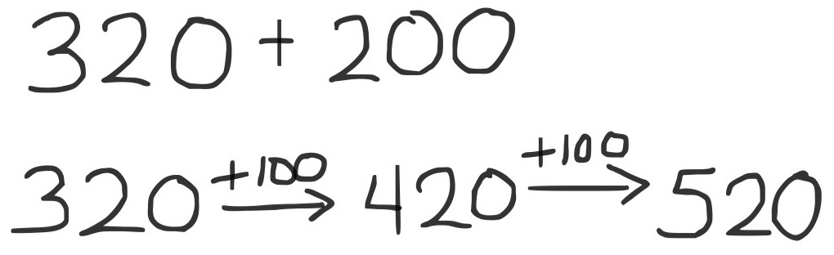
In Lesson 2, students add and subtract multiples of 100 by counting on by hundreds. For example, when adding 200 to 320, they may count up from 320: 420, 520. Students also develop flexibility in terms of using related addition problems. For example, to solve 519 – 200, one student might think, “5 hundreds minus 2 hundreds is 3 hundreds, plus 19 is 319,” while another starts at 200, adds on 19, and then 3 hundreds to reach 519, so 319.

In Lessons 3 and 4, students continue to add and subtract multiples of 100 with the added complexity of some tens. Problems are chosen so that, at first, the tens digit is close to a multiple of 100 (e.g., 190, 290, 380) to make it easier to form the next hundred by decomposing addends. This prompts students to analyze and use relationships between numbers to develop a variety of simplifying strategies.
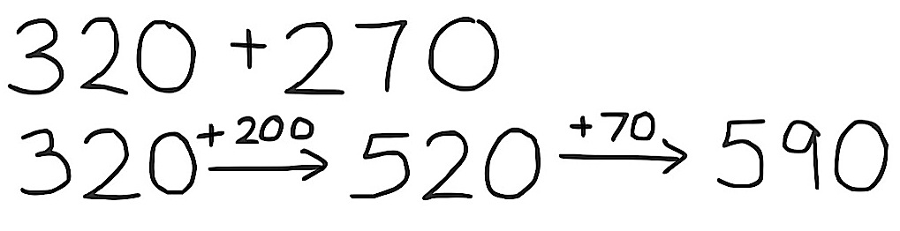
Students also use arrow notation to record their mental math. First, they add a multiple of 100, and then they count on by multiples of 10 to find the total (as shown at the right). Lesson 3 focuses on addition, while Lesson 4 emphasizes related strategies for subtraction.
In Lesson 5, students apply the use of number bonds to decompose larger numbers, just as they did with numbers within 100. For example, when solving 320 + 290, they can break 320 into 10 and 310 to make
310 + 300 = 610 (as shown below), just as they would have decomposed to add 32 and 29 in Module 4. They realize the problem can be conceived as 32 tens + 29 tens. Note that arrow notation can also be used to solve 320 + 290 by first adding 200, then 80, and then 10, or by adding 300, and then subtracting 10. Students work with problems, such as 298 + 137, using a number bond to decompose 137 into 2 and 135, thus creating the equivalent but simpler equation 300 + 135 = 435.
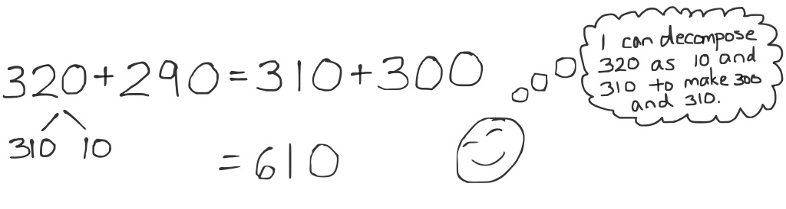

In Lesson 6, the ease of subtracting a multiple of 100 is highlighted again as students extend their work from Module 4 using compensation (i.e., the associative property) for subtraction. Students may add or subtract a multiple of 10 to make an equivalent problem that involves no renaming. For example, when subtracting
610 – 290, the same number, 10, can be added to both numbers to create a multiple of 100 (as shown below). Students also solve problems such as 451 – 195, adding 5 to both the minuend and subtrahend to make 456 – 200.
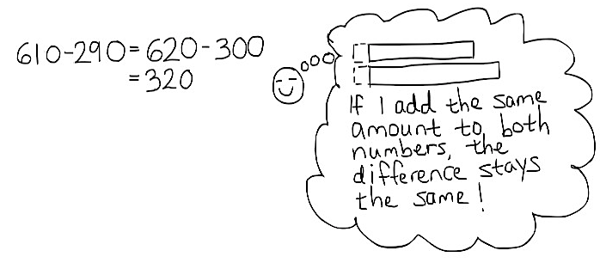

Topic A closes with Lesson 7, which provides students the opportunity to solidify their new skills. They confront a variety of problems, solve them, and then share their solution strategies. Through spirited discussion, students critique the work of their peers while deepening their understanding of various strategies.
The strategies taught in Topic A are designed to develop students’ conceptual understanding of addition and subtraction using models, drawings, properties of operations, and strategies based on place value. At the same time, students relate these strategies to written methods such as arrow notation and number bonds. This sets the stage for flexible thinking as students move into composing and decomposing units in Topics B and C.
A Teaching Sequence Toward Mastery of Strategies for Adding and Subtracting Within 1,000
Objective 1: Relate 10 more, 10 less, 100 more, and 100 less to addition and subtraction of 10 and 100.
(Lesson 1)
Objective 2: Add and subtract multiples of 100, including counting on to subtract.
(Lesson 2)
Objective 3: Add multiples of 100 and some tens within 1,000.
(Lesson 3)
Objective 4: Subtract multiples of 100 and some tens within 1,000.
(Lesson 4)
Objective 5: Use the associative property to make a hundred in one addend.
(Lesson 5)
Objective 6: Use the associative property to subtract from three-digit numbers and verify solutions with addition.
(Lesson 6)
Objective 7: Share and critique solution strategies for varied addition and subtraction problems within 1,000.
(Lesson 7)

