Topic F
Student Explanations of Written Methods
2.OA.1, 2.NBT.7, 2.NBT.9
Focus Standard: | 2.OA.1 | Use addition and subtraction within 100 to solve one- and two-step word problems involving situations of adding to, taking from, putting together, taking apart, and comparing, with unknowns in all positions, e.g., by using drawings and equations with a symbol for the unknown number to represent the problem.
 | 2.NBT.7 | Add and subtract within 1000, using concrete models or drawings and strategies based on place value, properties of operations, and/or the relationship between addition and subtraction; relate the strategy to a written method. Understand that in adding or subtracting three-digit numbers, one adds or subtracts hundreds and hundreds, tens and tens, ones and ones; and sometimes it is necessary to compose or decompose tens or hundreds.
 | 2.NBT.9 | Explain why addition and subtraction strategies work, using place value and the properties of operations. (Explanations may be supported by drawings or objects.)
Instructional Days: | 3
Coherence -Links from: | G1–M2 | Introduction to Place Value Through Addition and Subtraction Within 20
-Links to: | G3–M2 | Place Value and Problem Solving with Units of Measure
 | G4–M1 | Place Value, Rounding, and Algorithms for Addition and Subtraction
Module 4 culminates with Topic F, in which students think about and discuss the multiple strategies they have learned to represent and solve addition and subtraction problems. They share their reasoning as they link their drawings to two written methods and discuss the similarities, differences, and efficacy of each approach.
In Lesson 29, students learn the totals below written method. Throughout Grades 1 and 2, students decompose numbers into expanded form to recognize place value and to understand that they must add like units. These problems are written horizontally. Here, students use this prior learning to solve addition problems in a similar way. They decompose two- and three-digit numbers, then add like units and record the totals horizontally (see image on next page). They then transition into the vertical form of the method when they decompose the numbers mentally, add like units, and record the totals below. The totals below method gives students the option of adding from left to right or from right to left. Students explain how each step of their math drawings relates to this written method.
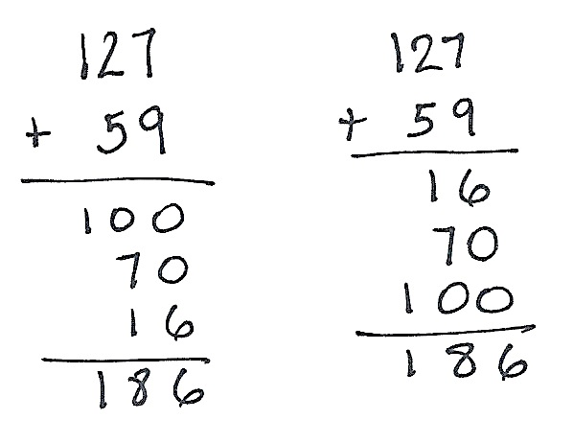
Totals Below
Horizontal Notation
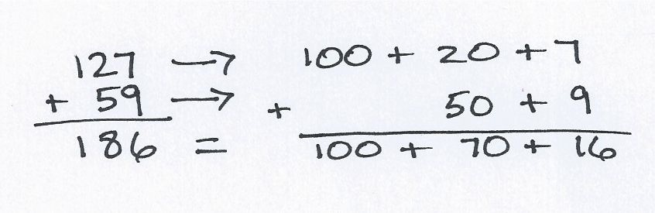

Left to Right Right to Left

In Lesson 30, students represent and solve problems using both the totals below and the new groups below methods (students used the latter method throughout the module). They relate both methods to their math drawings and discuss the differences and similarities between the two.
In Lesson 31, students apply knowledge of addition and subtraction strategies to solve two-step word problems. Students are challenged to make sense of more complex relationships as they are guided through more difficult problem types, such as comparison problems. These problems involve smaller numbers and are scaffolded to address the heightened level of difficulty.
A Teaching Sequence Towards Mastery of Student Explanations of Written Methods
Objective 1: Use and explain the totals below written method using words, math drawings, and numbers.
(Lesson 29)
Objective 2: Compare totals below to new groups below as written methods.
(Lesson 30)
Objective 3: Solve two-step word problems within 100.
(Lesson 31)

