Topic E
Strategies for Decomposing Tens and Hundreds
2.NBT.7, 2.NBT.9
Focus Standard: | 2.NBT.7 | Add and subtract within 1000, using concrete models or drawings and strategies based on place value, properties of operations, and/or the relationship between addition and subtraction; relate the strategy to a written method. Understand that in adding or subtracting three-digit numbers, one adds or subtracts hundreds and hundreds, tens and tens, ones and ones; and sometimes it is necessary to compose or decompose tens or hundreds.
 | 2.NBT.9 | Explain why addition and subtraction strategies work, using place value and the properties of operations. (Explanations may be supported by drawings or objects.)
Instructional Days: | 6
Coherence -Links from: | G1–M4 | Place Value, Comparison, Addition and Subtraction to 40
-Links to: | G3–M2 | Place Value and Problem Solving with Units of Measure
 | G4–M1 | Place Value, Rounding, and Algorithms for Addition and Subtraction
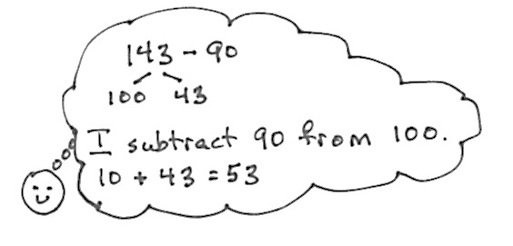
Topic E begins with an extension of mental math strategies learned in first grade, when students learned to subtract from the ten by using number bonds. In Lesson 23, they return to this strategy to break apart three-digit minuends and subtract from the hundred. For example, in first grade students solved 14 – 9 by restating the problem as 10 – 9 + 4. In second grade, students use the same strategy to restate 143 – 90 as 100 – 90 + 43.
In Lesson 24, students use place value disks on a place value chart to represent subtraction and develop an understanding of decomposition of tens and hundreds. This concrete model helps students see the answer to the question, “Do I have enough ones?” or “Do I have enough tens?” When they do not, they exchange one of the larger units for ten of the smaller units. Repeated practice with this exchange solidifies their understanding that within a unit of ten there are 10 ones, and within a unit of a hundred there are 10 tens. This practice is connected to the strategies they learned with tens and ones; they learn that the only real difference is in place value. The strategies are also connected to addition through part–whole understanding, which is reinforced throughout.
In Lesson 25, students move towards the abstract when they model decompositions on their place value charts while simultaneously recording the changes in the vertical form. Students draw a magnifying glass around the minuend, as they did in Topic C. They then ask the question, “Do I have enough ones?” They refer to the place value disks to answer and exchange a ten disk for 10 ones when necessary. They record the change in the vertical form. Students repeat these steps when subtracting the tens.
Students use math drawings in Lesson 26 as they move away from concrete representations and into the pictorial stage. They follow the same procedure for decomposing numbers as they did in Lesson 25 with the place value disks, but now they may use a chip model or place value disk drawing. They continue to record changes in the vertical form as they work with their models.
Topic E closes with the special case of subtracting from 200. Using place value disk drawings on a place value chart, students review the concept that a unit of 100 is comprised of 10 tens. They then model 1 hundred as 9 tens and 10 ones and practice counting to 100 both ways (i.e., 10, 20, 30, …100 and 10, 20, …90, 91, 92, 93, …100). Next, they model the decomposition of a hundred either in two steps (as 10 tens then decomposing 1 ten as 10 ones) or one step (as 9 tens and 10 ones) as they represent subtractions from 200 (see image to the right). Students use this same reasoning to subtract from numbers that have zero tens. For example, to subtract 48 from 106, students model the decomposition of 106 as 10 tens 6 ones and as 9 tens 16 ones. Throughout the lesson, students relate their models to the vertical form step by step.
A Teaching Sequence Towards Mastery of Strategies for Decomposing Tens and Hundreds
Objective 1: Use number bonds to break apart three-digit minuends and subtract from the hundred.
(Lesson 23)
Objective 2: Use manipulatives to represent subtraction with decompositions of 1 hundred as 10 tens and 1 ten as 10 ones.
(Lesson 24)
Objective 3: Relate manipulative representations to a written method.
(Lesson 25)
Objective 4: Use math drawings to represent subtraction with up to two decompositions and relate drawings to a written method.
(Lesson 26)
Objective 5: Subtract from 200 and from numbers with zeroes in the tens place.
(Lessons 27–28)

