Topic B
Strategies for Composing a Ten
2.NBT.7, 2.NBT.9, 2.OA.1, 2.NBT.5
Focus Standard: | 2.NBT.7 | Add and subtract within 1000, using concrete models or drawings and strategies based on place value, properties of operations, and/or the relationship between addition and subtraction; relate the strategy to a written method. Understand that in adding or subtracting three-digit numbers, one adds or subtracts hundreds and hundreds, tens and tens, ones and ones; and sometimes it is necessary to compose or decompose tens or hundreds.
 | 2.NBT.9 | Explain why addition and subtraction strategies work, using place value and the properties of operations. (Explanations may be supported by drawings or objects.)
Instructional Days: | 5
Coherence -Links from: | G1–M4 | Place Value, Comparison, Addition and Subtraction to 40
-Links to: | G2–M5 | Addition and Subtraction Within 1,000 with Word Problems to 100
 | G3–M2 | Place Value and Problem Solving with Units of Measure
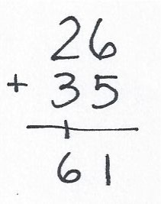
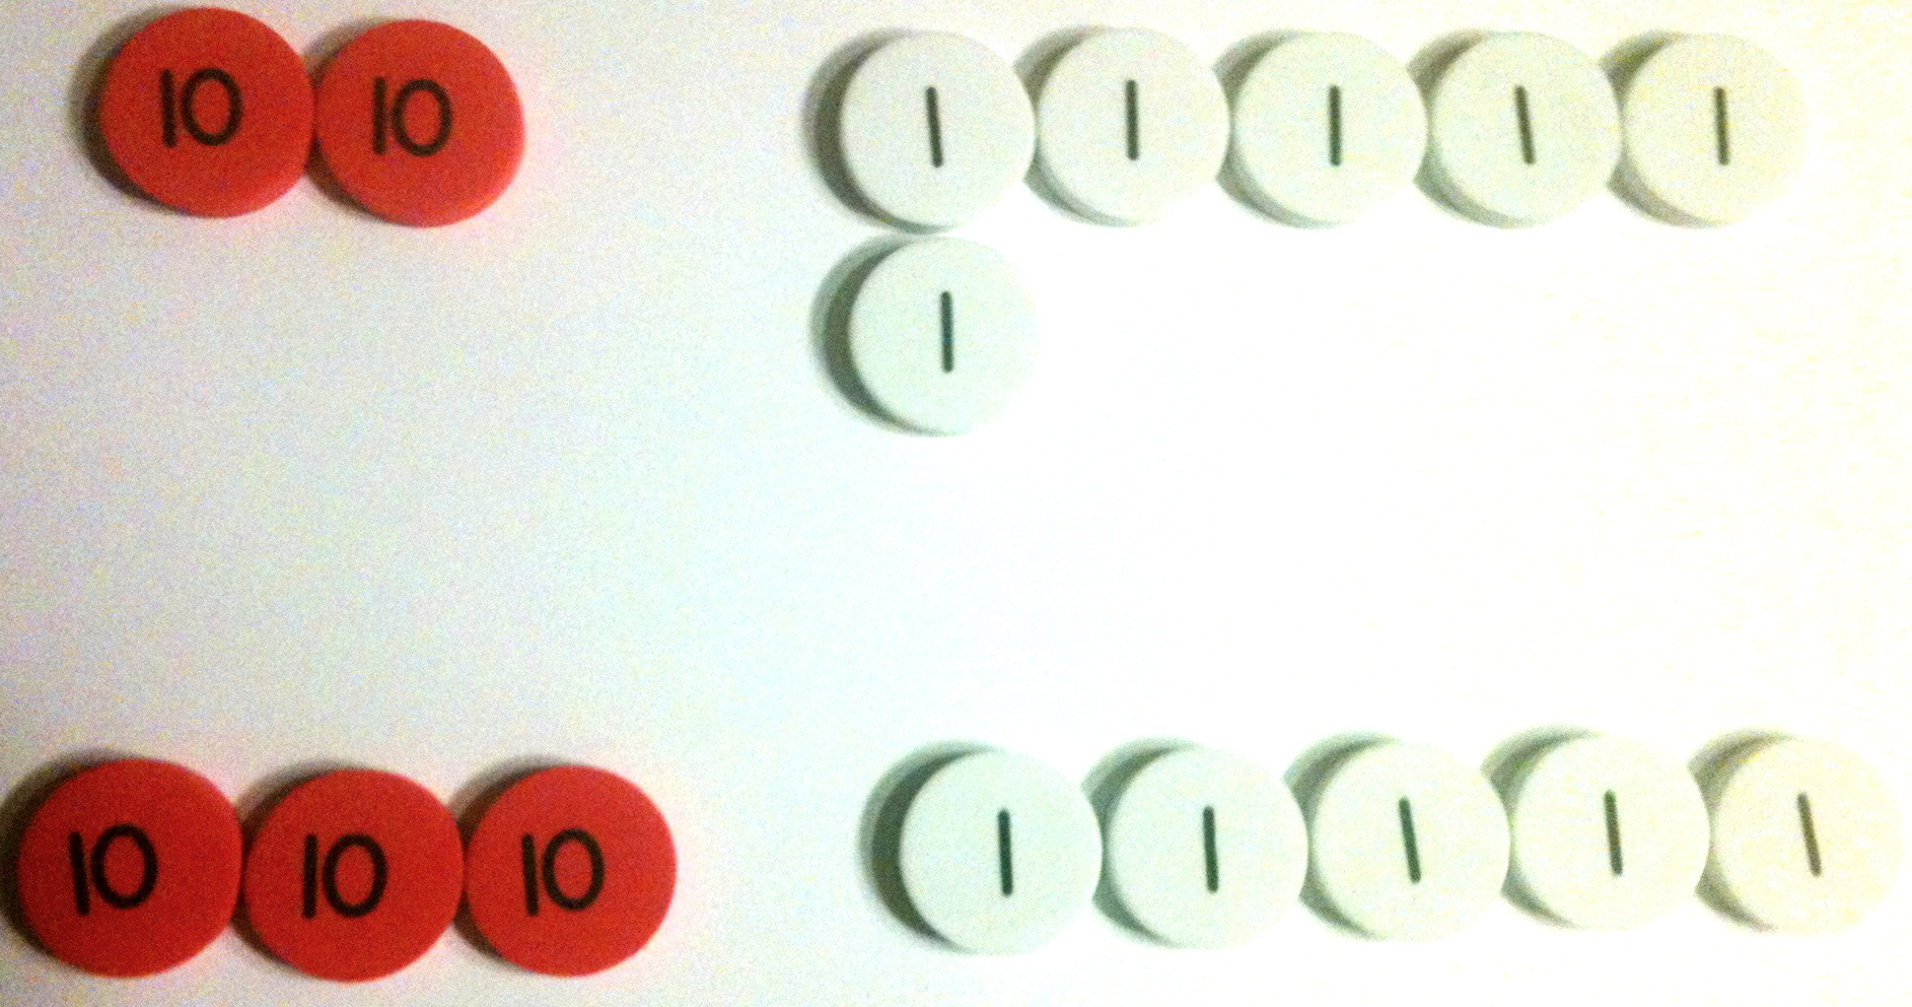
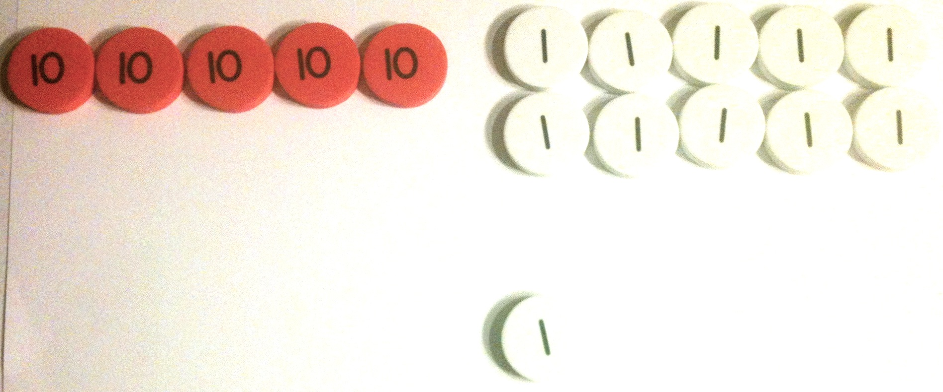
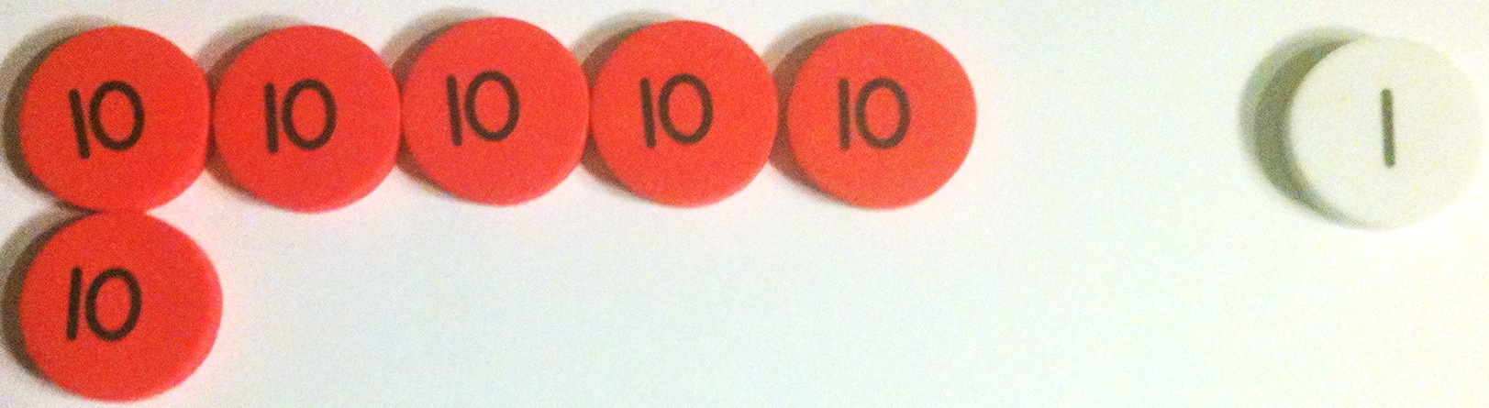
In Topic B, students apply their understanding of place value strategies to the addition algorithm, moving from horizontal to vertical notation. Their understanding of vertical addition starts with concrete work with place value disks, moving to pictorial place value chart drawings, and ending with abstract calculations. Consistent use of place value disks on a place value chart strengthens students’ place value understanding and helps them to systematically model the standard addition algorithm including the composition of a ten. It is important to note that the algorithm is introduced at this level and is connected deeply to the understanding of place value. However, fluency with the algorithm is a Grade 4 standard and is not expected at this level.
In Lesson 6, students use place value disks on a place value chart to represent the composition of 10 ones as 1 ten with two-digit addends. The use of manipulatives reminds students that they must add like units (e.g., 26 + 35 is 2 tens + 3 tens and 6 ones + 5 ones).
Lesson 7 builds upon this understanding as students relate manipulatives to vertical form, recording compositions as new groups below (as shown at right). As they move the manipulatives, students use place value language to express the action as they physically make a ten with 10 ones and exchange them for 1 ten. They record each step of the algorithm in vertical form.
In Lesson 8, students move from concrete to pictorial as they draw unlabeled place value charts with labeled disks to represent addition (as shown at right). As they did with the manipulatives, students record each action in their drawings step-by-step in vertical form.
In Lessons 9 and 10, students work within 200, representing the composition of 10 ones as 1 ten when adding a two-digit addend to a three-digit addend. This provides practice drawing three-digit numbers without the complexity of composing a hundred. It also provides practice with adding like units. As student understanding of the relationship between their drawings and the algorithm deepens, they move to the more abstract chip model, in which place value disks are replaced by circles or dots (as shown below right).
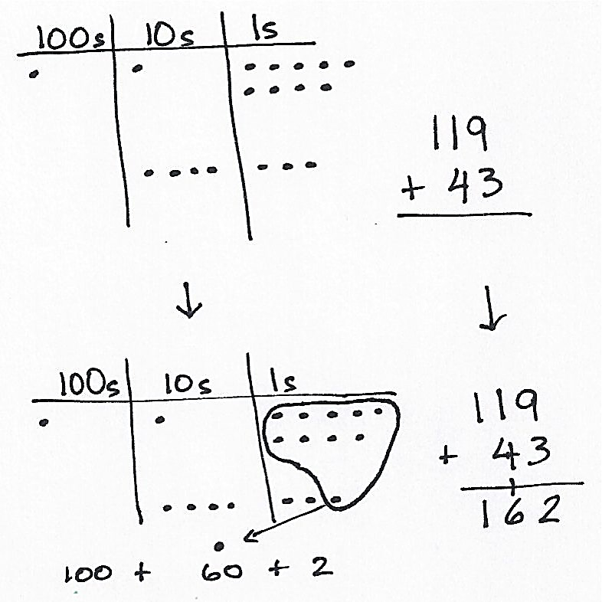
It is important to note that students must attend to precision in their drawings. Disks and dots are drawn in horizontal arrays of 5, recalling student work with 5-groups in Kindergarten and Grade 1. This visual reference enables students to clearly see the composition of the ten.
While some students may come into this topic already having learned addition in vertical form, including carrying above the tens, the process of connecting their understanding to the concrete and pictorial representations develops meaning and understanding of why the process works, not just how to use it. Therefore, students will be less prone to making place value errors.
A Teaching Sequence Towards Mastery of Strategies for Composing a Ten
Objective 1: Use manipulatives to represent the composition of 10 ones as 1 ten with two-digit addends.
(Lesson 6)
Objective 2: Relate addition using manipulatives to a written vertical method.
(Lesson 7)
Objective 3: Use math drawings to represent the composition and relate drawings to a written method.
(Lesson 8)
Objective 4: Use math drawings to represent the composition when adding a two-digit to a three-digit addend.
(Lessons 9–10)

