Topic A
Sums and Differences Within 100
2.OA.1, 2.NBT.5, 2.NBT.8, 2.NBT.9
Focus Standard: | 2.OA.1 | Use addition and subtraction within 100 to solve one- and two-step word problems involving situations of adding to, taking from, putting together, taking apart, and comparing, with unknowns in all positions, e.g., by using drawings and equations with a symbol for the unknown number to represent the problem.
 | 2.NBT.5 | Fluently add and subtract within 100 using strategies based on place value, properties of operations, and/or the relationship between addition and subtraction.
 | 2.NBT.8 | Mentally add 10 or 100 to a given number 100-900, and mentally subtract 10 or 100 from a given number 100-900.
 | 2.NBT.9 | Explain why addition and subtraction strategies work, using place value and the properties of operations. (Explanations may be supported by drawings or objects.)
Instructional Days: | 5
Coherence -Links from: | G2–M3 | Place Value, Counting, and Comparison of Numbers to 1,000
-Links to: | G2–M5 | Addition and Subtraction Within 1,000 with Word Problems to 100
 | G3–M2 | Place Value and Problem Solving with Units of Measure
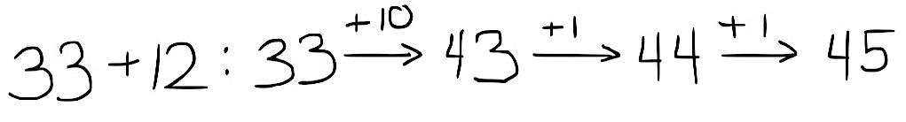
In Topic A, students build upon their understanding of the base ten system and their prior knowledge of place value strategies presented in Module 3. In Lesson 1, students relate 10 more and 10 less and 1 more and 1 less to addition and subtraction. They recognize that they must add and subtract like units and that the digit in the tens place changes when adding and subtracting 10, just as the digit in the ones place changes when adding or subtracting 1. Students see numbers in terms of place value units; 54 – 10 is 5 tens 4 ones minus 1 ten. Additionally, they learn to record the addition and subtraction of multiples of 10 using arrow notation.
In Lesson 2, students apply place value understanding to add and subtract multiples of 10 before counting on by tens. For example, when adding 20 to 43, they may count 53, 63. Students also develop flexibility in using related addition problems. For example, to solve 92 – 60, one student might think 9 tens – 6 tens is 3 tens, plus 2 is 32, while another starts at 60, adds on 3 tens and then 2 ones to reach 92, so 32.

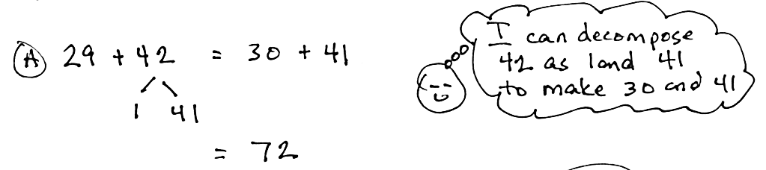
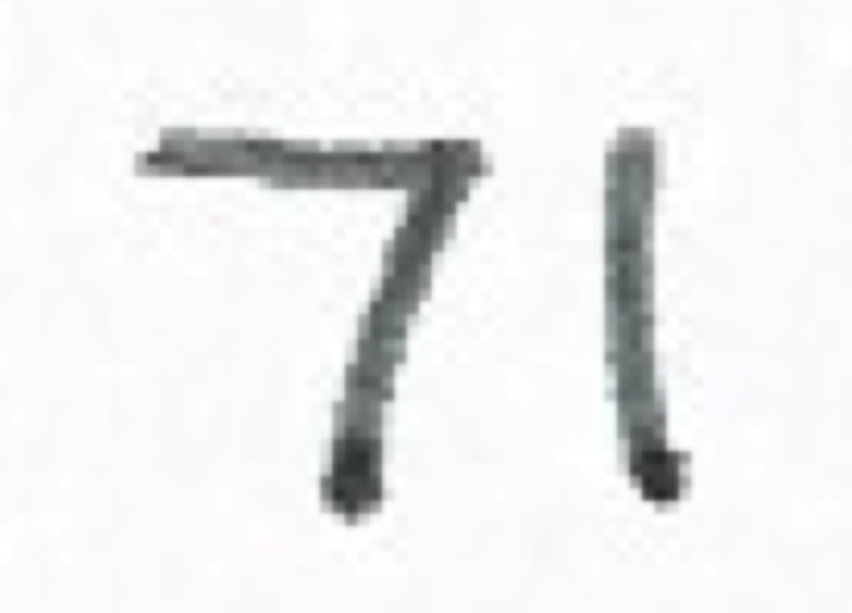
In Lessons 3 and 4, students continue to add and subtract multiples of 10 with the added complexity of some ones. Problems are intentionally chosen so that the ones digit is close to a multiple of 10 (e.g., 38, 39, 41). This prompts students to discover and use relationships between the numbers to develop a variety of simplifying strategies they can use to solve. For example, students might reason mentally that for 29 + 42 they can make a multiple of 10 and count on to solve. They use number bonds to decompose 42 as 1 and 41 to make 30 + 41 = 71 (as shown above right).
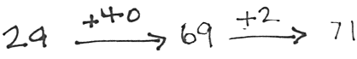
Students also learn to use arrow notation (the arrow way) to record their mental math and to show change in numbers as they work with them. First, students add a multiple of 10, then count on 2 to make 71 (as shown at right). This avoids common misconceptions arising from using the equal sign to record such computation (e.g., erroneously recording
29 + 40 = 69 + 2 = 71).
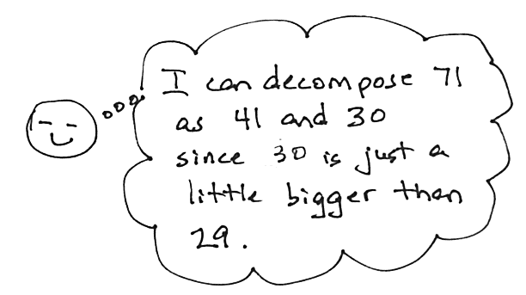
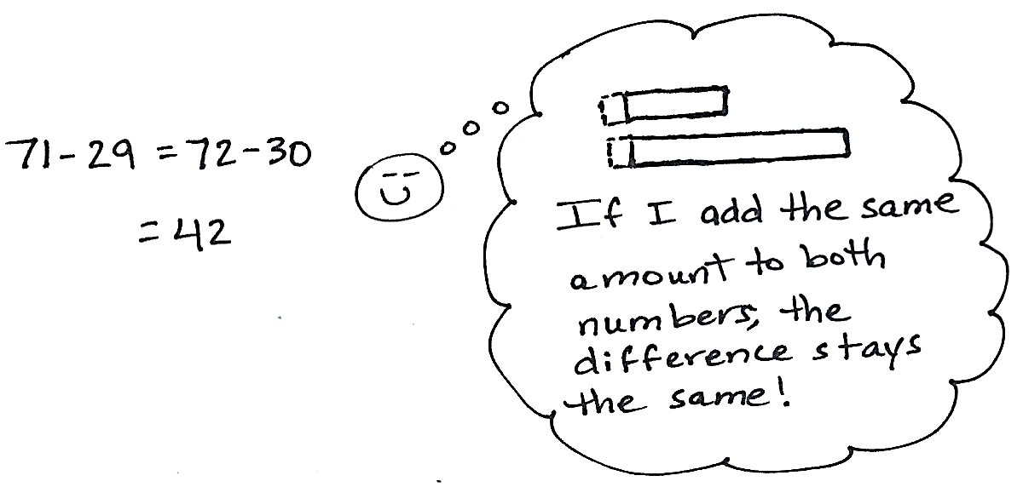
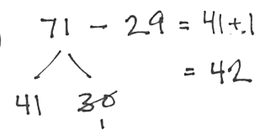
Similarly, students use number bonds to make a multiple of 10 when subtracting (as shown below). After students subtract 30 – 29, they add 41 + 1 to make 42.
The ease of subtracting a multiple of 10 is highlighted again, as students learn the strategy of compensation for subtraction. For example, in 71 – 29, the same amount, 1, can be added (or subtracted) to both numbers to create the equivalent problem that involves no renaming (as shown below right).
Topic A closes with a lesson that focuses on one- and two-step word problems within 100. Students apply their place value reasoning, mental strategies, and understanding of renaming to negotiate different problem types with unknowns in various positions. The lesson begins with guided practice and transitions to students solving problems on their own or with others, independent of teacher direction. Students are encouraged to be flexible in their thinking and to use multiple strategies in solving problems. For example, students might use tape diagrams to solve word problems, relating the diagrams to a situation equation
(e.g., ____ – 36 = 60) and rewriting it as a solution equation (e.g., 60 + 36 = ____), thus illustrating the relationship between operations and using this relationship to check their work. Or, students might use arrow notation and count on. Discussion ensues as each problem is solved, with students sharing strategies, analyzing the efficiency of each, defending their work, and/or critiquing or supporting the work of their peers.
The strategies taught in Topic A are designed to build fluency and develop students’ conceptual understanding of addition and subtraction using properties of operations and place value reasoning. This sets the stage for composing and decomposing a ten in Topics B and C.

A Teaching Sequence Towards Mastery of Sums and Differences Within 100
Objective 1: Relate 1 more, 1 less, 10 more, and 10 less to addition and subtraction of 1 and 10.
(Lesson 1)
Objective 2: Add and subtract multiples of 10 including counting on to subtract.
(Lesson 2)
Objective 3: Add and subtract multiples of 10 and some ones within 100.
(Lessons 3–4)
Objective 4: Solve one- and two-step word problems within 100 using strategies based on place value.
(Lesson 5)

Students mentally add and subtract 100 in Topics D and E of Module 4.
Students are formally introduced to the term compensation in Module 5.

