Topic C
Strategies for Addition and Subtraction Within 100
2.OA.1, 2.NBT.5, 2.OA.2, 1.NBT.4, 1.NBT.5, 1.NBT.6
Focus Standard: | 2.OA.1 | Use addition and subtraction within 100 to solve one- and two-step word problems involving situations of adding to, taking from, putting together, taking apart, and comparing, with unknowns in all positions, e.g., by using drawings and equations with a symbol for the unknown number to represent the problem.
 | 2.NBT.5 | Fluently add and subtract within 100 using strategies based on place value, properties of operations, and/or the relationship between addition and subtraction.
Instructional Days: | 3
Coherence -Links from: | G1–M2 | Introduction to Place Value Through Addition and Subtraction Within 20
-Links to: | G2–M2 | Addition and Subtraction Within of Length Units
 | G2–M4 | Addition and Subtraction Within 200 with Word Problems to 100
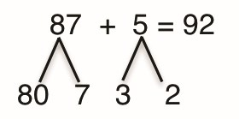
In Topic C, students revisit their addition and subtraction skills, practicing with larger numbers up to 100. Throughout this topic, students use ten-frames and number bonds to add and subtract using the structure of ten. In Lesson 6, students only add or subtract a number less than 10 without crossing the multiple
(e.g., 63 + 2, 65 – 2). Students use their knowledge of basic facts and place value to solve problems with larger numbers. For example, knowing that 5 – 2 = 3 enables students to easily subtract 65 – 2. At times, students respond using Say Ten form (e.g., 26 is 2 tens 6) to see that in a sequence (e.g., 6 – 4, 16 – 4 , 26 – 4, 36 – 4, etc.) the number of tens changes but the basic fact remains the same.
Lesson 7 builds upon students’ knowledge of basic facts within the teens (e.g., 7 + 8 = 15) to add 2-digit and 1-digit numbers (e.g., 77 + 8 = 85). Hence, the new complexity is to cross a multiple of 10. Students apply 7 + 5 = 10 + 2 to easily solve 87 + 5 = 90 + 2 (shown right). Again, students make use of the ten structure and place value to separate a two-digit number into tens and ones, and bond smaller numbers to make a ten.
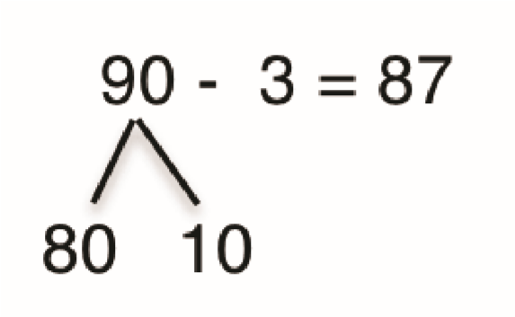
Lesson 8 mirrors the work of Lesson 7 in that students subtract single-digit numbers from multiples of 10. Students use 10 – 3 to solve 90 – 3 (shown right), and they use this strategy to solve a variety of one-step word problem types. Also, since students know partners of ten with automaticity, adding some ones after taking from the ten should not be too challenging (e.g., 91 – 3 = 88). Topic C culminates with students learning that it is possible to “get out the ten” in problems such as 23 – 9 and add back the remaining part, such that 13 + (10 – 9) = 14. This decomposing to make or take from a ten prepares students for adding and subtracting three-digit numbers in Module 4.

A Teaching Sequence Towards Mastery of Strategies for Addition and Subtraction Within 100
Objective 1: Add and subtract within multiples of ten based on understanding place value and basic facts.
(Lesson 6)
Objective 2: Add within 100 using properties of addition to make a ten.
(Lesson 7)
Objective 3: Decompose to subtract from a ten when subtracting within 100 and apply to one-step word problems.
(Lesson 8)

