Topic E
Coins and Their Values
1.MD.3
Focus Standard: | 1.MD.3 | Tell and write time in hours and half-hours using analog and digital clocks. Recognize and identify coins, their names, and their values.
Instructional Days: | 5
Coherence -Links from: | G1–M4 | Place Value, Comparison, Addition and Subtraction to 40
-Links to: | G2–M3 | Place Value, Counting, and Comparison of Numbers to 1,000
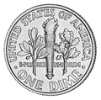
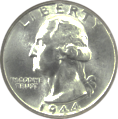
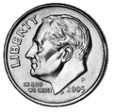
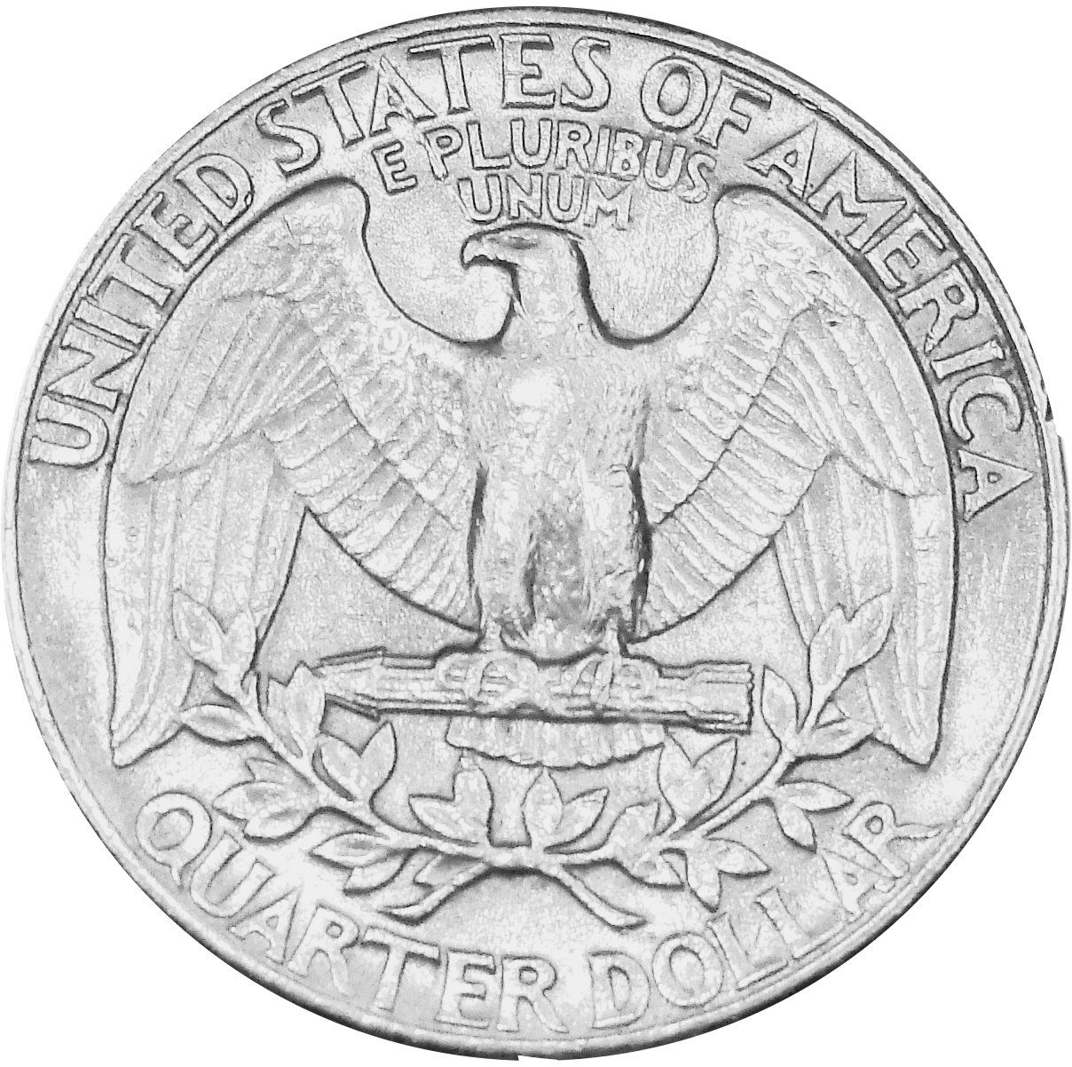
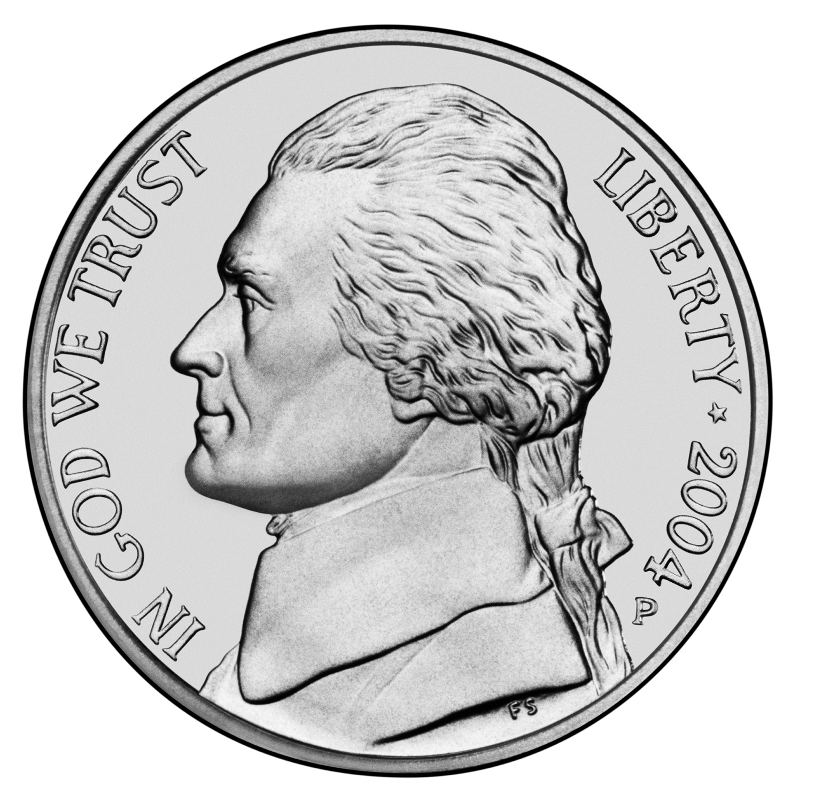
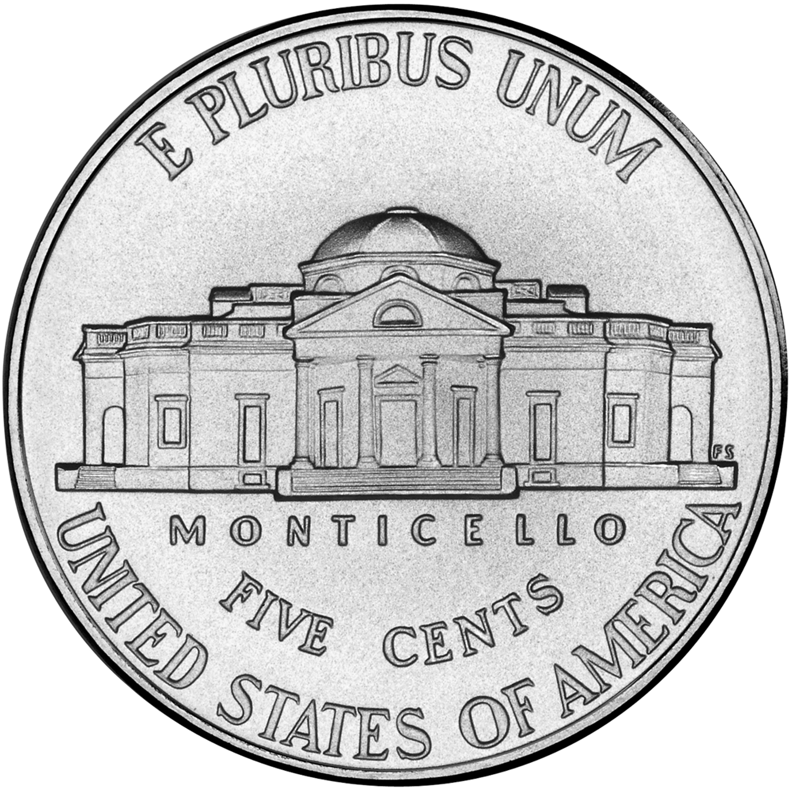
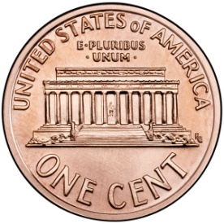
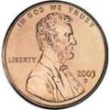
Through Topic E, students learn about the four most predominant U.S. coins in circulation, the penny, the nickel, the dime, and the quarter. Students identify and use the coins based on their image, name, and/or value (1.MD.3).
In Lesson 20, students are introduced to the nickel, which they then use alongside the familiar dime and penny. Students consider various ways to represent common values. For instance, students represent a value of 10 by using 1 ten (the dime) or 10 ones (pennies), as well as the well-known decomposition of 5 + 5 (2 nickels). Students use their background with number bonds to decompose the larger value into the various compositions.
Lesson 21 introduces students to the quarter, which can be the most challenging coin to learn. Students build on their understanding from Lesson 20, focusing specifically on the value of 25. They consider how many pennies they would need to have the same value as 1 quarter, and then trade in 2 dimes and 1 nickel or 2 dimes and 5 pennies for a quarter. Again, students use their prior work with number bonds and place value charts to consider the various compositions.
During Lesson 22, students continue to work with all four coins. Various sequences are provided to best match the learning needs of the class. And, in Lesson 23, students count on from any coin to create various values.
To culminate the topic, students use dimes and pennies as representations of numbers to 120, connecting the prior knowledge students have been developing throughout the module to the work they have been doing in Topic E.
A Teaching Sequence Towards Mastery of Coins and Their Values
Objective 1: Identify pennies, nickels, and dimes by their image, name, or value. Decompose the values of nickels and dimes using pennies and nickels.
(Lesson 20)
Objective 2: Identify quarters by their image, name, or value. Decompose the value of a quarter using pennies, nickels, and dimes.
(Lesson 21)
Objective 3: Identify varied coins by their image, name, or value. Add one cent to the value of any coin.
(Lesson 22)
Objective 4: Count on using pennies from any single coin.
(Lesson 23)
Objective 5: Use dimes and pennies as representations of numbers to 120.
(Lesson 24)

Focus on money.

