Topic C
Investigation of Measurements Expressed as Mixed Numbers
4.OA.3, 4.MD.1, 4.MD.2, 4.NBT.5, 4.NBT.6
Focus Standard: | 4.OA.3 | Solve multi-step word problems posed with whole numbers and having whole-number answers using the four operations, including problems in which remainders must be interpreted. Represent these problems using equations with a letter standing for the unknown quantity. Assess the reasonableness of answers using mental computation and estimation strategies including rounding.
 | 4.MD.1 | Know relative sizes of measurement units within one system of units including km, m, cm; kg, g; lb, oz; l, ml; hr, min, sec. Within a single system of measurement, express measurements in a larger unit in terms of a smaller unit. Record measurement equivalents in a two-column table. For example, know that 1 ft is 12 times as long as 1 in. Express length of a 4 ft snake as 48 in. Generate a conversion table for feet and inches listing the number pairs (1, 12), (2, 24), (3, 36), ….
 | 4.MD.2 | Use the four operations to solve word problems involving distances, intervals of time, liquid volumes, masses of objects, and money, including problems involving simple fractions or decimals, and problems that require expressing measurements given in a larger unit in terms of a smaller unit. Represent measurement quantities using diagrams such as number line diagrams that feature a measurement scale.
Instructional Days: | 3
Coherence -Links from: | G3–M1 | Properties of Multiplication and Division and Solving Problems with Units of 2–5 and 10
 | G3–M2 | Place Value and Problem Solving with Units of Measure
-Links to: | G5–M1 | Place Value and Decimal Fractions
 | G5–M2 | Multi-Digit Whole Number and Decimal Fraction Operations
In Topic C, students convert larger mixed measurement units to smaller units. Students partition a measurement scale in Lesson 11 to help them convert larger units of measurements with fractional parts into smaller units. For example, students will use a ruler to draw a number line 1 foot in length. Then, students will partition the number line into 12 equal parts. Combining fractions and conversions, students will see that 1 twelfth foot is the same as 1 inch. Repeating the same activity, but making different partitions, students will find how many inches are in $\frac{1}{2}$ foot, $\frac{1}{3}$ foot, and $\frac{1}{4}$ foot.
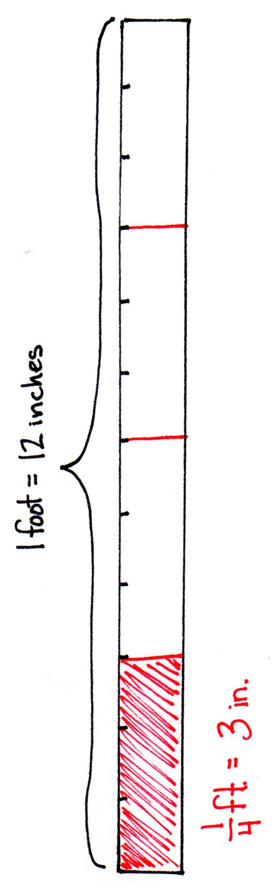

The same hands-on activity can be repeated for the capacity of part of a gallon represented as quarts. That hands-on experience leads students to make abstract connections in Lesson 12 for weight, identifying that $\frac{1}{16}$ pound is equal to 1 ounce, and with respect to time, finding that $\frac{1}{60}$ hour is equal to 1 minute, through the modeling of tape diagrams and number lines. Moving forward, students use their knowledge of conversion tables with this new understanding to convert mixed number units into smaller units, such as $\text{3}\frac{1}{4}$ foot equals 39 inches, by applying mixed number units to solve multi-step problems in Lesson 13.
Erin has $\text{1}\frac{3}{4}$ pounds of apples. A recipe for apple tarts requires 4 ounces of apples. How many apple tarts can Erin make?
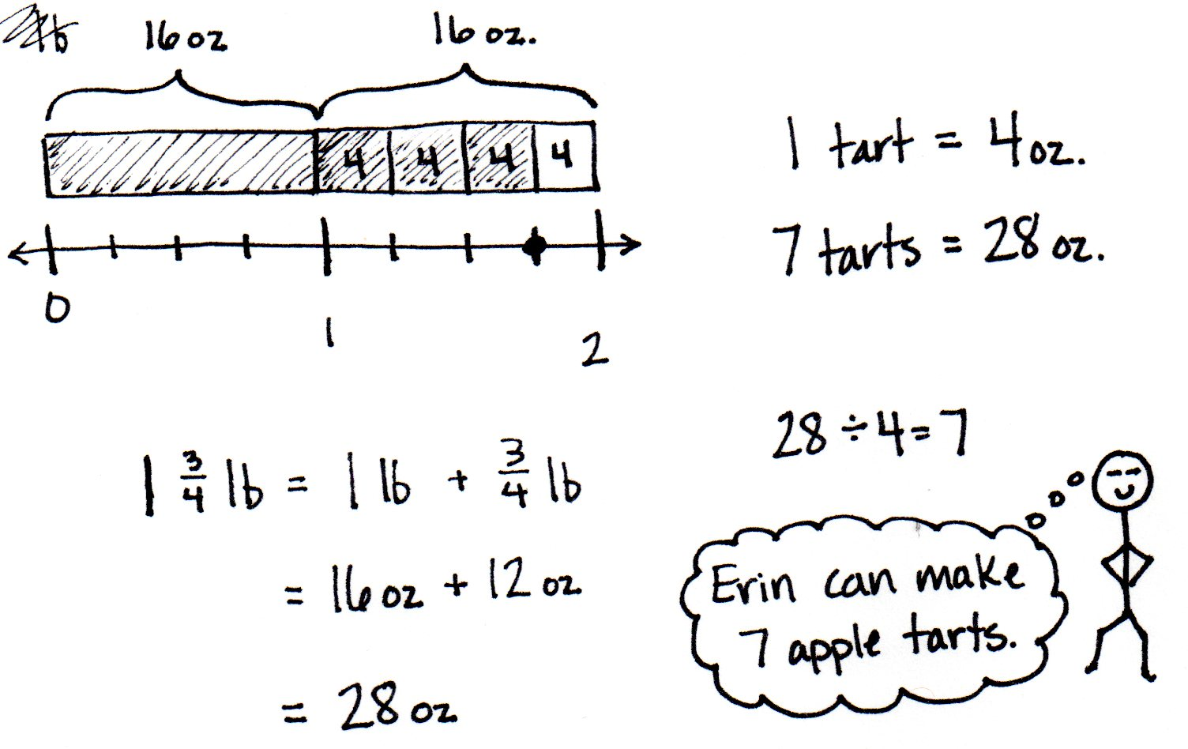

A Teaching Sequence Towards Mastery of Investigation of Measurements Expressed as Mixed Numbers
Objective 1: Use measurement tools to convert mixed number measurements to smaller units.
(Lessons 12–13)
Objective 2: Solve multi-step word problems involving converting mixed number measurements to a single unit.
(Lesson 14)

