Topic B
Problem Solving with Measurement
4.OA.2, 4.OA.3, 4.MD.1, 4.MD.2, 4.NBT.5, 4.NBT.6
Focus Standard: | 4.OA.2 | Multiply or divide to solve word problems involving multiplicative comparison, e.g., by using drawings and equations with a symbol for the unknown number to represent the problem, distinguishing multiplicative comparison from additive comparison. (See CCSS Glossary, Table 2.)
 | 4.OA.3 | Solve multi-step word problems posed with whole numbers and having whole-number answers using the four operations, including problems in which remainders must be interpreted. Represent these problems using equations with a letter standing for the unknown quantity. Assess the reasonableness of answers using mental computation and estimation strategies including rounding.
 | 4.MD.1 | Know relative sizes of measurement units within one system of units including km, m, cm; kg, g; lb, oz; l, ml; hr, min, sec. Within a single system of measurement, express measurements in a larger unit in terms of a smaller unit. Record measurement equivalents in a two-column table. For example, know that 1 ft is 12 times as long as 1 in. Express length of a 4 ft snake as 48 in. Generate a conversion table for feet and inches listing the number pairs (1, 12), (2, 24), (3, 36), ….
 | 4.MD.2 | Use the four operations to solve word problems involving distances, intervals of time, liquid volumes, masses of objects, and money, including problems involving simple fractions or decimals, and problems that require expressing measurements given in a larger unit in terms of a smaller unit. Represent measurement quantities using diagrams such as number line diagrams that feature a measurement scale.
Instructional Days: | 6
Coherence -Links from: | G3–M1 | Properties of Multiplication and Division and Solving Problems with Units of 2–5 and 10
 | G3–M2 | Place Value and Problem Solving with Units of Measure
-Links to: | G5–M1 | Place Value and Decimal Fractions
 | G5–M2 | Multi-Digit Whole Number and Decimal Fraction Operations
Each lesson in Topic B builds upon the conversion work from Topic A to add and subtract mixed units of capacity, length, weight, and time. Unlike the mixed unit work in Module 2, now students work with the two systems of measurement, customary and metric, as well as being posed with fractional amounts of measurement, e.g., $\text{2}\frac{3}{4}$ feet or $\text{4}\frac{3}{8}$ pounds. As students add like units, they make comparisons to adding like fractional units, further establishing the importance of deeply understanding the unit. Just as 2 fourths + 3 fourths = 5 fourths, so does 2 quarts + 3 quarts = 5 quarts. 5 fourths can be decomposed into 1 one 1 fourth, and therefore 5 quarts can be decomposed into 1 gallon 1 quart. Students realize the same in subtraction, just as 1 – $\frac{3}{4}$ must be renamed to $\frac{4}{4}-\frac{1}{4}$ so that the units are alike, students must also rename units of measurements to make like units (1 quart – 3 cups = 4 cups – 1 cup). Students go on to add and subtract mixed units of measurements, finding multiple solution strategies, similar to the mixed number work in fractions.
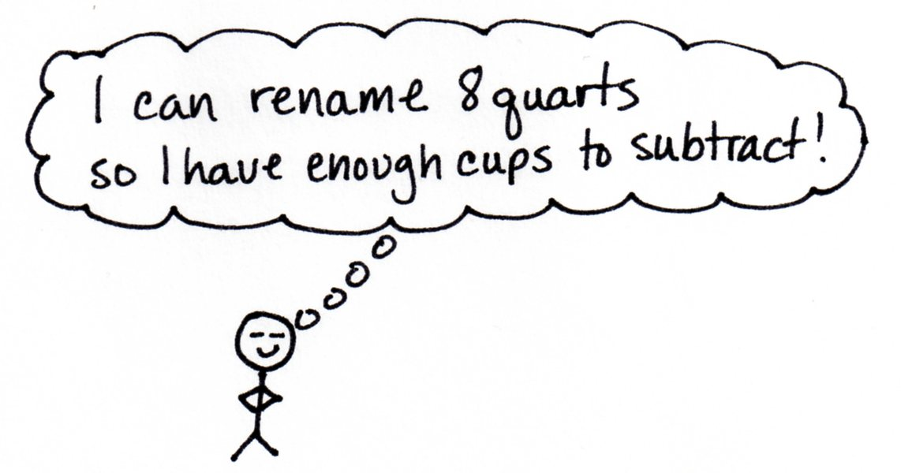
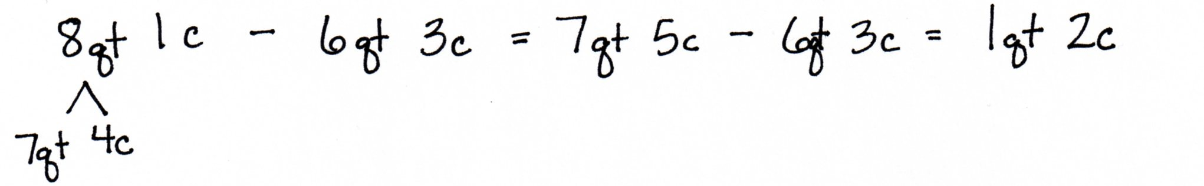

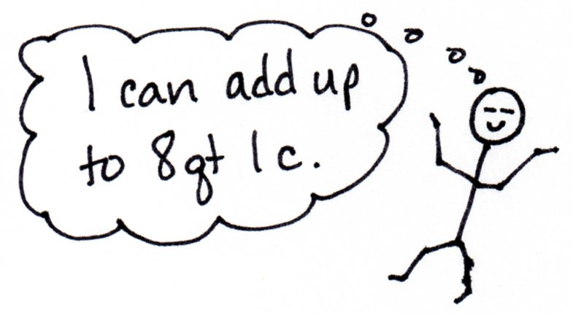
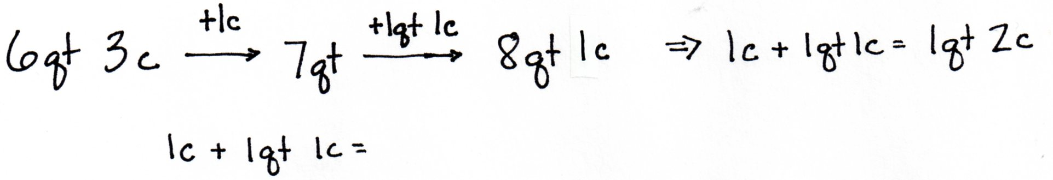

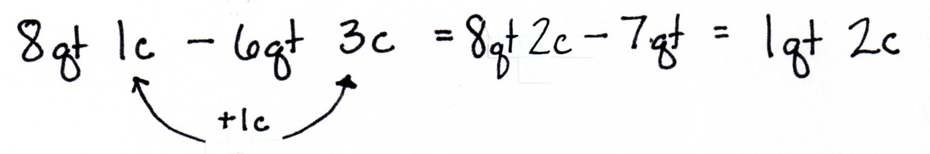
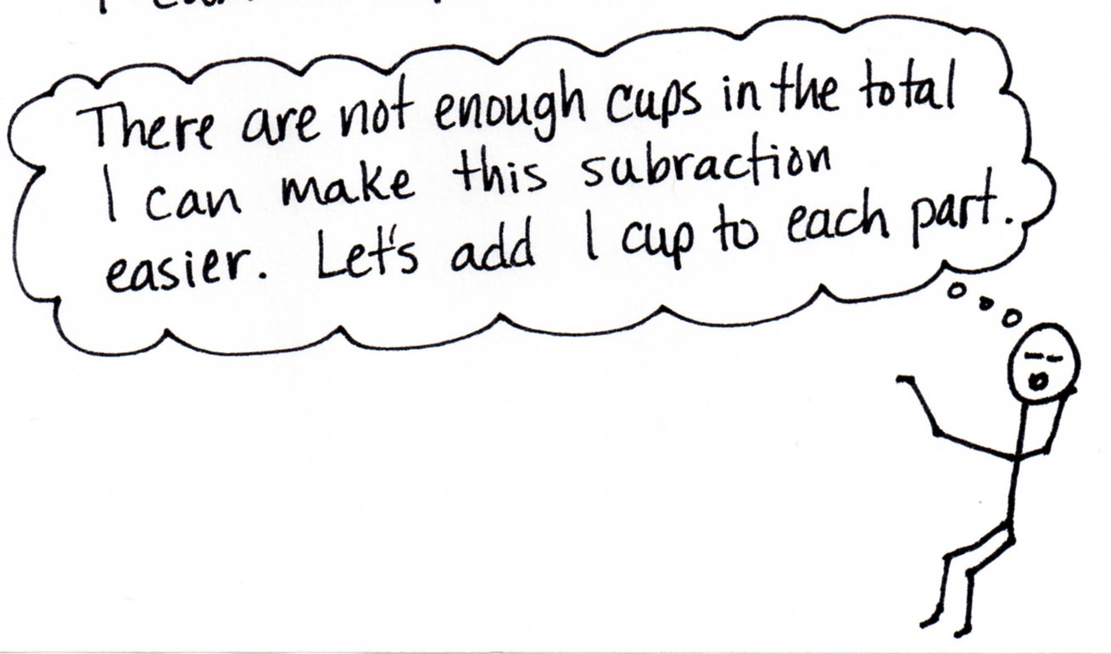

In Lessons 6–9, each lesson focuses on a specific type of measurement: capacity, length, weight, or time. Students go on to practice addition and subtraction of mixed units of measurements to solve multi-step word problems in Lessons 10 and 11.
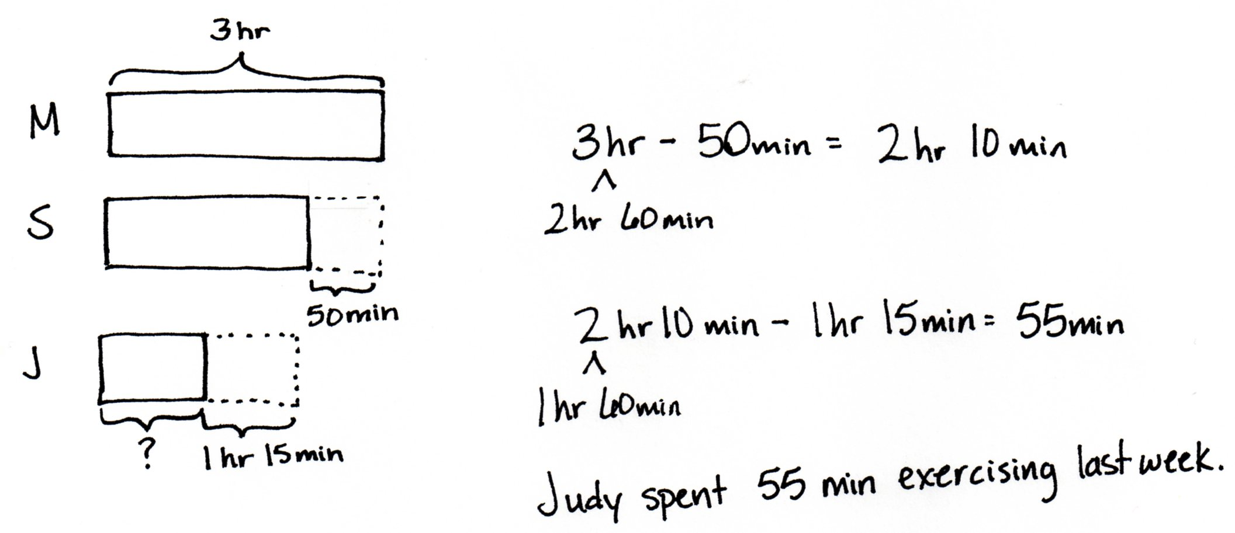
Judy spent 1 hour and 15 minutes less than Sandy exercising last week. Sandy spent 50 minutes less than Mary who spent 3 hours at the gym. How long did Judy spend exercising?

A Teaching Sequence Towards Mastery of Problem Solving with Measurement
Objective 1: Solve problems involving mixed units of capacity.
(Lesson 6)
Objective 2: Solve problems involving mixed units of length.
(Lesson 7)
Objective 3: Solve problems involving mixed units of weight.
(Lesson 8)
Objective 4: Solve problems involving mixed units of time.
(Lesson 9)
Objective 5: Solve multi-step measurement word problems.
(Lessons 10–11)

