Topic A
Measurement Conversion Tables
4.OA.1, 4.OA.2, 4.MD.1, 4.NBT.5, 4.MD.2
Focus Standard: | 4.OA.1 | Interpret a multiplication equation as a comparison, e.g., interpret 35 = 5 × 7 as a statement that 35 is 5 times as many as 7 and 7 times as many as 5. Represent verbal statements of multiplicative comparisons as multiplication equations.
 | 4.OA.2 | Multiply or divide to solve word problems involving multiplicative comparison, e.g., by using drawings and equations with a symbol for the unknown number to represent the problem, distinguishing multiplicative comparison from additive comparison. (See CCSS Glossary, Table 2.)
 | 4.MD.1 | Know relative sizes of measurement units within one system of units including km, m, cm; kg, g; lb, oz; l, ml; hr, min, sec. Within a single system of measurement, express measurements in a larger unit in terms of a smaller unit. Record measurement equivalents in a two-column table. For example, know that 1 ft is 12 times as long as 1 in. Express length of a 4 ft snake as 48 in. Generate a conversion table for feet and inches listing the number pairs (1, 12), (2, 24), (3, 36), ….
Instructional Days: | 5
Coherence -Links from: | G3–M1 | Properties of Multiplication and Division and Solving Problems with Units of 2–5 and 10
 | G3–M2 | Place Value and Problem Solving with Units of Measure
-Links to: | G5–M1 | Place Value and Decimal Fractions
 | G5–M2 | Multi-Digit Whole Number and Decimal Fraction Operations
In Topic A, students build on the work they did in Module 2 with measurement conversions. In this Module, however, they have the opportunity to work more extensively with tools while creating two-column tables that are then used to solve a variety of measurement problems.
In Lesson 1, students use two-column conversion tables (4.MD.1) to practice conversion rates. Students convert from pounds to ounces, yards to feet, and feet to inches. Students begin Lesson 1 by using a balance scale, a 1-pound weight, and individual 1-ounce weights (like fishing sinkers). With the 1-pound weight on one side of the balance, they add one ounce at a time to the other side until it balances to discover that there are 16 ounces in one pound. Students then generate a two-column conversion table listing the number of ounces in two, three, and up to 10 pounds. They use their multiplication skills from Module 3 to complete the table and reason about why they do not need to complete the table beyond 10 pounds.
Students use various strategies to determine how many smaller units would make up a larger unit not listed in the table. A student could reason, for example, that since the table shows that there are 160 ounces in 10 pounds and 48 ounces in 3 pounds that he can add them together to tell that there are 208 ounces in 13 pounds. Another student might reason that since there are 16 ounces in each pound, she can use the rule of the table and multiply 13 pounds by 16 to find that there are 208 ounces in 13 pounds.
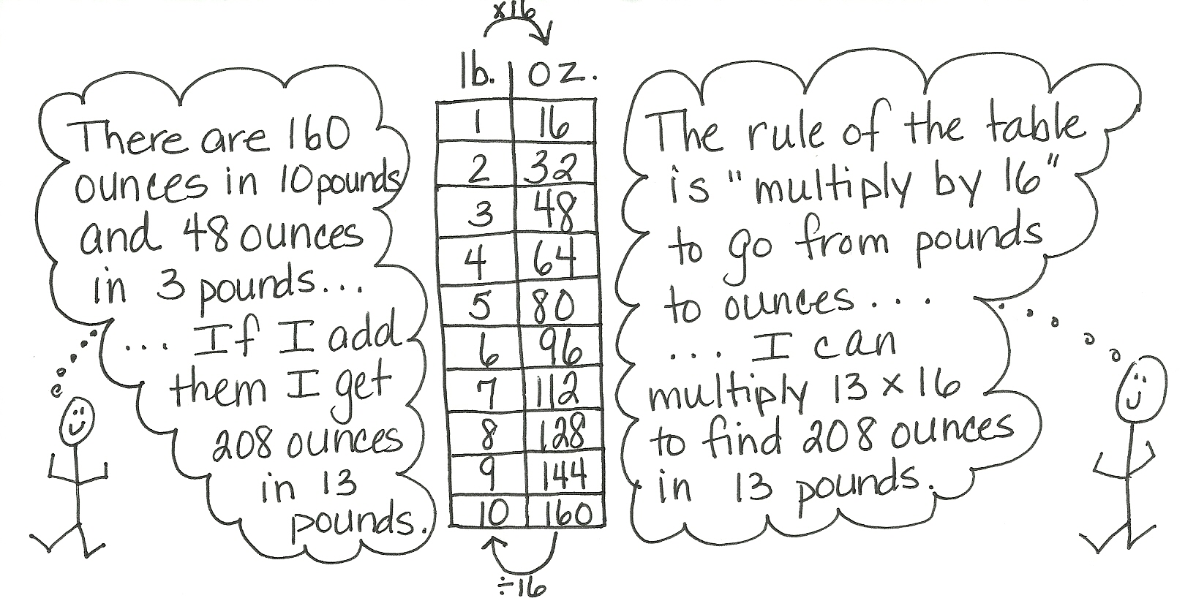

Similar to Lesson 1, in Lesson 2 students complete conversion tables, this time focusing on capacity and converting gallons to quarts, quarts to pints, and pints to cups. Adding to the complexity of the conversions, students explore two-step conversions solving, for example, to find how many cups are equal to one gallon.
In Lesson 3, students investigate the relationships between units of time. They discover a similarity in converting from hours to minutes and minutes to seconds. Students are able to reason that, for both sets of conversion, the values in the two tables will be the same because there are 60 seconds in a minute and 60 minutes in an hour. Students also convert from days to hours. The clock and the number line are used as tools to develop the conversion tables.
In Lesson 4, students use the conversions that they discovered in Lessons 1–3 in order to solve multiplicative comparison word problems. Working in small groups, students have the opportunity to share and discuss their solution strategies. (4.OA.1, 4.OA.2)
Students are given tape diagrams and are then challenged to create word problems to match the information displayed within the tape diagrams in Lesson 5. The given information requires students to use the customary or metric units practiced during this topic. After first solving the problems that they create, students share and critique the problem solving strategies used by their peers. In the Debrief, through the use of guided questions, students discuss not only how the problems were solved but also the advantages and disadvantages of using each strategy. They further discuss what makes one strategy more efficient than another.

A Teaching Sequence Towards Mastery of Measurement Conversion Tables
Objective 1: Create conversion tables for length, weight, and capacity units using measurement tools, and use the tables to solve problems.
(Lessons 1–2)
Objective 2: Create conversion tables for units of time, and use the tables to solve problems.
(Lesson 3)
Objective 3: Solve multiplicative comparison word problems using measurement conversion tables.
(Lesson 4)
Objective 4: Share and critique peer strategies.
(Lesson 5)

