Topic A
Comparison Word Problems
1.OA.1
Focus Standard: | 1.OA.1 | Use addition and subtraction within 20 to solve word problems involving situations of adding to, taking from, putting together, taking apart, and comparing, with unknowns in all positions, e.g., by using objects, drawings, and equations with a symbol for the unknown number to represent the problem. (See CCLS Glossary, Table 1.)
Instructional Days: | 2
Coherence -Links from: | G1–M3  G1–M4 | Ordering and Comparing Length Units as Numbers  Place Value, Comparison, Addition and Subtraction to 40
-Links to: | G2–M7 | Problem Solving with Length, Money, and Data
Topic A of Module 6 opens with students exploring one of the most challenging problem types for their grade level, comparison word problems (1.OA.1). Students were informally introduced to the problem type in Module 3 as they analyzed data and compared measurements. During Module 5, students worked with comparison contexts through Application Problems. It is with this background that teachers can make informed choices during Module 6 to support students in recognizing and solving comparison word problems.
In Lesson 1, students work with compare with difference unknown problem types using double tape diagrams. They then carry their understanding of double tape diagrams into Lesson 2 to tackle compare with bigger or smaller unknown problem types. Throughout the module, students continue to practice these problem types as they solve Application Problems in the topics that follow.
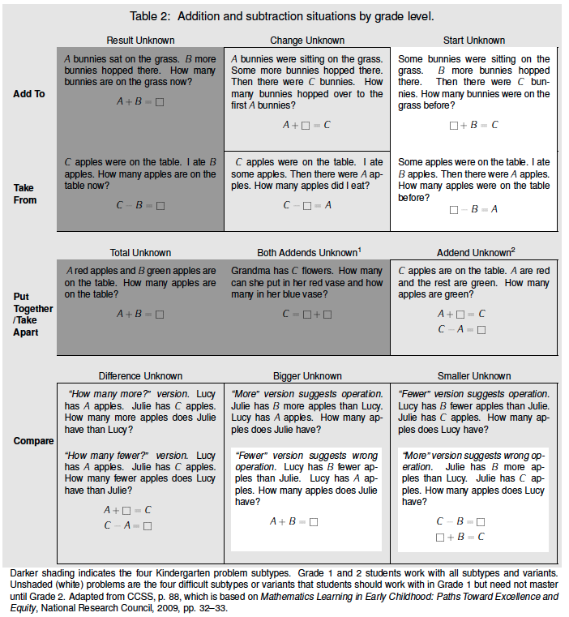

A Teaching Sequence Towards Mastery of Comparison Word Problems
Objective 1: Solve compare with difference unknown problem types.
(Lesson 1)
Objective 2: Solve compare with bigger or smaller unknown problem types.
(Lesson 2)

Found in the Counting and Cardinality and Operations and Algebraic Thinking Progressions Document, p. 9.

