Topic G
Repeated Addition of Fractions as Multiplication
4.NF.4, 4.OA.2, 4.MD.2, 4.MD.4
Focus Standard: | 4.NF.4 | Apply and extend previous understandings of multiplication to multiply a fraction by a whole number.  - Understand a fraction a/b as a multiple of 1/b. For example, use a visual fraction model to represent 5/4 as the product 5 × (1/4), recording the conclusion by the equation 5/4 = 5 × (1/4).  - Understand a multiple of a/b as a multiple of 1/b, and use this understanding to multiply a fraction by a whole number. For example, use a visual fraction model to express 3 × (2/5) as 6 × (1/5), recognizing this product as 6/5. (In general, n × (a/b) = (n × a)/b.)  - Solve word problems involving multiplication of a fraction by a whole number, e.g., by using visual fraction models and equations to represent the problem.  For example, if each person at a party will eat 3/8 of a pound of roast beef, and there will be 5 people at the party, how many pounds of roast beef will be needed? Between what two whole numbers does your answer lie?
Instructional Days: | 6
Coherence -Links from: | G3–M5 | Fractions as Numbers on the Number Line
-Links to: | G5–M3 | Addition and Subtraction of Fractions
 | G5–M4 | Multiplication and Division of Fractions and Decimal Fractions

Topic G extends the concept of representing repeated addition as multiplication, applying this familiar concept to work with fractions.
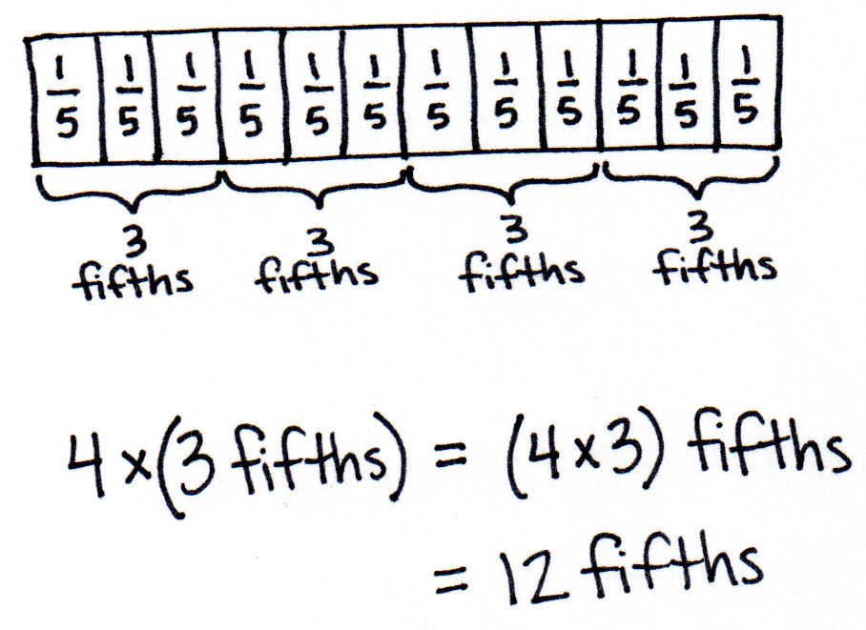
Multiplying a whole number times a fraction was introduced in Topic A as students learned to decompose fractions, e.g., $\frac{\text{3}}{\text{5}}$ = $\frac{\text{1}}{\text{5}}\text{+}\frac{\text{1}}{\text{5}}\text{+}\frac{\text{1}}{\text{5}}$ = 3 × $\frac{\text{1}}{\text{5}}$. In Lessons 35 and 36, students use the associative property, as exemplified below, to multiply a whole number times a mixed number.
3 bananas + 3 bananas + 3 bananas + 3 bananas
= 4 $\text{×}$3 bananas
= 4 $\text{×}$ (3 $\text{×}$ 1 banana) = (4 $\text{×}$ 3) $\text{×}$ 1 banana = 12 bananas
3 fifths + 3 fifths + 3 fifths + 3 fifths
= 4 $\text{×}$3 fifths
= 4 $\text{×}$ (3 fifths) = (4 $×$ 3) fifths= 12 fifths
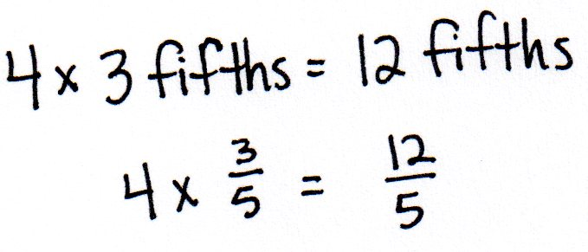
$\text{4 ×}\frac{\text{3}}{\text{5}}$
$$\text{4} \text{×}\left(\text{3} \text{×}\frac{\text{1}}{\text{5}}\right)\text{=} \left(\text{4} \text{×} \text{3}\right) \text{×} \frac{\text{1}}{\text{5}} \text{=} \frac{\text{4 ×} \text{3}}{\text{5}} \text{=} \frac{\text{12}}{\text{5}}$$

Students may have never before considered that 3 bananas = 3 $\text{×}$1 banana, but it is an understanding that connects place value, whole number work, measurement conversions, and fractions, e.g., 3 hundreds = 3 $\text{× }$1 hundred or 3 feet = 3 $\text{×}$ (1 foot); 1 foot = 12 inches; therefore, 3 feet = 3 $\text{×}$ (12 inches) = (3 $\text{×}$ 12) inches = 36 inches.
Students explore the use of the distributive property in Lessons 37 and 38 to multiply a whole number by a mixed number. They see the multiplication of each part of a mixed number by the whole number and use the appropriate strategies to do so. As students progress through each lesson, they are encouraged to record only as much as they need to keep track of the math. As shown below, there are multiple steps when using the distributive property, and students can become lost in those steps. Efficiency in solving is encouraged.
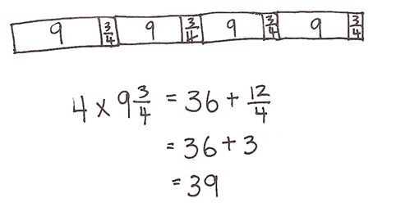
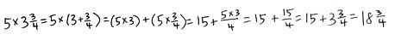
In Lesson 39, students build their problem-solving skills by solving multiplicative comparison word problems involving mixed numbers, e.g., “Jennifer bought 3 times as much meat on Saturday as she did on Monday. If she bought $\text{1}\frac{\text{1}}{\text{2}}$pounds on Monday, what is the total amount of meat bought for the two days?” They create and use tape diagrams to represent these problems before using various strategies to solve them numerically.
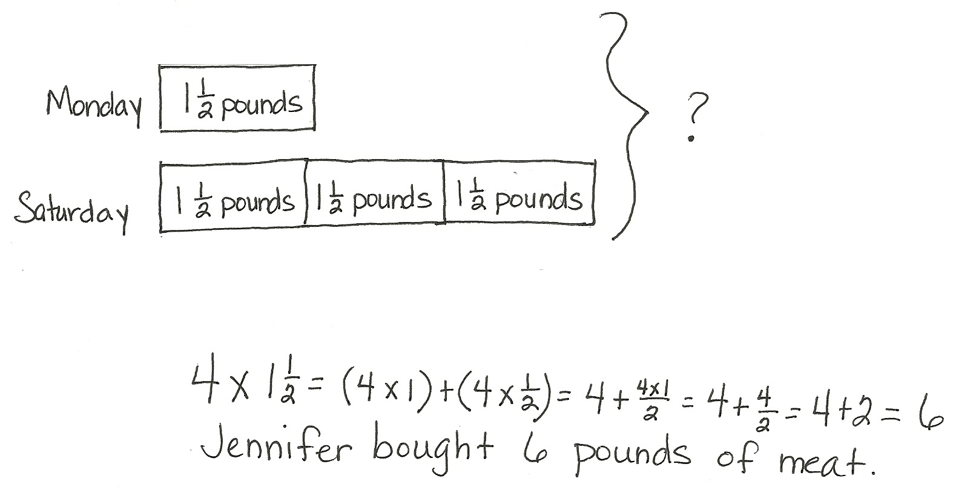

In Lesson 40, students solve word problems involving multiplication of a fraction by a whole number. Additionally, students work with data presented in line plots.
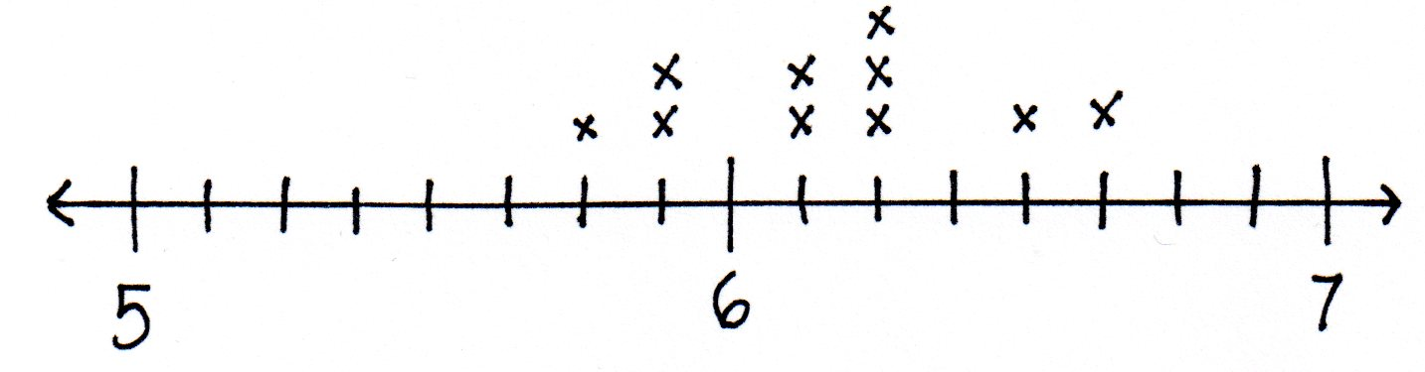

A Teaching Sequence Toward Mastery of Repeated Addition of Fractions as Multiplication
Objective 1: Represent the multiplication of n times a/b as (n × a)/b using the associative property and visual models.
(Lessons 35–36)
Objective 2: Find the product of a whole number and a mixed number using the distributive property.
(Lessons 37–38)
Objective 3: Solve multiplicative comparison word problems involving fractions.
(Lesson 39)
Objective 4: Solve word problems involving the multiplication of a whole number and a fraction including those involving line plots.
(Lesson 40)

