Topic F
Addition and Subtraction of Fractions by Decomposition
4.NF.3c, 4.MD.2
Focus Standard: | 4.NF.3c | Understand a fraction a/b with a > 1 as a sum of fractions 1/b.  - Add and subtract mixed numbers with like denominators, e.g., by replacing each mixed number with an equivalent fraction, and/or by using properties of operations and the relationship between addition and subtraction.
Instructional Days: | 6
Coherence -Links from: | G3–M5 | Fractions as Numbers on the Number Line
-Links to: | G5–M3 | Addition and Subtraction of Fractions
Topic F provides students with the opportunity to use their understandings of fraction addition and subtraction as they explore mixed number addition and subtraction by decomposition.
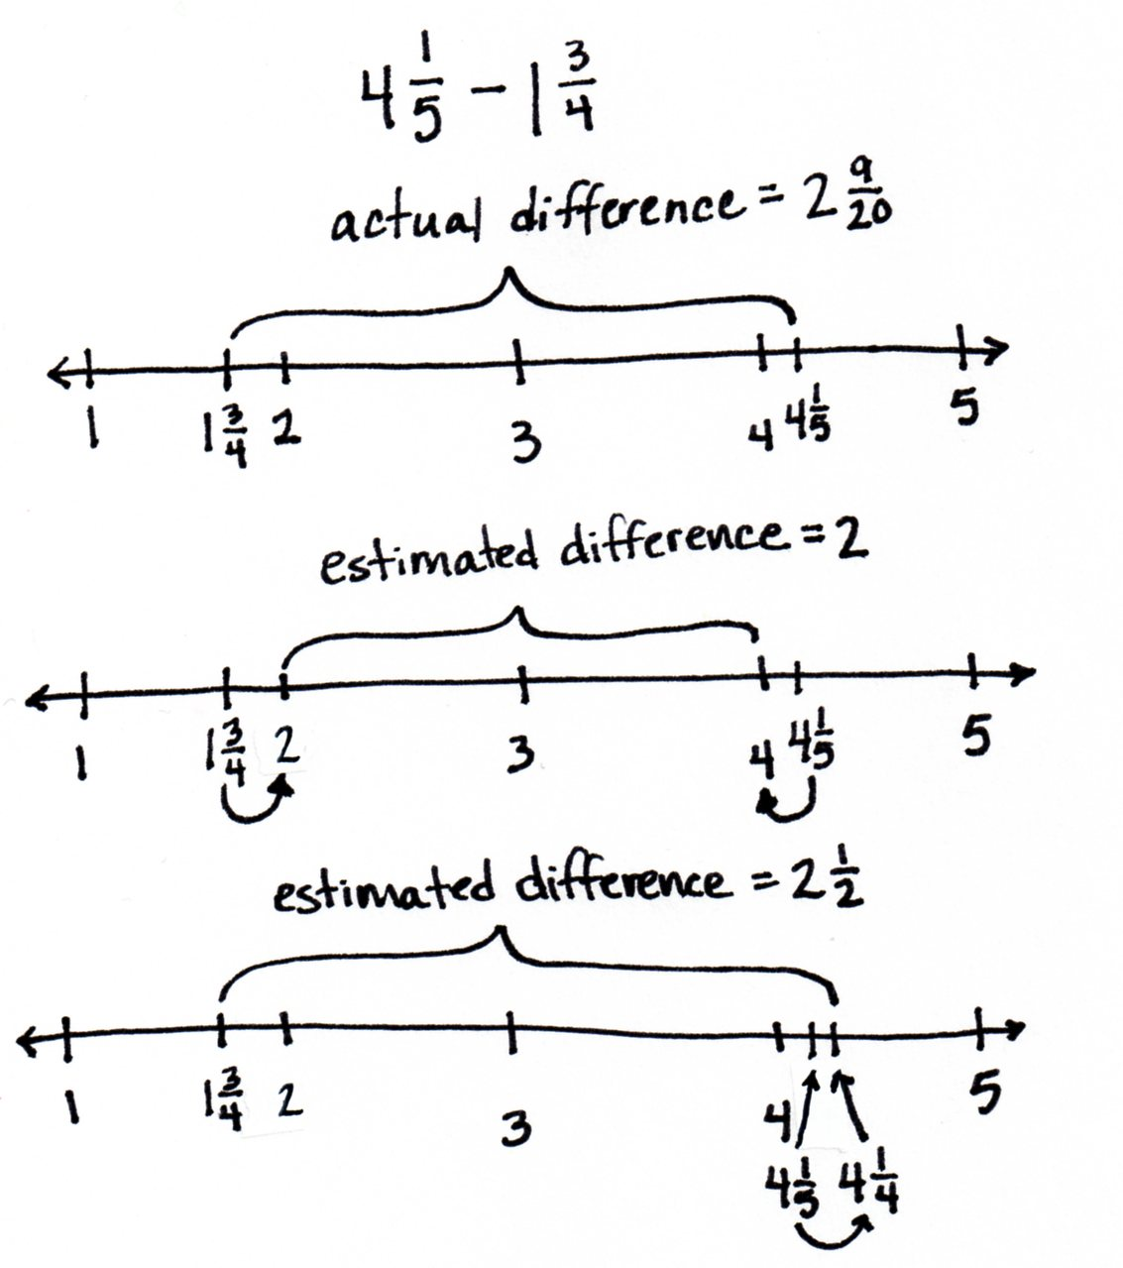
Lesson 29 focuses on the process of using benchmark numbers to estimate sums and differences of mixed numbers. Students once again call on their understanding of benchmark fractions as they determine, prior to performing the actual operation, what a reasonable outcome will be. One student might use benchmark whole numbers and reason, for example, that the difference between $\text{4}\frac{\text{1}}{\text{5}}$ and $\text{1}\frac{\text{3}}{\text{4}}$ is close to 2 because $\text{4}\frac{\text{1}}{\text{5}}$ is closer to 4 than 5, $\text{1}\frac{\text{3}}{\text{4}}$ is closer to 2 than 1, and the difference between 4 and 2 is 2. Another student might use familiar benchmark fractions and reason that the answer will be closer to $\text{2}\frac{\text{1}}{\text{2}}$ since $\text{4}\frac{\text{1}}{\text{5}}$ is about $\frac{\text{1}}{\text{4}}$ more than 4 and $\text{1}\frac{\text{3}}{\text{4}}$ is about $\frac{\text{1}}{\text{4}}$ less than 2, making the difference about a half more than 2 or $2\frac{1}{2}$.

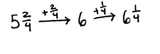
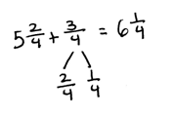
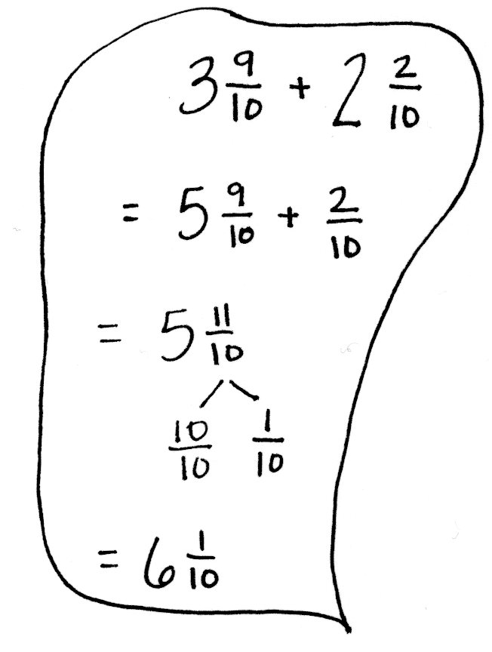
In Lesson 30, students begin adding a mixed number to a fraction using unit form. They add like units, applying their Grades 1 and 2 understanding of completing a unit to add when the sum of the fractional units exceeds 1. Students ask, “How many more do we need to make one?” rather than “How many more do we need to make ten?” as was the case in Grade 1. A number bond decomposes the fraction to make one and can be modeled on the number line or using the arrow way, as shown to the right. Alternatively, a number bond can be used after adding like units, when the sum results in a mixed number with a fraction greater than 1, to decompose the fraction greater than 1 into ones and fractional units.
Directly applying what was learned in Lesson 30, Lesson 31 starts with adding like units, e.g., ones with ones and fourths with fourths, to add two mixed numbers. Students can, again, choose to make one before finding the sum or to decompose the sum to result in a proper mixed number.
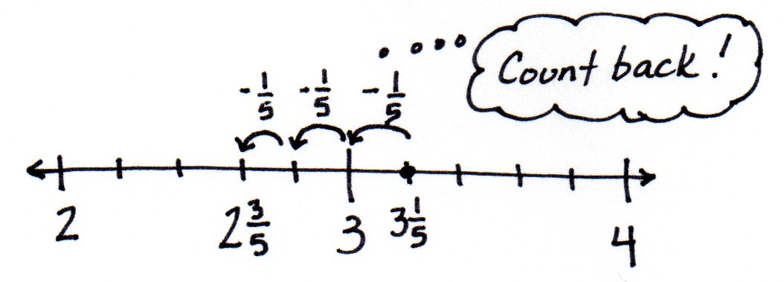
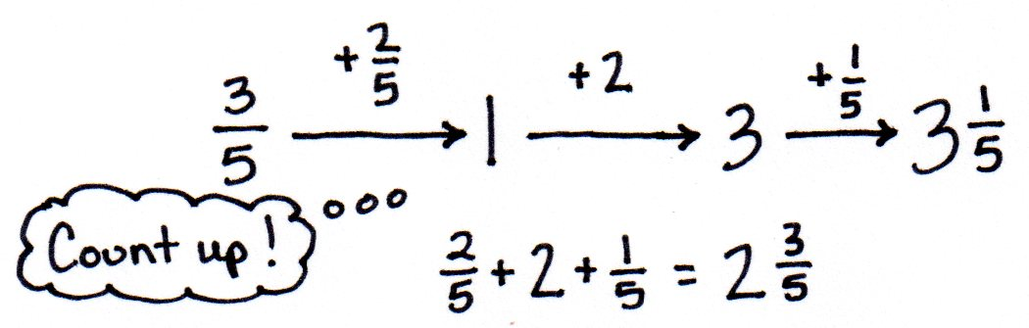
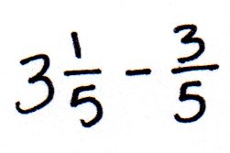
Lessons 32 and 33 follow the same sequence for subtraction. In Lesson 32, students simply subtract a fraction from a mixed number, using three main strategies both when there are and there are not enough fractional units. They count back or up, subtract from 1, or take one out to subtract from 1. In Lesson 33, students apply these strategies after subtracting the ones first. They model subtraction of mixed numbers using a number line or the arrow way.

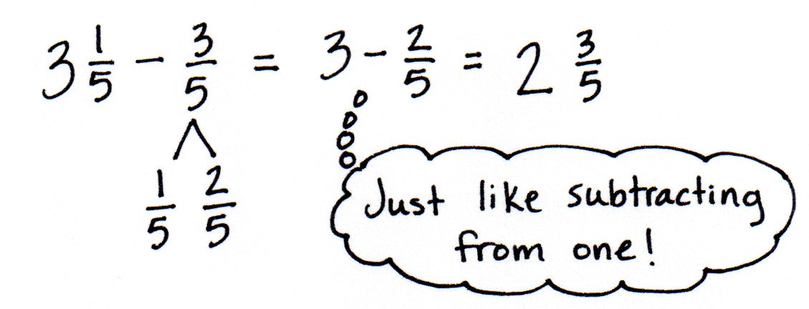

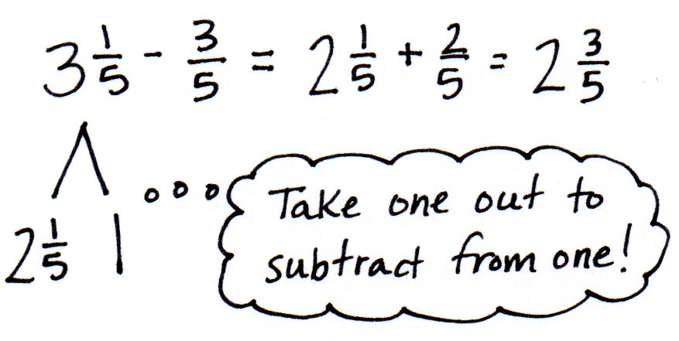

In Lesson 34, students learn another strategy for subtraction by decomposing the total into a whole number and a fraction greater than one to either subtract a fraction or a mixed number.
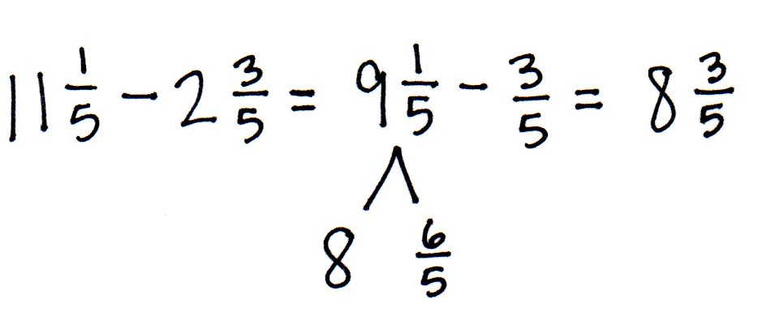
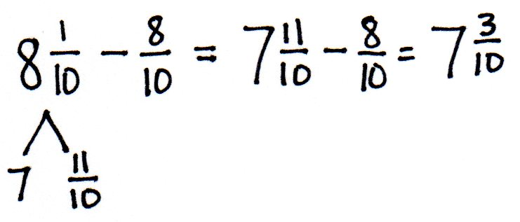

A Teaching Sequence Toward Mastery of Addition and Subtraction of Fractions by Decomposition
Objective 1: Estimate sums and differences using benchmark numbers.
(Lesson 29)
Objective 2: Add a mixed number and a fraction.
(Lesson 30)
Objective 3: Add mixed numbers.
(Lesson 31)
Objective 4: Subtract a fraction from a mixed number.
(Lesson 32)
Objective 5: Subtract a mixed number from a mixed number.
(Lesson 33)
Objective 6: Subtract mixed numbers.
(Lesson 34)

