Topic D

Application of Halves to Tell Time

**1.MD.3, 1.G.3**

|  |  |  |
| --- | --- | --- |
| Focus Standard: | 1.MD.3  1.G.3 | Tell and write time in hours and half-hours using analog and digital clocks. Recognize and identify coins, their names, and their values.  Partition circles and rectangles into two and four equal shares, describe the shares using the words *halves, fourths*, and *quarters*, and use the phrases *half of*, *fourth of*, and *quarter of*. Describe the whole as two of, or four of the shares. Understand for these examples that decomposing into more equal shares creates smaller shares. |
| Instructional Days: | 4 |  |
| Coherence -Links from: | GK–M2 | Two-Dimensional and Three-Dimensional Shapes |
| -Links to: | G2–M8 | Time, Shapes, and Fractions as Equal Parts of Shapes |

Topic D builds on students’ knowledge of parts of circles to tell time. In Lesson 10, students count and color the parts on a partitioned circle, forming the base of a paper clock. Relating this 12-section circle to the clock, students learn about the hour hand and tell time on both analog and digital clocks.

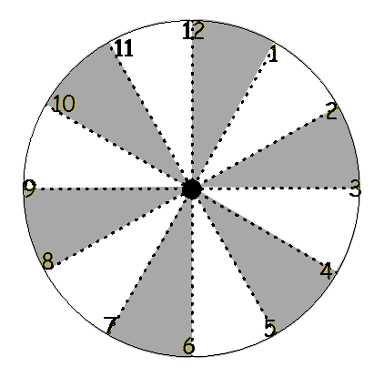

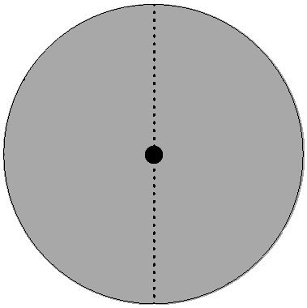In Lesson 11, students recognize the two half-circles on the circular clock face and connect this understanding with the half hour. Counting by fives to 30, students see that there are two 30-minute parts that make 1 hour, helping them connect the time displayed on a digital clock with the time displayed on an analog clock. Students notice that the hour hand is halfway through, but still within, the hour section on the partitioned paper clock. They tell time to the half hour on both analog and digital clocks.

Students continue to practice these skills in Lesson 12. In Lesson 13, they extend these new skills to telling time to the hour and half-hour using a variety of analog and digital clock faces.

|  |
| --- |
| A Teaching Sequence Toward Mastery of Application of Halves to Tell Time |
| Objective 1: Construct a paper clock by partitioning a circle and tell time to the hour. (Lesson 10) |
| Objective 2: Recognize halves within a circular clock face and tell time to the half hour.  (Lessons 11–13) |