Topic B
Part–Whole Relationships Within Composite Shapes
1.G.2
Focus Standard: | 1.G.2 | Compose two-dimensional shapes (rectangles, squares, trapezoids, triangles, half-circles, and quarter-circles) or three-dimensional shapes (cubes, right rectangular prisms, right circular cones, and right circular cylinders) to create a composite shape, and compose new shapes from the composite shape. (Students do not need to learn formal names such as “right rectangular prism.”)
Instructional Days: | 3
Coherence -Links from: | GK–M2 | Two-Dimensional and Three-Dimensional Shapes
-Links to: | G2–M8 | Time, Shapes, and Fractions as Equal Parts of Shapes
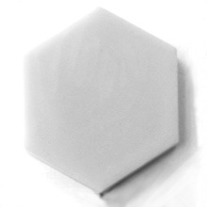
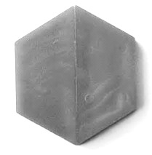
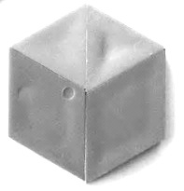
In Topic B, students combine shapes to form composite shapes, which in turn get larger as they add yet more shapes. As students work toward the objectives within the topic, they informally explore relationships between parts and wholes.
2 trapezoids
2 triangles and
2 rhombuses
Lessons 4 and 5 build on students’ knowledge of attributes of shapes to create composite shapes. In Lesson 4, students create composite shapes (hexagons, rectangles, and trapezoids) from triangles, squares, and rectangles. The students recognize that the same composite shape (whole) can be made from a variety of shapes (parts). For example, a hexagon might be made by composing six triangles or two trapezoids or one trapezoid and three triangles. Students also use square tiles to see that a large rectangle can have many combinations of smaller rectangles within it.
1 hexagon
In Lesson 5, students begin by identifying the hidden shapes within a large square as they cut the seven tangram pieces from this special rectangle. Students use the pieces to form new shapes from composite shapes, including recomposing the original square. Students explore the variety of ways they can compose new shapes by positioning pieces alongside composite shapes.
For example, students cannot only form a larger triangle from two right triangles, but they can use the shapes to form two composite triangles and push them together to make the original tangram square. Students also see how the same shapes can form different composite shapes. For instance, the same two right triangle pieces that formed a larger triangle can also be repositioned to form a square or parallelogram.
In Lesson 6, students extend their exploration of parts and wholes to three-dimensional shapes. Students create and hide composite shapes and describe the shape to a partner using attributes and positional words. The partner listens and attempts to create the same composite shape. In this way, students attend to the parts within the whole of their created shape and continue to develop clear, precise language.
A Teaching Sequence Toward Mastery of Part–Whole Relationships Within Composite Shapes
Objective 1: Create composite shapes from two-dimensional shapes.
(Lesson 4)
Objective 2: Compose a new shape from composite shapes.
(Lesson 5)
Objective 3: Create a composite shape from three-dimensional shapes and describe the composite shape using shape names and positions.
(Lesson 6)

