Topic F
Addition of Tens and Ones to a
Two-Digit Number
1.NBT.4, 1.NBT.2
Focus Standard: | 1.NBT.4 | Add within 100, including adding a two-digit number and a one-digit number, and adding a two-digit number and a multiple of 10, using concrete models or drawings and strategies based on place value, properties of operations, and/or the relationship between addition and subtraction; relate the strategy to a written method and explain the reasoning used. Understand that in adding two-digit numbers, one adds tens and tens, ones and ones; and sometimes it is necessary to compose a ten.
 | 1.NBT.2 | Understand that the two digits of a two-digit number represent amounts of tens and ones. Understand the following as special cases:  a. 10 can be thought of as a bundle of ten ones—called a “ten.”  c. The numbers 10, 20, 30, 40, 50, 60, 70, 80, 90 refer to one, two, three, four, five, six, seven, eight, or nine tens (and 0 ones).
Instructional Days: | 7
Coherence -Links from: | G1–M2 | Introduction to Place Value Through Addition and Subtraction Within 20
-Links to: | G1–M6 | Place Value, Comparison, Addition and Subtraction to 100
 | G2–M4 | Addition and Subtraction Within 200 with Word Problems to 100
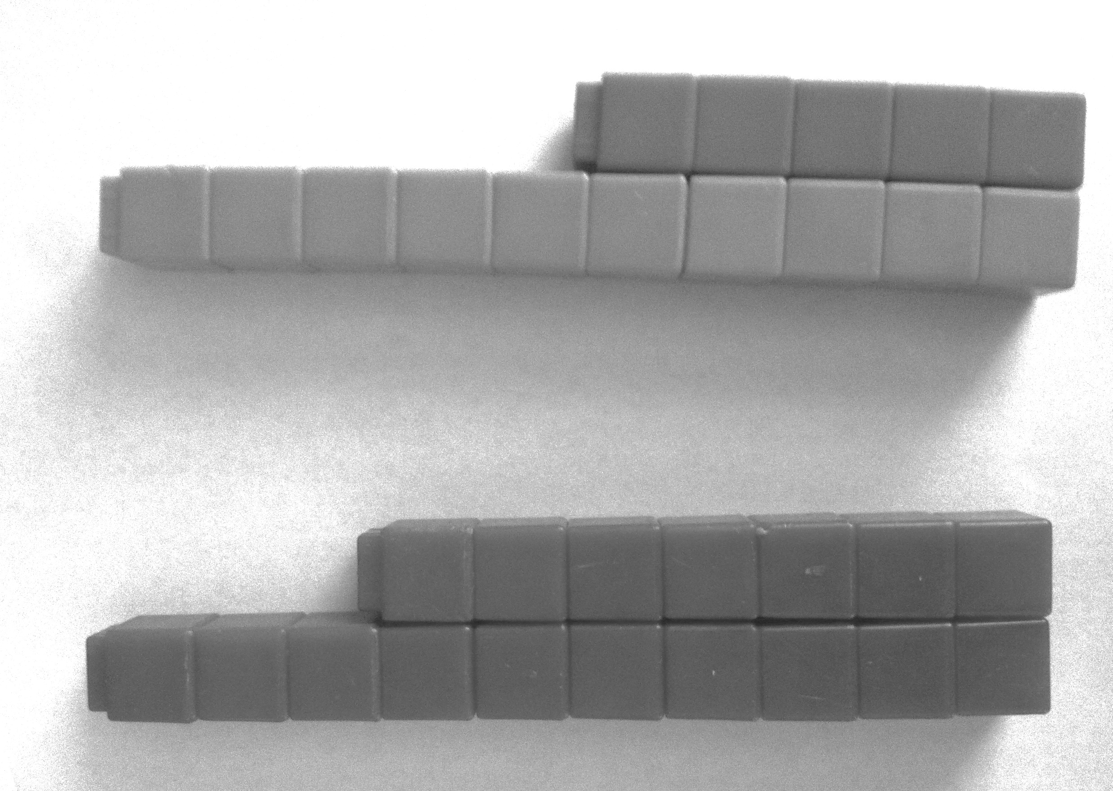
In Topic F, students begin adding like units within pairs of two-digit numbers. Lesson 23 focuses on taking interpretations of two-digit numbers a step further, having students interpret numbers such as 25 as 1 ten and 15 ones, as well as 2 tens and 5 ones and as 25 ones. Working with this concept supports student understanding in the next lessons when students add pairs such as 14 + 16 and initially make 2 tens and 10 ones.
During Lessons 24 and 25, students interchangeably add sets of two-digit numbers, where the ones digits produce a sum less than or equal to 10. For example, when adding 17 + 13, students decompose the second addend into 10 and 3. They then add 10 to 17, making 27, and then add the remaining ones. In Lesson 25, students also practice adding ones to the first addend and then adding the remaining ten.

Lesson 24
Lesson 25

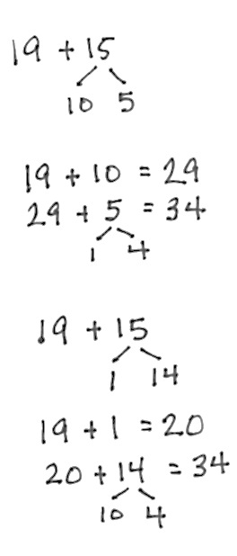
Adding on Ten First

In Lessons 26 and 27, students add tens and ones when the ones digits have a sum greater than 10, such as 19 + 15. Students continue to decompose the second addend, alternating between adding on the ten first and making the next ten, as shown to the right. In Lesson 27, students solve the same problem using the varying strategies taught throughout the topic. Students continue to strengthen their use of Level 3 strategies for adding numbers to 40.
Adding to Make the Next Ten First

The module closes with Lessons 28 and 29, wherein students solve Problem Sets of varied types to support flexibility in thinking as they add any pair of two digits whose sum is within 40. In Lesson 29, students again share methods and representations for finding the sums.
A Teaching Sequence Toward Mastery of Addition of Tens and Ones to a Two-Digit Number
Objective 1: Interpret two-digit numbers as tens and ones, including cases with more than 9 ones.
(Lesson 23)
Objective 2: Add a pair of two-digit numbers when the ones digits have a sum less than or equal to 10.
(Lessons 24–25)
Objective 3: Add a pair of two-digit numbers when the ones digits have a sum greater than 10.
(Lessons 26–27)
Objective 4: Add a pair of two-digit numbers with varied sums in the ones.
(Lessons 28–29)

