Topic D
Addition of Tens or Ones to a
Two-Digit Number
1.NBT.4
Focus Standard: | 1.NBT.4 | Add within 100, including adding a two-digit number and a one-digit number, and adding a two-digit number and a multiple of 10, using concrete models or drawings and strategies based on place value, properties of operations, and/or the relationship between addition and subtraction; relate the strategy to a written method and explain the reasoning used. Understand that in adding two-digit numbers, one adds tens and tens, ones and ones; and sometimes it is necessary to compose a ten.
Instructional Days: | 6
Coherence -Links from: | G1–M2 | Introduction to Place Value Through Addition and Subtraction Within 20
-Links to: | G1–M6 | Place Value, Comparison, Addition and Subtraction to 100
 | G2–M4 | Addition and Subtraction Within 200 with Word Problems to 100
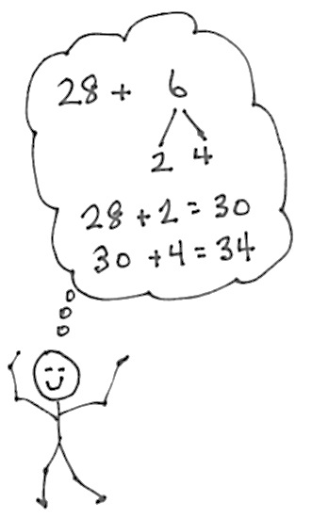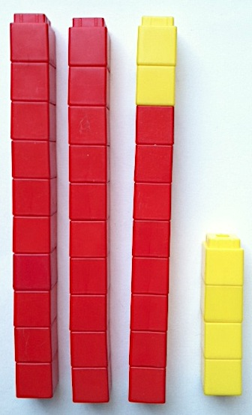Topic D begins with students applying the Module 2 strategies of counting on and making ten to larger numbers, this time making a ten that is built on a structure of other tens. In Lesson 13, students use linking cubes as a concrete representation of the numbers, write a matching number sentence, and write the total in a place value chart. As they add cubes, students see that sometimes a new ten can be made, for example, 33 + 7 = 40, or 4 tens.
In Lesson 14, students use arrow notation to reach the next ten, and then add the remaining amount when adding across ten. For example, when adding 28 + 6, students recognize that they started with 2 tens 8 ones and, after adding 6, had 3 tens 4 ones. Students also use the number bond notation from Module 2 to represent how they are breaking apart the second addend to make the ten (1.NBT.4).
Lesson 15 provides the chance to notice the ways smaller addition problems can help with larger ones. Students add 8 + 4, 18 + 4, and 28 + 4 and notice that 8 + 4 is embedded in all three problems, which connects to their previous work in Topic C.
Lessons 16, 17, and 18 focus on adding ones with ones or adding tens with tens. During Lesson 16, students recognize single-digit addition facts as they solve
15 + 2, 25 + 2, and 35 + 2. When adding 33 + 4, students see that they are adding 4 ones to 3 ones, while the tens remain unchanged, to make 3 tens 7 ones or 37. When adding 12 + 20, students see that they are adding 2 tens to
1 ten to make 3 tens 2 ones or 32. In both cases, one unit remains unchanged. Students work at a more abstract level by using dimes and pennies to model each addend. For instance, students model 14 cents using 1 dime and
4 pennies, and add 2 additional dimes or 2 additional pennies.
Adding Ones with Ones
In Lesson 17, students continue working with addition of like units and making ten as a strategy for addition. They use quick tens and number bonds as methods for representing their work.
During Lesson 18, students share and critique strategies for adding two-digit numbers. They reexamine all of the strategies used thus far in the module, including arrow notation, quick tens, and number bonds. Projecting varying correct work samples, students compare for clarity, discussing questions such as the following: Which drawing best shows the tens? Which drawings make it easier to not count all? Which number sentence is easiest to relate to the drawing? What is a compliment you would like to give [the student]? What is a way that [the student] might improve his work? How are [Partner A’s] methods different from or the same as yours?
A Teaching Sequence Toward Mastery of Addition of Tens or Ones to a Two-Digit Number
Objective 1: Use counting on and the make ten strategy when adding across a ten.
(Lessons 13–14)
Objective 2: Use single-digit sums to support solutions for analogous sums to 40.
(Lesson 15)
Objective 3: Add ones and ones or tens and tens.
(Lessons 16–17)
Objective 4: Share and critique peer strategies for adding two-digit numbers.
(Lesson 18)

