Topic C
Addition and Subtraction of Tens
1.NBT.4, 1.NBT.6
Focus Standard: | 1.NBT.4 | Add within 100, including adding a two-digit number and a one-digit number, and adding a two-digit number and a multiple of 10, using concrete models or drawings and strategies based on place value, properties of operations, and/or the relationship between addition and subtraction; relate the strategy to a written method and explain the reasoning used. Understand that in adding two-digit numbers, one adds tens and tens, ones and ones; and sometimes it is necessary to compose a ten.
 | 1.NBT.6 | Subtract multiples of 10 in the range 10–90 from multiples of 10 in the range 10–90 (positive or zero differences), using concrete models or drawings and strategies based on place value, properties of operations, and/or relationship between addition and subtraction; relate the strategy to a written method and explain the reasoning used.
Instructional Days: | 2
Coherence -Links from: | G1–M2 | Introduction to Place Value Through Addition and Subtraction Within 20
-Links to: | G1–M6 | Place Value, Comparison, Addition and Subtraction to 100
 | G2–M3 | Place Value, Counting, and Comparison of Numbers to 1,000
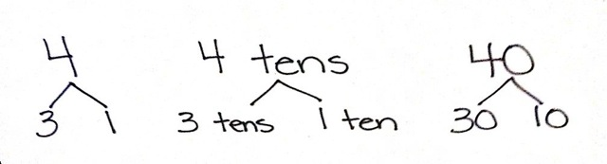
In Topic C, students continue from their previous work with 10 more and 10 less to extend the concept to adding and subtracting multiples of 10.

In Lesson 11, students represent the addition of ten more with concrete objects and number bonds, first using the numeral and then writing as units of ten, as shown to the right. After creating such number bonds for several examples, students notice that only the unit has changed (e.g., 3 bananas + 1 banana = 4 bananas, just as 3 tens + 1 ten = 4 tens). As students explore, they see that this relationship is present, even when adding more than 1 ten. They come to realize that 2 tens + 2 tens = 4 tens, just as 2 + 2 = 4 (1.NBT.4). Students also explore this relationship with subtraction, seeing that 4 tens can be decomposed as 3 tens and 1 ten and that 4 tens – 3 tens = 1 ten, just as 4 – 3 = 1 (1.NBT.6). Students see that the arrow is used to show the addition or subtraction of an amount, regardless of whether the number is increasing (adding) or decreasing (subtracting). This provides an important foundation for applying strategies such as the make ten strategy, which is described in Topic D.
In Lesson 12, students add multiples of 10 to two-digit numbers that include both tens and ones. They recognize that, when tens are added to a number, the ones remain the same. Students use the cubes within their kits of 4 ten-sticks, as well as the more abstract manipulatives of dimes and pennies, to explore the concept. They represent their computation in familiar ways such as number bonds, quick ten drawings, arrow notation, and by using the place value chart to organize the quantities as tens and ones.
A Teaching Sequence Toward Mastery of Addition and Subtraction of Tens
Objective 1: Add and subtract tens from a multiple of 10.
(Lesson 11)
Objective 2: Add tens to a two-digit number.
(Lesson 12)

