Topic A
Tens and Ones
1.NBT.1, 1.NBT.2, 1.NBT.5
Focus Standard: | 1.NBT.1 | Count to 120, starting at any number less than 120. In this range, read and write numerals and represent a number of objects with a written numeral.
 | 1.NBT.2 | Understand that the two digits of a two-digit number represent amounts of tens and ones. Understand the following as special cases:  - 10 can be thought of as a bundle of ten ones—called a “ten.”  - The numbers 10, 20, 30, 40, 50, 60, 70, 80, 90 refer to one, two, three, four, five, six, seven, eight, or nine tens (and 0 ones).
 | 1.NBT.5 | Given a two-digit number, mentally find 10 more or 10 less than the number, without having to count; explain the reasoning used.
Instructional Days: | 6
Coherence -Links from: | G1–M2 | Introduction to Place Value Through Addition and Subtraction Within 20
-Links to: | G2–M3 | Place Value, Counting, and Comparison of Numbers to 1,000
Module 4 builds on students’ work with teen numbers to now work within 40. Working within 40 helps students focus on the units, tens and ones, which can be easily modeled pictorially and concretely with these smaller numbers. The smaller numbers also allow students to count all while having an important experience with its inefficiency. Students’ innate ability to subitize to 4 keeps the numbers friendly when adding and subtracting tens for the first time and managing the new, complex task of considering both tens and ones when adding. Through their work within 40, students develop essential skills and concepts that generalize easily to numbers to 100 in Module 6.
tens
ones
4
3
Place Value Chart
In Lesson 1, students are presented with a collection of 20 to 40 items. They discuss and decide how to count the items, and then compare the efficiency of counting individual ones with counting tens and ones. Through this exploration, students come to understand the utility of ten as a unit: both as a method for counting and for efficiently recording a given number (1.NBT.1, 1.NBT.2). Students keep their own set of 40 linking cubes, organized as a kit of 4 ten-sticks, to use as they progress through the module.
In Lesson 2, students represent and decompose two-digit numbers as tens and ones and record their findings on a place value chart, supported by the familiar Hide Zero cards. Students share thoughts such as, “The 3 in 34 stands for 3 tens. And, the 4 in 34 is just 4 ones!” Up to this point, students have worked with representations of ten where 10 ones are clearly visible (e.g., as two 5-groups). While the digit 3 in 34 may appear less than the digit 4, its value is determined by its position. Use of the place value chart represents the students’ first experience with this additional layer of abstraction.
Lesson 3 allows students to explore two-digit numbers as tens and ones, as well as just ones. Students use their fingers to represent bundled tens and unbundled ones by clasping and unclasping their fingers. For example, students model 34 with 3 students showing their hands clasped to make a ten and a fourth student showing 4 fingers to represent 4 ones. Taking student understanding of place value a step further, Lesson 4 asks students to decompose and compose two-digit numbers as addition equations. Students develop an understanding that “34 is the same as 30 + 4,” as they move between writing the number when given the equations and writing the equations when given a number. Throughout these lessons, students use concrete objects and/or drawings to support their understanding and explain their thinking.
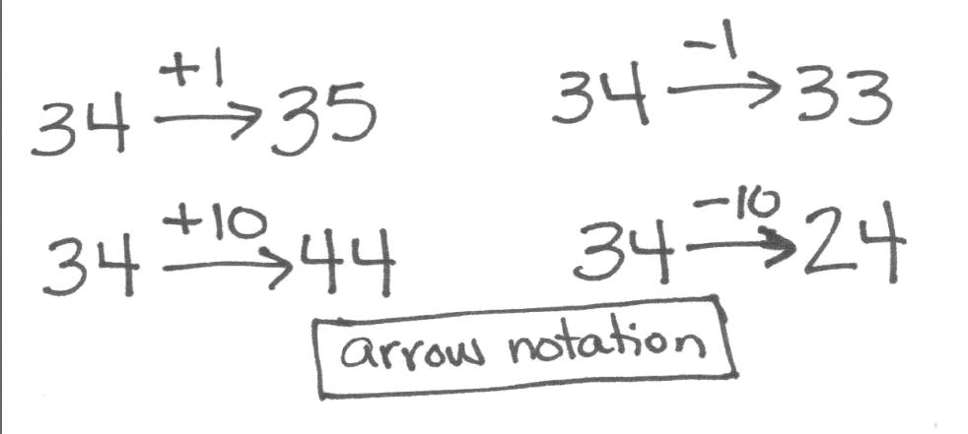
Topic A concludes with Lessons 5 and 6, where students use materials and drawings to find 10 more, 10 less, 1 more, and 1 less than a given number (1.NBT.5). In Lesson 5, students use the familiar linking cubes (organized into tens) and 5-group columns. They engage in conversation about patterns they observe: “I see that 10 less than 34 is just 1 less ten, so it must be 24!” Students represent how the number changed using arrow notation, or the arrow way, as shown to the right. Lesson 6 then introduces the dime and penny as representations of ten and one, respectively. Students make the connection between the familiar representations of tens and ones to the dime and the penny and work to find 10 more, 10 less, 1 more, and 1 less.
A Teaching Sequence Toward Mastery of Tens and Ones
Objective 1: Compare the efficiency of counting by ones and counting by tens.
(Lesson 1)
Objective 2: Use the place value chart to record and name tens and ones within a two-digit number.
(Lesson 2)
Objective 3: Interpret two-digit numbers as either tens and some ones or as all ones.
(Lesson 3)
Objective 4: Write and interpret two-digit numbers as addition sentences that combine tens and ones.
(Lesson 4)
Objective 5: Identify 10 more, 10 less, 1 more, and 1 less than a two-digit number.
(Lesson 5)
Objective 6: Use dimes and pennies as representations of tens and ones.
(Lesson 6)

Integrates the 1.MD.3 standard for dime and penny. This standard will become a focal standard in Module 6, when all 4 coins have been introduced.

