Topic B
Counting On or Taking from Ten to Solve Result Unknown and Total Unknown Problems
1.OA.1, 1.OA.3, 1.OA.4, 1.OA.6, 1.OA.5, 1.OA.7
Focus Standard: | 1.OA.1 | Use addition and subtraction within 20 to solve word problems involving situations of adding to, taking from, putting together, taking apart, and comparing, with unknowns in all positions, e.g., by using objects, drawings, and equations with a symbol for the unknown number to represent the problem.
 | 1.OA.3 | Apply properties of operations as strategies to add and subtract. (Students need not use formal terms for these properties.) Examples: If 8 + 3 = 11 is known, then 3 + 8 = 11 is also known. (Commutative property of addition.) To add 2 + 6 + 4, the second two numbers can be added to make a ten, so 2 + 6 + 4 = 2 + 10 = 12. (Associative property of addition.)
 | 1.OA.4 | Understand subtraction as an unknown-addend problem. For example, subtract 10 – 8 by finding the number that makes 10 when added to 8.
 | 1.OA.6 | Add and subtract within 20, demonstrating fluency for addition and subtraction within 10. Use mental strategies such as counting on; making ten (e.g., 8 + 6 = 8 + 2 + 4 = 10 + 4 = 14); decomposing a number leading to a ten (e.g., 13 – 4 = 13 – 3 – 1 = 10 – 1 = 9); using the relationship between addition and subtraction (e.g., knowing that 8 + 4 = 12, one knows 12 – 8 = 4); and creating equivalent but easier or known sums (e.g., adding 6 + 7 by creating the known equivalent 6 + 6 + 1 = 12 + 1 = 13).
Instructional Days: | 10
Coherence -Links from: | GK–M4 | Number Pairs, Addition and Subtraction to 10
-Links to: | G2–M3 | Place Value, Counting, and Comparison of Numbers to 1,000
 | G2–M5 | Addition and Subtraction Within 1,000 with Word Problems to 100
Topic B focuses on the take from ten Level 3 strategy (1.OA.6). Students begin with word problems calling on them to subtract 9 from 10 in Lessons 12 and 13, first with concrete objects, then with drawings, and then with number bonds. The problems students solve are similar to this one: “Mary has two plates of cookies, one with 10 and one with 2. At the party, 9 cookies were eaten from the plate with 10 cookies. How many cookies were left after the party?” (1.OA.1) 10 – 9 = 1 and 1 + 2 = 3. This allows students to use this take from ten strategy when the ten is already separated for them and in a variety of contexts (concrete, pictorial,
and abstract), which sets them up for the work of the later lessons of the topic where they must decompose teen numbers on their own to take from ten.
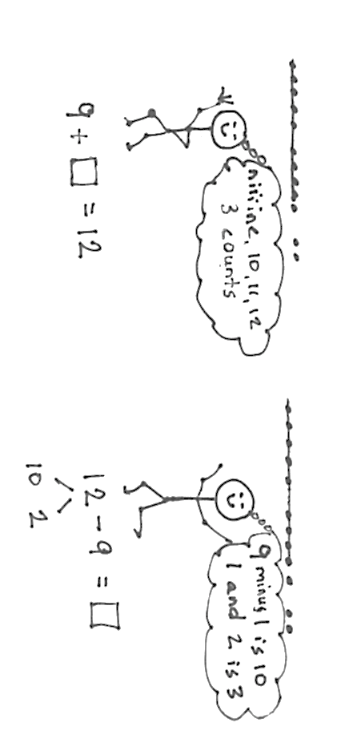
Lessons 14, 15, and 16 focus students on modeling subtraction of 9 from teen numbers, first with manipulatives, then 5-groups drawings, and finally number bonds. Students relate counting on to subtraction in a couple of ways (pictured below) (1.OA.4). Students begin to realize that there is both simplicity and efficiency when they decompose the teen number into 10 and some ones, subtract the 9 from 10, and finally add the 1 left over with some ones; this is key in Lesson 16 as students share their thinking and compare efficiency.
S: To solve 12 – 9, I count on from 9 to 12, niiiine, 10, 11, 12, three counts. To solve 12 – 9, I make 12 into 10 and 2 and subtract 9 from ten. 1 + 2 = 3.
Level 3: Decompose ten and compose with the ones
Level 2: Count on

This same progression that occurred with subtracting 9 from teen numbers repeats itself in Lessons 17, 18, and 19 as students subtract 8 from teen numbers in concrete, pictorial, and abstract contexts. Students practice a pattern of action, take from ten and add the ones, as they face different contexts in word problems (MP.8), e.g., “Maria has 12 snowballs. She threw 8 of them. How many does she have left?” (1.OA.3).
Lesson 20 both broadens and solidifies students’ strategy use as they are faced with a combination of 7, 8, and 9 as subtrahends being taken away from teen numbers in both story problems and abstract equations. Lesson 21 closes Topic B with student-centered discussion about solution strategies as they solve both action-oriented (take from with result unknown) and relationship (take apart with addend unknown) problems. Students ask each other, “How and why did you solve it this way?” and then discuss which strategies are the most efficient.

A Teaching Sequence Towards Mastery of Counting On or Taking from Ten to Solve Result Unknown and Total Unknown Problems
Objective 1: Solve word problems with subtraction of 9 from 10.
(Lessons 12–13)
Objective 2: Model subtraction of 9 from teen numbers.
(Lessons 14–15)
Objective 3: Relate counting on to making ten and taking from ten.
(Lesson 16)
Objective 4: Model subtraction of 8 from teen numbers.
(Lessons 17–18)
Objective 5: Compare efficiency of counting on and taking from ten.
(Lesson 19)
Objective 6: Subtract 7, 8, and 9 from teen numbers.
(Lesson 20)
Objective 7: Share and critique peer solution strategies for take from with result unknown and take apart with addend unknown word problems from the teens.
(Lesson 21)

