Topic A
Counting On or Making Ten to Solve Result Unknown and Total Unknown Problems
1.OA.1, 1.OA.2, 1.OA.3, 1.OA.6
Focus Standard: | 1.OA.1 | Use addition and subtraction within 20 to solve word problems involving situations of adding to, taking from, putting together, taking apart, and comparing, with unknowns in all positions, e.g., by using objects, drawings, and equations with a symbol for the unknown number to represent the problem.
 | 1.OA.2 | Solve word problems that call for addition of three whole numbers whose sum is less than or equal to 20, e.g., by using objects, drawings, and equations with a symbol for the unknown number to represent the problem.
 | 1.OA.3 | Apply properties of operations as strategies to add and subtract. (Students need not use formal terms for these properties.) Examples: If 8 + 3 = 11 is known, then 3 + 8 = 11 is also known. (Commutative property of addition.) To add 2 + 6 + 4, the second two numbers can be added to make a ten, so 2 + 6 + 4 = 2 + 10 = 12. (Associative property of addition.)
 | 1.OA.6 | Add and subtract within 20, demonstrating fluency for addition and subtraction within 10. Use mental strategies such as counting on; making ten (e.g., 8 + 6 = 8 + 2 + 4 = 10 + 4 = 14); decomposing a number leading to a ten (e.g., 13 – 4 = 13 – 3 – 1 = 10 – 1 = 9); using the relationship between addition and subtraction (e.g., knowing that 8 + 4 = 12, one knows 12 – 8 = 4); and creating equivalent but easier or known sums (e.g., adding 6 + 7 by creating the known equivalent 6 + 6 + 1 = 12 + 1 = 13).
Instructional Days: | 11
Coherence -Links from: | GK–M4 | Number Pairs, Addition and Subtraction to 10
-Links to: | G2–M3 | Place Value, Counting, and Comparison of Numbers to 1,000
 | G2–M5 | Addition and Subtraction Within 1,000 with Word Problems to 100

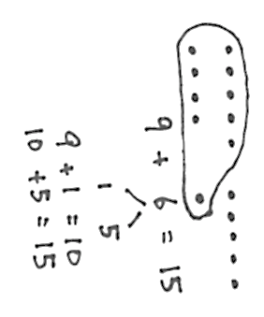
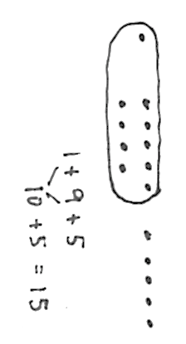
Topic A begins with students solving word problems with three addends (1.OA.2) as a way for them to begin to explore the make ten Level 3 strategy in a meaningful context. With problems that always include at least two numbers that yield 10 when added together, Lesson 1 encourages students to use the associative and commutative properties as they set up and read equations in various ways. The story problem on the right, for instance, can be solved by adding 1 + 9 first, then adding the five (see image below story problem).
We had 1 upper grade buddy come visit with 9 more buddies following him. Soon after that, 5 more buddies came to our classroom. How many buddies came altogether?
This leads into Lesson 2’s focus of explicitly using the associative and commutative properties to add three addends without the context of story problems (1.OA.3). This lesson is where students practice associating the two addends that make ten (1.OA.6) and then adding the third addend; they prove to themselves that this simplification of addition is a viable strategy.
Following this introduction, Lessons 3, 4, and 5 afford students ample practice with adding 9 and another single-digit number as they decompose the second addend to make ten with the 9. Students solve problems such as, "Maria has 9 snowballs and Tony has 6. How many do they have in all?" as follows: 9 + 6 = 9 + (1 + 5) = (9 + 1) + 5 = 10 + 5 = 15. This triad of lessons takes students through a concrete–pictorial–abstract progression as they work with physical 5-groups using objects, 5-group drawings, and finally number bonds.
Lesson 6 reminds students of the commutative property again, by focusing them on when and why they might apply commutativity: to compose ten from the larger addend. Lessons 7, 8, and 9 mirror the earlier set of three lessons, but students decompose one addend to make ten with 8 as the key addend. This extensive practice allows students to internalize both why and how they would compose ten from the larger addend as they come to realize that this is an efficient strategy.
Students use the make ten strategy with 5-group drawings and number bonds to solve a variety of problems involving a mixture of 7, 8, or 9 as addends in Lesson 10. This gives students an opportunity to not only practice their newly discovered strategies, but it also allows them to generalize this make ten strategy to a new number: 7. It is important to note that students can continue to use counting on as a strategy throughout the entirety of Topic A, although many students will begin to use the make ten strategy more and more as they continually discuss addition strategies and efficiency with one another.
Topic A ends with Lesson 11 where students solve story problems with two addends (1.OA.1) using independently selected methods. By asking questions such as, "Why did you solve the problem that way? How did we solve these differently?" students are able to engage in rich dialogue about the mathematical strategies and determine which are most useful.

A Teaching Sequence Towards Mastery of Counting On or Making Ten to Solve Result Unknown and Total Unknown Problems
Objective 1: Solve word problems with three addends, two of which make ten.
(Lesson 1)
Objective 2 Use the associative and commutative properties to make ten with three addends.
(Lesson 2)
Objective 3: Make ten when one addend is 9.
(Lessons 3–4)
Objective 4: Compare efficiency of counting on and making ten when one addend is 9.
(Lesson 5)
Objective 5: Use the commutative property to make ten.
(Lesson 6)
Objective 6: Make ten when one addend is 8.
(Lessons 7–8)
Objective 7: Compare efficiency of counting on and making ten when one addend is 8.
(Lesson 9)
Objective 8: Solve problems with addends of 7, 8, and 9.
(Lesson 10)
Objective 9: Share and critique peer solution strategies for put together with total unknown word problems.
(Lesson 11)

Just as the Common Core State Standards note, students do not learn or use these formal terms.

