Topic J
Development of Subtraction Fluency Within 10
1.OA.6
Focus Standard: | 1.OA.6 | Add and subtract within 20, demonstrating fluency for addition and subtraction within 10. Use strategies such as counting on; making ten (e.g., 8 + 6 = 8 + 2 + 4 = 10 + 4 = 14); decomposing a number leading to a ten (e.g., 13 – 4 = 13 – 3 – 1 = 10 – 1 = 9); using the relationship between addition and subtraction (e.g., knowing that 8 + 4 = 12, one knows 12 – 8 = 4); and creating equivalent but easier or known sums (e.g., adding 6 + 7 by creating the known equivalent 6 + 6 + 1 = 12 + 1 = 13.)
Instructional Days: | 2
Coherence -Links from: | GK–M4 | Number Pairs, Addition and Subtraction to 10
-Links to: | G2–M4 | Addition and Subtraction Within 200 with Word Problems to 100
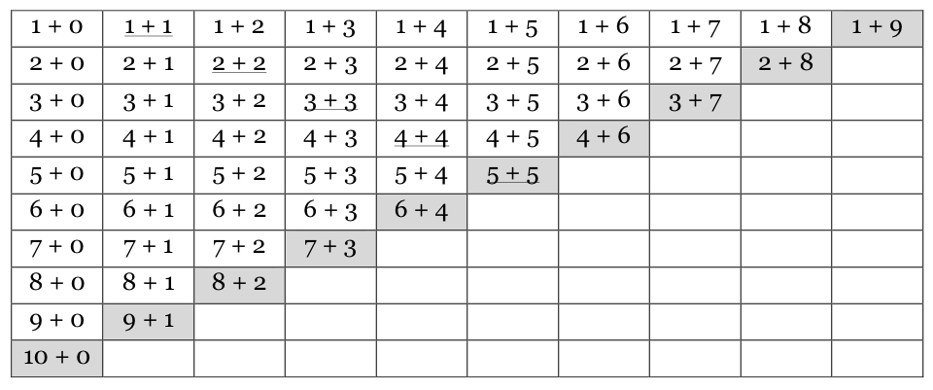
Grade 1’s Module 1 closes with Topic J, where students spend Lesson 38 exploring the addition chart (similar to Topic F) and looking for patterns within the context of subtraction (MP.7, MP.8, 1.OA.6).
When presented with a subtraction equation such as
7 - 3, students then use their knowledge of the decompositions of 7 to help them solve, and discuss to find related addition equations on the addition chart such as 3 + 4 or 4 + 3.
The final lesson, Lesson 39, allows students to further analyze the addition chart to create their own sets of related addition and subtraction facts for them to practice throughout the year as they work toward mastery of these foundational facts.

A Teaching Sequence Towards Mastery of Development of Subtraction Fluency Within 10
Objective 1: Look for and make use of repeated reasoning and structure using the addition chart to solve subtraction problems.
(Lesson 38)
Objective 2: Analyze the addition chart to create sets of related addition and subtraction facts.
(Lesson 39)

